Brava Island, Cape Verde
Cape Verde's 'Island of Flowers' is a tender port of rugged volcanic mountains, cobblestone colonial streets, and a pace of life that big-ship itineraries rarely disturb.
⚓ Tender port (anchor off Furna) · 🕒 Typical call: 6-8 hrs · 💵 Cape Verdean Escudo (CVE) · 🗣️ Portuguese / Creole (Kriolu)
✍️ MY DAY IN PORT (FILL IN)
Ship / Date
In port | arrive ______ · all aboard ______
Booked excursion
Notes / meeting point
GETTING ASHORE
- Docking: Tender — ships anchor offshore; tenders land at Furna quay
- Walk to center: Furna to Nova Sintra is ~6 km (99-curve mountain road; taxi recommended)
- Best For: Hiking, off-the-beaten-path culture, slow travel
- Don't Miss: Nova Sintra's Praça Eugénio Tavares and views toward Fogo
GETTING AROUND
- 🚕 Taxi: ~€6 — Private taxis (called aluguers) meet ships at Furna port. The ~7km winding road up to Nova Sintra takes about 20 minutes
- 📱 Rideshare: ❌ not available
TOP THINGS TO DO
- Nova Sintra Walking Tour — Explore the capital's pastel colonial houses, cobblestone lanes, and Praça Eugénio Tavares — a shaded square honoring Cape…
- Hike Furna to Nova Sintra — The classic Brava hike follows the 99-curve road (or footpaths cutting across switchbacks) up 500 m through terraced gardens, fig…
- Fajã d'Água Coastal Village — A serene fishing bay on the island's western coast with natural volcanic rock pools, a pebble beach, and views of Fogo.
- Monte Vigía & Highland Trails — Brava's interior ridge trails wind through some of the greenest landscapes in Cape Verde.
- Nossa Senhora do Monte Pilgrimage Church — A hilltop pilgrimage church in the Nossa Senhora do Monte parish, a short trip from Nova Sintra, that serves as a religious site…
BEST WALKS
- Nova Sintra Town Stroll: 1-2 km · Easy · 30-60 min — From the central Praça Eugénio Tavares, wander the cobblestone streets past colorful colonial…
- Furna Quay to Village: 0.5 km · Easy · 15 min — A short flat stroll around Furna village itself — a fishing community with colorful boats and the…
WEATHER · DAYLIGHT · MONEY
Month | High °F | Low °F | Rainy days
May | 74 | 71 | 0
Jul | 77 | 74 | 0
Sep | 81 | 78 | 8
Daylight: May 6:10AM–6:59PM · Jul 6:17AM–7:12PM · Sep 6:27AM–6:39PM
cruiseports.org/brava-island · Confirm terminal & all-aboard time with your ship

Brava Island, Cape Verde — Port Map
Red = walkable sights · Amber = excursions farther out · P = cruise terminal
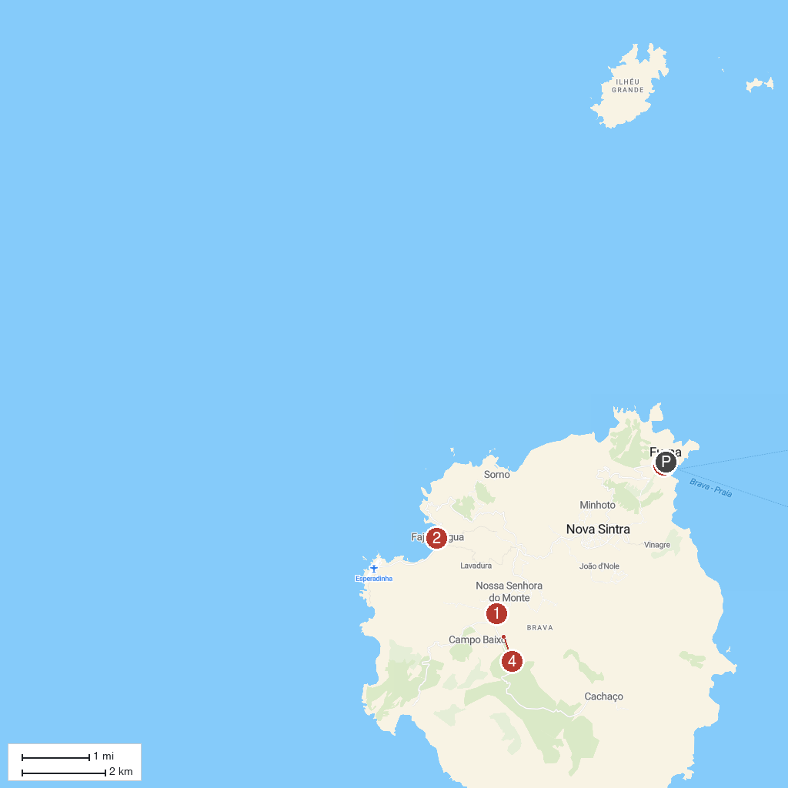
MAP KEY
1. Nova Sintra Viewpoint | 3. Church of Nossa Senhora do Monte
2. Faja d'Agua | 4. Pico de Fontainhas
P. Cruise port / terminal
Map © MapTiler © OpenStreetMap contributors · cruiseports.org

