Brest, Brittany, France
At the wild western edge of Brittany, Brest pairs a formidable medieval castle and first-rate ocean discovery park with easy access to dramatic cliffs, medieval villages, and the windswept Crozon Peninsula.
⚓ Docked (Port de Commerce) · 🕒 Typical call: 8-10 hrs · 💶 Currency: Euro (€) · 🗣️ Language: French · 🌧️ Weather: Mild, often overcast
✍️ MY DAY IN PORT (FILL IN)
Ship / Date
In port | arrive ______ · all aboard ______
Booked excursion
Notes / meeting point
GETTING ASHORE
- Docking: Docked at Port de Commerce, ~1.5 km from city center (steep uphill — shuttle recommended)
- Walk to Center: 15-20 min uphill walk or free port shuttle to Place de la Liberté
- Best For: Naval history, ocean science, Breton day trips, coastal scenery
- Don't Miss: Château de Brest & Navy Museum, Océanopolis ocean park, Cours Dajot promenade
GETTING AROUND
- 🚕 Taxi: €7–€9 — Taxis from the port to Brest city center cover roughly 2.4 km in about 4 minutes. Fares are regulated and vary slightly
- 📱 Rideshare: ✅ Uber, Bolt
TOP THINGS TO DO
- Château de Brest & National Navy Museum — The oldest monument in Brest — its origins trace back to a Roman castellum and it remains one of the world's oldest castles still…
- Océanopolis Ocean Discovery Park — One of Europe's top aquariums, with three massive pavilions covering polar, tropical, and temperate ocean ecosystems.
- Crozon Peninsula Coastal Drive — About an hour southwest of Brest, the Crozon Peninsula delivers towering Atlantic cliffs, wild beaches, and sweeping views across…
- Locronan Medieval Village — About an hour away, Locronan is classified among France's most beautiful villages (Les Plus Beaux Villages de France) — its…
- Pointe Saint-Mathieu Lighthouse & Abbey Ruins — A dramatic headland about 25 km west of Brest where a working lighthouse stands beside the ruins of a medieval abbey, overlooking…
BEST WALKS
- Cours Dajot to Château de Brest: 2 km · 45 min · Easy-moderate — From the city center, stroll along the Cours Dajot promenade for panoramic views over the…
- Rue de Siam to Ateliers des Capucins: 1.5 km · 30 min · Moderate (cable car available) — Walk Brest's main shopping street Rue de Siam, cross the Recouvrance cable car or footbridge over…
WEATHER · DAYLIGHT · MONEY
Month | High °F | Low °F | Rainy days
May | 66 | 48 | 13
Jul | 76 | 59 | 13
Sep | 67 | 51 | 9
Daylight: May 6:38AM–9:51PM · Jul 6:32AM–10:14PM · Sep 7:55AM–8:29PM
Representative sunrise/sunset — 2025, 15th of each month; local civil time including DST (Europe/Paris). Source: Astral; not a forecast or climate average.
cruiseports.org/brest · Confirm terminal & all-aboard time with your ship

Brest, Brittany, France — Port Map
Red = walkable sights · Amber = excursions farther out · P = cruise terminal
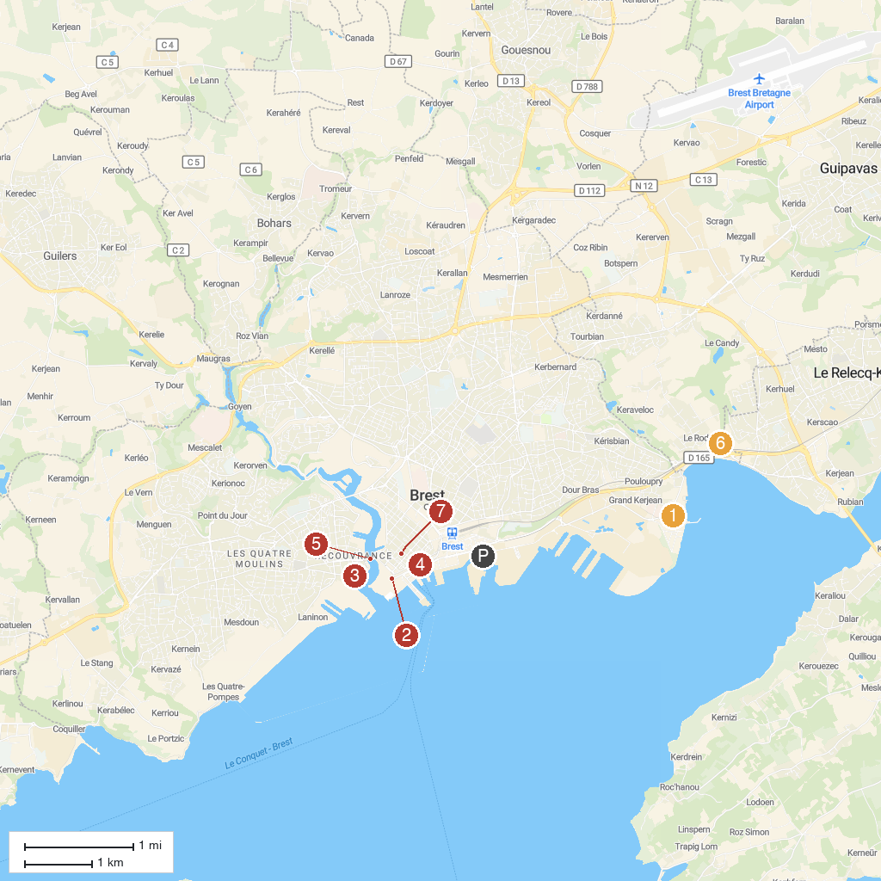
MAP KEY
1. Oceanopolis | 5. Pont de Recouvrance
2. Musée National de la Marine | 6. Vallée du Costour
3. Maison de la Fontaine | 7. Brest Museum of Fine Arts
4. US Naval Monument at Brest
P. Cruise port / terminal
Map © MapTiler © OpenStreetMap contributors · cruiseports.org

