Briare, Loiret, France
Where Gustave Eiffel's 662-metre aqueduct carries canal boats across the Loire, Briare offers a quiet slice of old France — enamel mosaics, lock-side walks, and wine country within easy reach.
⚓ River port (docked at quay) · 🕒 Typical call: 6–8 hrs · 💶 Currency: Euro · 🗣️ Language: French
✍️ MY DAY IN PORT (FILL IN)
Ship / Date
In port | arrive ______ · all aboard ______
Booked excursion
Notes / meeting point
GETTING ASHORE
- Docking: River barges tie up at the Port de Plaisance quay in town; short walk to the aqueduct
- Walk to center: Town center is 5 min on foot from the quay; aqueduct is 10 min
- Best For: Engineering history, canal walks, enamel art, wine-country day trips
- Don't Miss: Walking across the Pont-canal de Briare — once the world's longest navigable aqueduct
GETTING AROUND
- 🚕 Taxi: €5–€15 — Taxi Mario is a well-known local operator serving Briare 24/7. Given the small town size, most rides are short and inexp
- 📱 Rideshare: ✅ Uber
TOP THINGS TO DO
- Walk the Pont-canal de Briare — Stroll across the 662-metre iron aqueduct designed with input from Gustave Eiffel's workshop, opened in 1896.
- Musée des Deux Marines et du Pont-Canal — Compact museum dedicated to the history of river navigation on the Loire and Canal de Briare, with exhibits on the construction…
- Enamel & Mosaic Museum (Musée des Émaux et de la Mosaïque) — Briare was France's leading enamel manufacturer for over 160 years.
- Gien — Castle & Faïencerie — The handsome red-brick Château de Gien, about 10 km downstream along the Loire, houses a museum dedicated to French hunting…
- Sancerre Wine & Village — Perched on a hilltop 40 km south, Sancerre is one of the Loire Valley's most celebrated wine villages.
BEST WALKS
- Canal Towpath to the Pont-canal: 1.5 km one-way · 20 min · Easy · Flat towpath — From the Port de Plaisance, follow the Canal Latéral à la Loire towpath north-east to the entrance…
- Town Centre Loop — Enamels & Église Saint-Étienne: 2 km loop · 45 min · Easy · Pavements — A short loop from the quay through the town centre, taking in the Friday market square, the Église…
WEATHER · DAYLIGHT · MONEY
Month | High °F | Low °F | Rainy days
May | 66 | 50 | 12
Jul | 78 | 60 | 8
Sep | 72 | 55 | 8
Daylight: May 6:11AM–9:19PM · Jul 6:07AM–9:42PM · Sep 7:26AM–8:00PM
cruiseports.org/briare · Confirm terminal & all-aboard time with your ship

Briare, Loiret, France — Port Map
Red = walkable sights · Amber = excursions farther out · P = cruise terminal
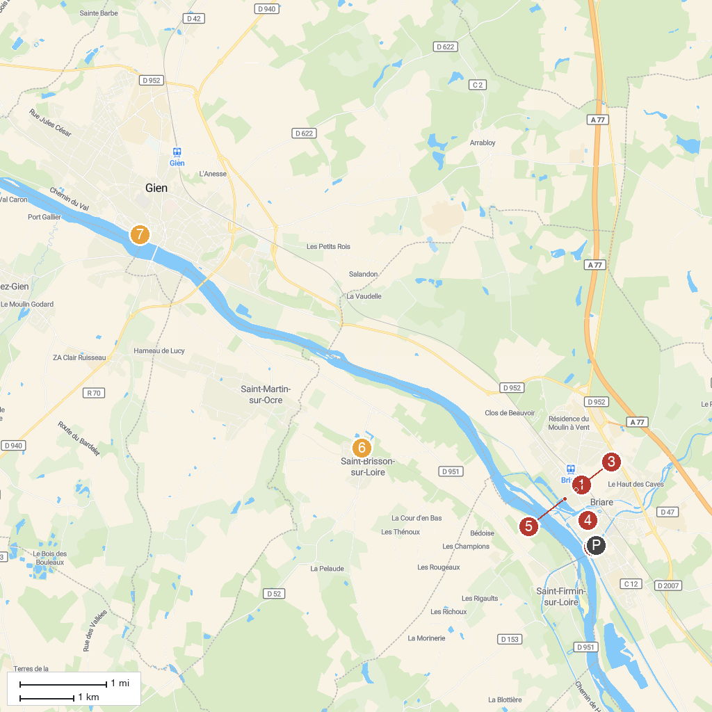
MAP KEY
1. Château de Trousse-Barrière | 5. Église Saint-Étienne de Briare
2. Château de la Bussiere | 6. Station Location Loisirs briare
3. Le Petit Train de Briare | 7. Castle of Saint Brisson sur Loire
4. Musée des 2 Marines et du Pont-Canal | 8. Aerial Pole Fitness
P. Cruise port / terminal
Map © MapTiler © OpenStreetMap contributors · cruiseports.org

