Bridgetown, Barbados
The birthplace of rum and a UNESCO-listed capital, Bridgetown packs history, white-sand beaches, and sea-turtle snorkeling into one easy port day — all walking distance or a short taxi from the ship.
⚓ Docked (Deep Water Harbour) · 🕒 Typical call: 8-10 hrs · 💵 Barbadian Dollar (BBD) / USD widely accepted · 🗣️ English
✍️ MY DAY IN PORT (FILL IN)
Ship / Date
In port | arrive ______ · all aboard ______
Booked excursion
Notes / meeting point
GETTING ASHORE
- Docking: Deep Water Harbour, 1.5 km west of city center; up to 6 ships docked simultaneously
- Walk to center: 15-25 min along paved waterfront path, or $2 shuttle / $6 taxi
- Best For: History buffs, beach lovers, rum enthusiasts, snorkelers
- Don't Miss: Swim with turtles in Carlisle Bay; Mount Gay Rum tour; UNESCO Garrison walk
GETTING AROUND
- 🚕 Taxi: US$2/pp shared · US$8–10 private — Official taxi fares are posted at the cruise terminal in USD and BBD. Shared van taxis run ~US$2 per person to downtown;
TOP THINGS TO DO
- Swim with Sea Turtles — Carlisle Bay — Carlisle Bay, just south of the cruise terminal, is home to a resident hawksbill and leatherback turtle population.
- Catamaran Sail & Snorkel — Board a large catamaran from Bridgetown Harbour, cruise Barbados's calm west coast, anchor for turtle swimming and snorkeling…
- UNESCO Bridgetown & Garrison Walk — Wander the UNESCO World Heritage-listed city center: Parliament Buildings, National Heroes Square, the 1654 Nidhe Israel…
- Mount Gay Rum Distillery Tour — Founded in 1703, Mount Gay is the world's oldest commercial rum distillery.
- Harrison's Cave Tram Tour — Ride an electric tram through an underground limestone cathedral of stalactites, stalagmites, streams, and waterfalls in…
BEST WALKS
- UNESCO City Center Loop: 2-3 hrs · 3 km · Easy · Self-guided — Walk from the cruise terminal along Harbour Road to National Heroes Square, then loop through the…
- Carlisle Bay Beach Walk: 1 hr each way · 1.5 km · Easy · Beach — Stroll south from the terminal along Bay Street to Carlisle Bay's white-sand crescent.
- Bridgetown Historic City Walk: ~2.5 km · 45–60 min · easy — Walk east from the cruise terminal along Harbour Road to the Careenage — Bridgetown's photogenic…
WEATHER · DAYLIGHT · MONEY
Month | High °F | Low °F | Rainy days
May | 86 | 76 | 9
Jul | 86 | 76 | 16
Sep | 87 | 76 | 15
Daylight: May 5:33AM–6:16PM · Jul 5:40AM–6:28PM · Sep 5:47AM–5:59PM
Representative sunrise/sunset — 2025, 15th of each month; local civil time including DST (America/Barbados). Source: Astral; not a forecast or climate average.
cruiseports.org/bridgetown · Confirm terminal & all-aboard time with your ship

Bridgetown, Barbados — Port Map
Red = walkable sights · Amber = excursions farther out · P = cruise terminal
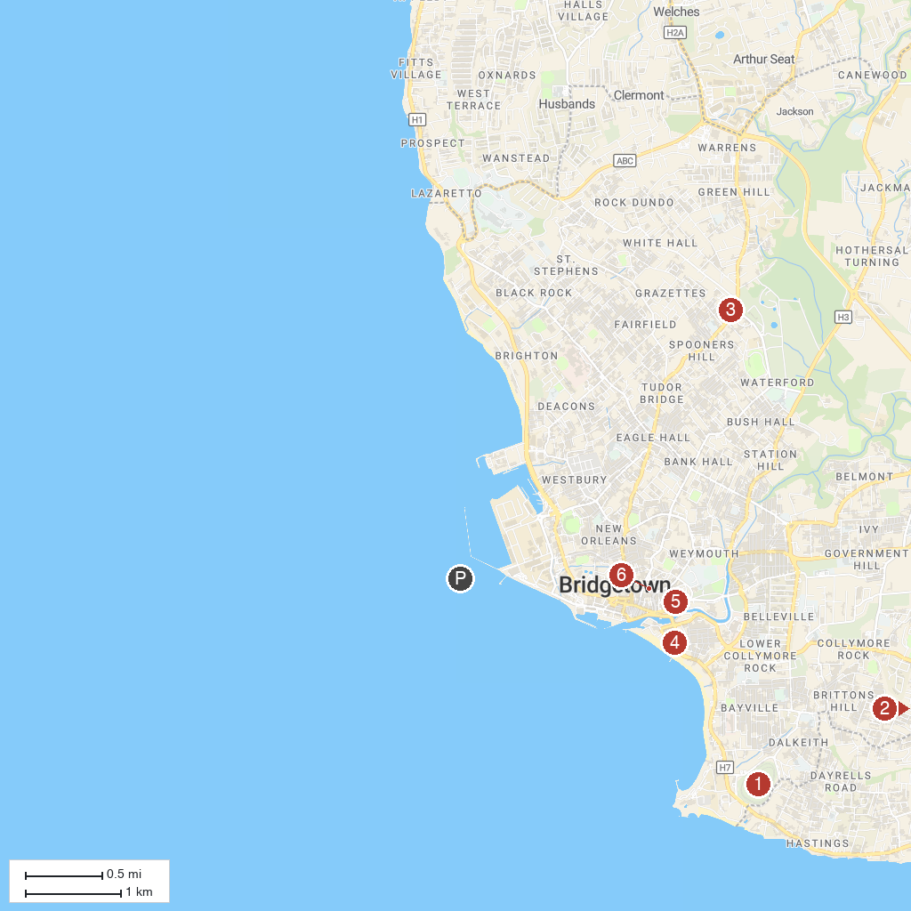
MAP KEY
1. Garrison Savannah | 4. Bethel Methodist Church
2. Harry Bayley Observatory | 5. St. Michael's Cathedral
3. Tyrol Cot Heritage Village | 6. Nidhe Israel Synagogue
P. Cruise port / terminal
Map © MapTiler © OpenStreetMap contributors · cruiseports.org

