Brindisi, Puglia, Italy
Where the ancient Appian Way meets the Adriatic. Brindisi offers Roman relics, Baroque villages, and the trulli of Alberobello — all from a compact, walkable old town.
⚓ Docked (pier) · 🕒 Typical call: 7–10 hrs · 💶 Euro (EUR) · 🗣️ Italian
✍️ MY DAY IN PORT (FILL IN)
Ship / Date
In port | arrive ______ · all aboard ______
Booked excursion
Notes / meeting point
GETTING ASHORE
- Docking: Costa Morena Terminal (3–4 km from center) or Sant'Apollinare Pier (1–2 km, walkable)
- Walk to Center: 10–15 min from Sant'Apollinare; shuttle or taxi from Costa Morena
- Best For: History buffs, day trippers to Alberobello & Lecce, Puglia cuisine
- Don't Miss: The Roman Column at the end of Via Appia, Piazza Duomo, a plate of orecchiette
GETTING AROUND
- 🚕 Taxi: €8–€16 — Taxis wait at both Costa Morena (~4 km from old town) and Sant'Apollinare (~2 km) terminals. Journey is 6–15 min; confir
TOP THINGS TO DO
- Alberobello & the Trulli — A UNESCO World Heritage site unlike anything else in Europe.
- Lecce Baroque Walking Tour — Called the 'Florence of the South,' Lecce is 40 minutes from Brindisi and packed with extravagant Baroque churches and palazzi…
- Brindisi Old Town on Foot — The Roman Columns that once marked the end of the Via Appia, the 11th-century Cathedral on Piazza Duomo, Castello Svevo…
- Ostuni & the Itria Valley — Ostuni — the dazzling 'White City' — crowns a hilltop with whitewashed lanes and a 15th-century Gothic cathedral.
- Torre Guaceto Beach & Nature Reserve — A protected coastal reserve about 20 km north of Brindisi with clear Adriatic water, white sand, and no development.
BEST WALKS
- Via Appia End to Piazza Duomo: 1.5 km · 30 min · Easy — Start at the surviving Roman Column on Via Colonne — the ancient marker of the Appian Way's…
- Lungomare Regina Margherita: 2 km · 40 min · Easy — Follow the palm-lined seafront promenade along the inner harbor, past the Castello Alfonsino…
WEATHER · DAYLIGHT · MONEY
Month | High °F | Low °F | Rainy days
May | 73 | 58 | 8
Jul | 88 | 72 | 3
Sep | 81 | 67 | 6
Daylight: May 5:31AM–7:58PM · Jul 5:30AM–8:17PM · Sep 6:29AM–6:56PM
cruiseports.org/brindisi · Confirm terminal & all-aboard time with your ship

Brindisi, Puglia, Italy — Port Map
Red = walkable sights · Amber = excursions farther out · P = cruise terminal
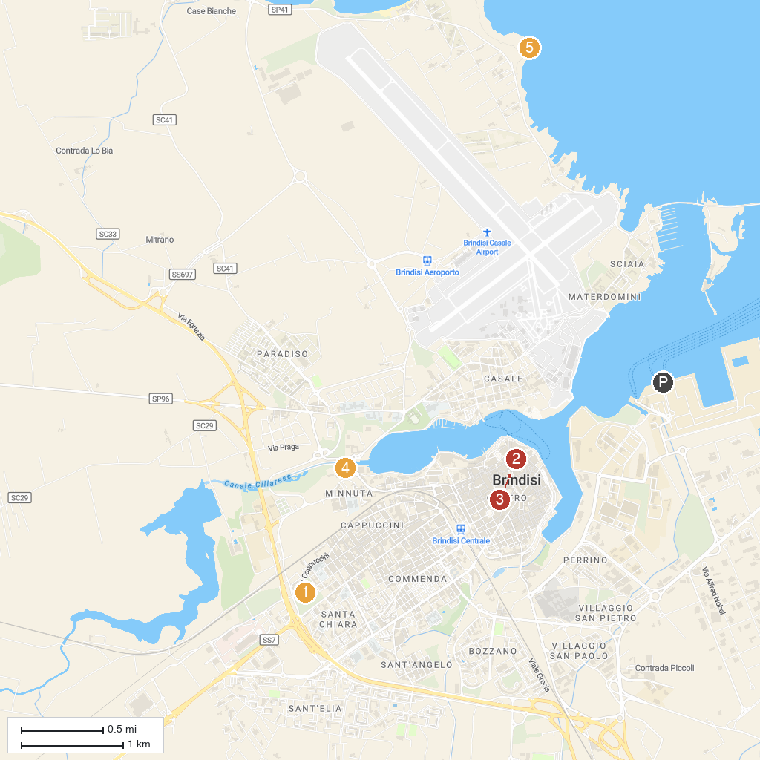
MAP KEY
1. Parco Comunale Cesare Braico | 4. Parco del Cillarese
2. Catholic cathedral of Saint John the Baptist, Brindisi, Italy | 5. Punta del Serrone
3. Area Archeologica di San Pietro degli Schiavoni
P. Cruise port / terminal
Map © MapTiler © OpenStreetMap contributors · cruiseports.org

