Brisbane, Queensland, Australia
Australia's river city punches well above its weight for a cruise port day — wildlife sanctuaries, river beaches, island day trips, and a compact CBD are all in easy range from the dock.
⚓ Docked (pier) · 🕒 Typical call: 8-10 hrs · 💵 Australian Dollar (AUD) · 🗣️ English
✍️ MY DAY IN PORT (FILL IN)
Ship / Date
In port | arrive ______ · all aboard ______
Booked excursion
Notes / meeting point
GETTING ASHORE
- Docking: BICT (Luggage Point) for large ships; Portside Wharf (Hamilton) for smaller vessels — both docked, no tendering
- Walk to center: BICT is ~20 km from CBD; taxi/rideshare 20-30 min. Portside Wharf is ~7 km; CityCat ferry 25 min.
- Best For: Wildlife encounters (Lone Pine Koala Sanctuary), island day trips (Moreton Island), South Bank strolling
- Don't Miss: A koala close-up photo at Lone Pine — the world's largest koala sanctuary, plus hand-feeding kangaroos
GETTING AROUND
- 🚕 Taxi: AUD $50–65 — Metered taxis are available at the Brisbane International Cruise Terminal. The 19–20 km ride to the CBD typically costs
- 📱 Rideshare: ✅ Uber, DiDi, Ola
- 🚌 Hop-on hop-off: ✅
TOP THINGS TO DO
- Lone Pine Koala Sanctuary — The world's largest koala sanctuary sits about 12 km from the city in Fig Tree Pocket.
- Moreton Island Day Trip — A 75-minute ferry from the city drops you on a sand island with clear turquoise waters, snorkeling around the Tangalooma wrecks…
- South Bank & QAGOMA — South Bank Parklands hugs the river opposite the CBD: a pedestrian beach (Streets Beach), riverside paths, the Queensland Art…
- Story Bridge Adventure Climb — Scale the cantilever arches of Brisbane's iconic 1940 bridge for 360° views over the river, CBD, and Moreton Bay.
- Gold Coast Day Trip — An hour south by road, the Gold Coast offers long surf beaches, Surfers Paradise, and hinterland rainforest at Lamington National…
BEST WALKS
- South Bank Riverwalk & Streets Beach: 4 km round trip | Flat | ~1.5 hrs — From South Bank ferry stop, walk the riverside promenade past Streets Beach (man-made lagoon…
- Howard Smith Wharves & Kangaroo Point Cliffs: 3 km | Easy-moderate | ~1.5 hrs — From the CBD ferry terminal, head to Howard Smith Wharves — a riverside precinct under the Story…
WEATHER · DAYLIGHT · MONEY
Month | High °F | Low °F | Rainy days
May | 74 | 57 | 6
Jul | 69 | 50 | 5
Sep | 76 | 56 | 6
Daylight: May 6:21AM–5:06PM · Jul 6:37AM–5:10PM · Sep 5:46AM–5:40PM
cruiseports.org/brisbane · Confirm terminal & all-aboard time with your ship

Brisbane, Queensland, Australia — Port Map
Red = walkable sights · Amber = excursions farther out · P = cruise terminal
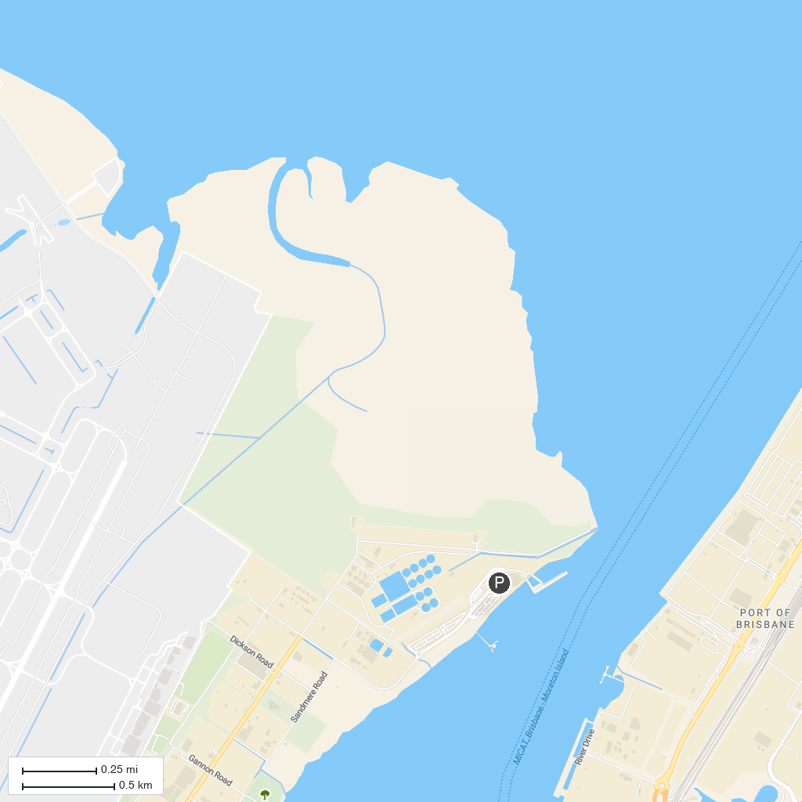
MAP KEY
1. Old Windmill Observatory: The Tower Mill | 5. Rocks Riverside Park
2. Lone Pine Koala Sanctuary | 6. Queensland Police Museum
3. Brisbane City Hall | 7. The Collective Markets
4. Saint Stephen’s Cathedral
P. Cruise port / terminal
Map © MapTiler © OpenStreetMap contributors · cruiseports.org

