Bristol, Rhode Island, USA
Home to America's oldest Fourth of July celebration and the birthplace of six America's Cup-winning yachts, Bristol is a compact, walkable New England gem on Narragansett Bay — best explored on foot along its historic Thames Street waterfront.
⚓ Docked (town pier / marina) · 🕒 Typical call: 6–8 hrs · 💵 USD · 🗣️ English · 🚢 Small ships & river cruise lines
✍️ MY DAY IN PORT (FILL IN)
Ship / Date
In port | arrive ______ · all aboard ______
Booked excursion
Notes / meeting point
GETTING ASHORE
- Docking: Small ships dock at Bristol Town Dock or Herreshoff Marina on Thames Street
- Walk to center: Immediate — downtown is steps from the pier on Thames Street
- Best For: Maritime history, New England architecture, waterfront cycling, mansion gardens
- Don't Miss: Herreshoff Marine Museum & America's Cup Hall of Fame
GETTING AROUND
- 🚕 Taxi: $45–$60 — Local taxi and private car services connect the ferry terminal to downtown Bristol and nearby areas. Pre-booking a priva
- 📱 Rideshare: ✅ Uber, Lyft
TOP THINGS TO DO
- Herreshoff Marine Museum & America's Cup Hall of Fame — The Herreshoff Manufacturing Company built six consecutive America's Cup defenders between 1893 and 1920.
- Linden Place Mansion Tour — This 1810 Federal-style mansion on Hope Street was the home of the DeWolf family — Bristol's most prominent merchant dynasty…
- Colt State Park Waterfront Walk — The 464-acre former estate of Samuel P.
- East Bay Bike Path — A flat, paved 14.5-mile rail trail beginning at Independence Park in Bristol Harbor, running north to Providence along the…
- Blithewold Mansion, Gardens & Arboretum — A magnificent 45-room English-country manor (the current house completed in 1908, after the original 1896 mansion burned) built…
BEST WALKS
- Thames Street Waterfront Stroll: 0.8 mi · Easy · All flat — Walk the boardwalk south from the town dock past Rockwell Park and the Bristol Maritime Welcome…
- Historic Hope Street Walk: 1.3 mi loop · Easy — Head inland from the waterfront to Hope Street for a self-guided walking tour of Bristol's colonial…
WEATHER · DAYLIGHT · MONEY
Month | High °F | Low °F | Rainy days
May | 61 | 47 | 12
Jul | 70 | 56 | 12
Sep | 65 | 52 | 11
Daylight: May 5:25AM–7:58PM · Jul 5:24AM–8:17PM · Sep 6:25AM–6:53PM
Representative sunrise/sunset — 2025, 15th of each month; local civil time including DST (America/New_York). Source: Astral; not a forecast or climate average.
cruiseports.org/bristol-ri · Confirm terminal & all-aboard time with your ship

Bristol, Rhode Island, USA — Port Map
Red = walkable sights · Amber = excursions farther out · P = cruise terminal
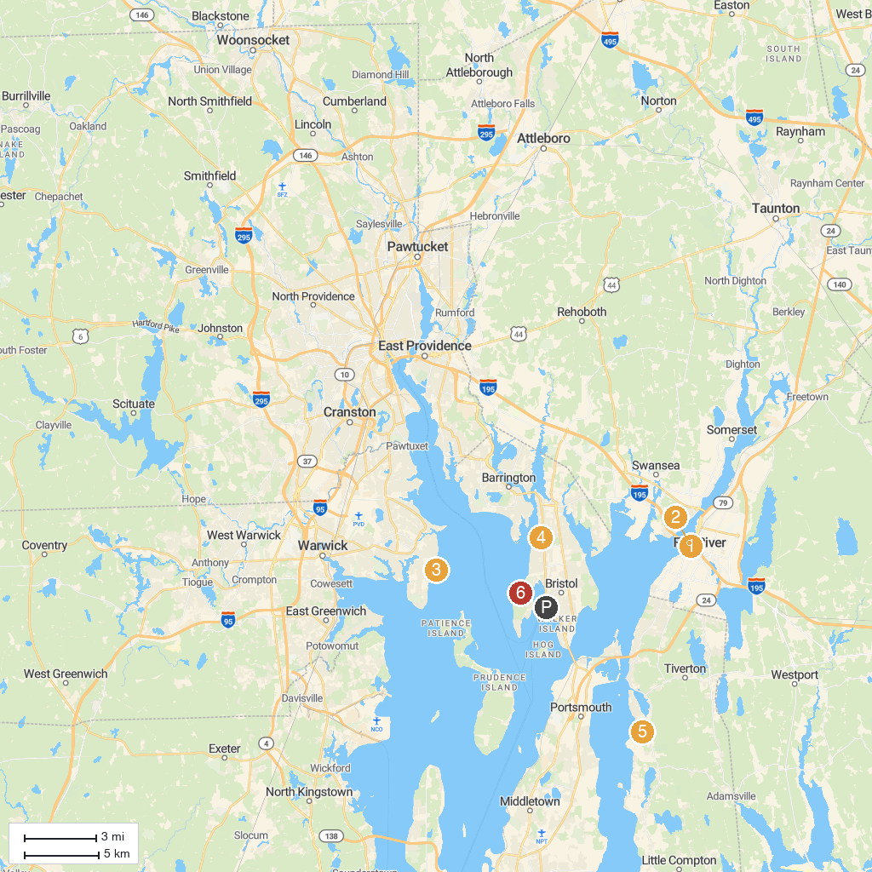
MAP KEY
1. Battleship Cove | 5. Rocky Point State Park
2. Goddard Memorial State Park | 6. Claire D. McIntosh Wildlife Refuge
3. USS Massachusetts (BB-59) | 7. Audubon Emilie Ruecker Wildlife Refuge
4. Seekonk Grand Prix | 8. Colt State Park
P. Cruise port / terminal
Map © MapTiler © OpenStreetMap contributors · cruiseports.org

