Bristol, England, United Kingdom
Brunel's city delivers Victorian engineering icons, world-famous street art, and one of England's finest Georgian cities — Bath — just 13 miles away. A shore day here punches well above its weight.
⚓ Docked (Avonmouth) · 🕒 Typical call: 8-10 hrs · 💷 British Pound (GBP) · 🗣️ English
✍️ MY DAY IN PORT (FILL IN)
Ship / Date
In port | arrive ______ · all aboard ______
Booked excursion
Notes / meeting point
GETTING ASHORE
- Docking: Royal Portbury Docks or Avonmouth, ~7 miles from city centre
- Walk to Centre: Not walkable — taxi (~£20-25) or train from Avonmouth station
- Best For: History buffs, Brunel fans, day-trippers to Bath & Cotswolds
- Don't Miss: SS Great Britain and Clifton Suspension Bridge
GETTING AROUND
- 🚕 Taxi: £18–25 — A taxi rank is located at Royal Portbury Dock terminal. Estimated metered fare to Bristol city center (8 miles) is aroun
- 📱 Rideshare: ✅ Uber, Bolt
- 🚌 Hop-on hop-off: ✅ Tootbus Bristol (City Sightseeing)
TOP THINGS TO DO
- SS Great Britain & Brunel's Dock — Board the world's first ocean-going iron-hulled, screw-propelled ship, designed by Isambard Kingdom Brunel and restored in her…
- Clifton Suspension Bridge & Gorge — Another Brunel masterpiece, this 1864 suspension bridge spans the spectacular Avon Gorge.
- Harbourside & Banksy Street Art Walk — Bristol's regenerated docklands buzz with waterside bars, the M Shed museum, Arnolfini arts centre, and original Banksy works…
- Day Trip to Bath — Bath is only 13 miles from Bristol and accessible by frequent direct train (15 minutes from Temple Meads).
- Cotswolds Villages — A guided coach tour takes you into the honey-stone villages of the Cotswolds — Bourton-on-the-Water, Burford, or Castle Combe.
BEST WALKS
- Harbourside & Old City Loop: 2.5 miles · mostly flat · 1-1.5 hrs — From Bristol Temple Meads, walk along the floating harbour past M Shed and the Arnolfini, across…
- Clifton Village & Suspension Bridge: 1 mile in Clifton · hilly · 1 hr — Take a bus or taxi to Clifton Village, browse the boutiques on Regent Street and The Mall, then…
WEATHER · DAYLIGHT · MONEY
Month | High °F | Low °F | Rainy days
May | 61 | 47 | 12
Jul | 70 | 56 | 12
Sep | 65 | 52 | 11
Daylight: May 5:18AM–8:55PM · Jul 5:11AM–9:20PM · Sep 6:45AM–7:24PM
cruiseports.org/bristol-uk · Confirm terminal & all-aboard time with your ship

Bristol, England, United Kingdom — Port Map
Red = walkable sights · Amber = excursions farther out · P = cruise terminal
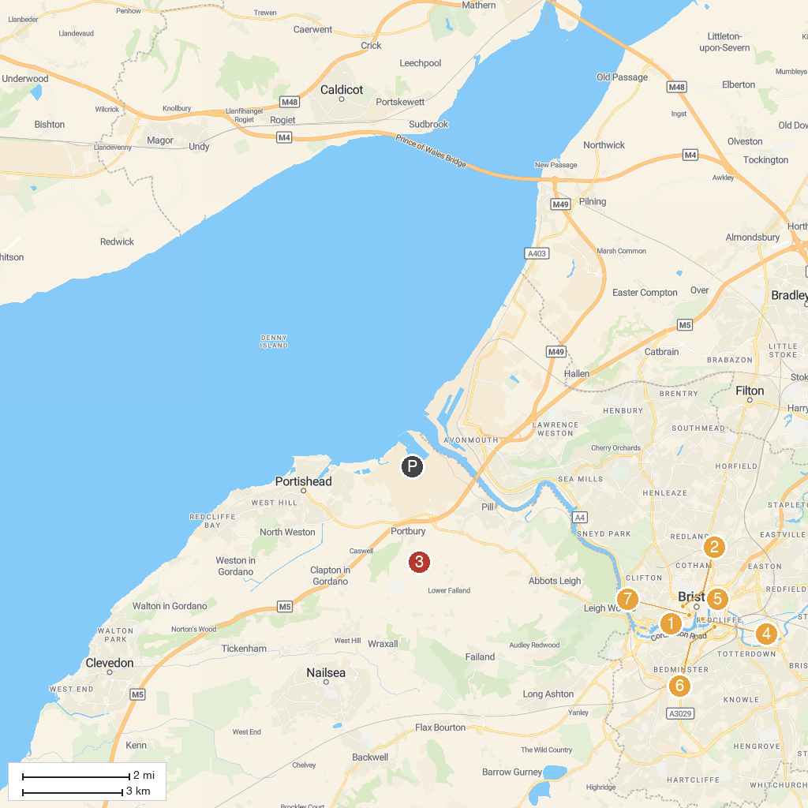
MAP KEY
1. Brunel's SS Great Britain | 5. Queen Square
2. Avon Valley Adventure Park | 6. Castle Park
3. The Georgian House Museum | 7. St Mary Redcliffe Church
4. Oakham Treasures | 8. Bristol Cathedral
P. Cruise port / terminal
Map © MapTiler © OpenStreetMap contributors · cruiseports.org

