Broome, Western Australia, Australia
Red pindan cliffs meet turquoise ocean where the Kimberley meets the sea. Broome is outback Australia with a pearling soul — Cable Beach stretches 22 km, camels plod at sunset, and Chinatown glitters with South Sea pearls.
⚓ Docked (port jetty) · 🕒 Typical call: 8-10 hrs · 💵 AUD · 🗣️ English · 🌞 Dry season: May–Oct
✍️ MY DAY IN PORT (FILL IN)
Ship / Date
In port | arrive ______ · all aboard ______
Booked excursion
Notes / meeting point
GETTING ASHORE
- Docking: Port of Broome jetty, ~6 km south of town; shuttle buses to Chinatown
- Walk to centre: Not walkable — free cruise-line shuttles run to Chinatown/Napier Terrace
- Best For: Cable Beach sunsets, South Sea pearl shopping, Horizontal Falls seaplane tours
- Don't Miss: Camel ride on Cable Beach, dinosaur footprints at Gantheaume Point (low tide)
GETTING AROUND
- 🚕 Taxi: A$22–28 — The port is about 7 km from the city center. Local taxis charge a base fare plus per-km rate; expect around A$24 one-way
- 📱 Rideshare: ✅ Uber
TOP THINGS TO DO
- Cable Beach Camel Ride at Sunset — A Broome institution: ride a camel along 22 km of pristine white sand as the sun drops into the Indian Ocean.
- Horizontal Falls Seaplane Tour — Fly by seaplane into the Kimberley to see the extraordinary Horizontal Falls — tidal water rushing through narrow gorges creating…
- Gantheaume Point & Dinosaur Footprints — Red pindan cliffs plunge into turquoise sea at Gantheaume Point.
- Malcolm Douglas Crocodile Park — Meet massive saltwater crocodiles relocated from the wild at this well-regarded park just outside Broome.
- Pearl Luggers Museum & Chinatown — Broome's multicultural pearling past is preserved at the Pearl Luggers Museum — restored 19th-century pearl luggers, dangerous…
BEST WALKS
- Chinatown Heritage Stroll: 1 km · Flat · 30–45 min — From the shuttle drop at Napier Terrace, explore Broome's historic Chinatown — pearl showrooms, the…
- Cable Beach & Gantheaume Point Loop: 3 km · Easy sand/path · 1-1.5 hrs — Take the Explorer Bus to Cable Beach, walk south along the sand toward Gantheaume Point.
WEATHER · DAYLIGHT · MONEY
Month | High °F | Low °F | Rainy days
May | 90 | 71 | 1
Jul | 85 | 64 | 0
Sep | 90 | 71 | 0
Daylight: May 6:09AM–5:25PM · Jul 6:22AM–5:31PM · Sep 5:47AM–5:45PM
cruiseports.org/broome-wa · Confirm terminal & all-aboard time with your ship

Broome, Western Australia, Australia — Port Map
Red = walkable sights · Amber = excursions farther out · P = cruise terminal
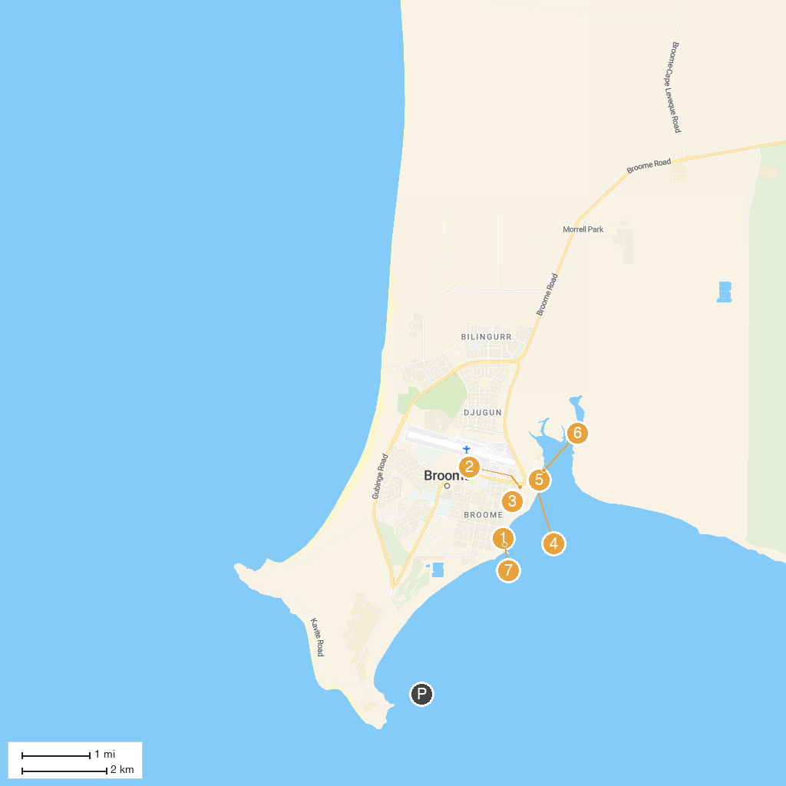
MAP KEY
1. Broome Historical Museum | 5. Pearl Luggers Broome
2. Broome Courthouse Markets | 6. Streeter's Jetty Broome
3. Our Lady Queen of Peace Cathedral | 7. Town Beach
4. Roebuck Bay Lookout
P. Cruise port / terminal
Map © MapTiler © OpenStreetMap contributors · cruiseports.org

