Brunswick, Georgia, USA
Gateway to the Golden Isles, Brunswick pairs Victorian-era streetscapes and ancient live oaks with easy access to the beaches, forts, and marshes of Jekyll and St. Simons Islands.
⚓ Docked — downtown waterfront · 🕒 Typical call: 6-8 hrs · 💵 USD · 🗣️ English
✍️ MY DAY IN PORT (FILL IN)
Ship / Date
In port | arrive ______ · all aboard ______
Booked excursion
Notes / meeting point
GETTING ASHORE
- Docking: Small cruise ships dock at the downtown Brunswick waterfront; American Cruise Lines uses the Mary Ross Waterfront area
- Walk to center: Steps — historic downtown and Lover's Oak are within a short walk of the waterfront
- Best For: Golden Isles day trips, shrimping heritage, colonial history at Fort Frederica
- Don't Miss: Lover's Oak (900+ year old live oak) and a shrimping excursion on Lady Jane
GETTING AROUND
- 🚕 Taxi: $25–$30 — Local taxis (On Time Taxi, Latino Taxi Glynn) operate 24/7. Short rides may cost less if docking downtown with American
- 📱 Rideshare: ✅ Uber, Lyft
TOP THINGS TO DO
- Historic Downtown Brunswick Walking Tour — Stroll the Victorian squares of Historic Brunswick — Old City Hall, the Ritz Theatre, and the 900-year-old Lover's Oak are all…
- Lady Jane Shrimping Excursion — Board a retired shrimp trawler for a hands-on shrimping trip on the Brunswick River.
- Fort Frederica National Monument — Drive 20 minutes to St.
- Jekyll Island & Driftwood Beach — A 20-minute taxi ride south leads to Jekyll Island's famous Driftwood Beach — a hauntingly beautiful stretch of bleached, twisted…
- Dolphin & Sunset Cruise — Several operators on St.
BEST WALKS
- Historic Downtown Brunswick Squares Walk: 1.5 miles · Easy · 45-60 min — From the Mary Ross Waterfront Park, walk into the historic squares, passing Old City Hall, the Ritz…
WEATHER · DAYLIGHT · MONEY
Month | High °F | Low °F | Rainy days
May | 82 | 68 | 10
Jul | 89 | 76 | 19
Sep | 84 | 73 | 16
Daylight: May 6:30AM–8:14PM · Jul 6:32AM–8:30PM · Sep 7:10AM–7:31PM
cruiseports.org/brunswick-ga · Confirm terminal & all-aboard time with your ship

Brunswick, Georgia, USA — Port Map
Red = walkable sights · Amber = excursions farther out · P = cruise terminal
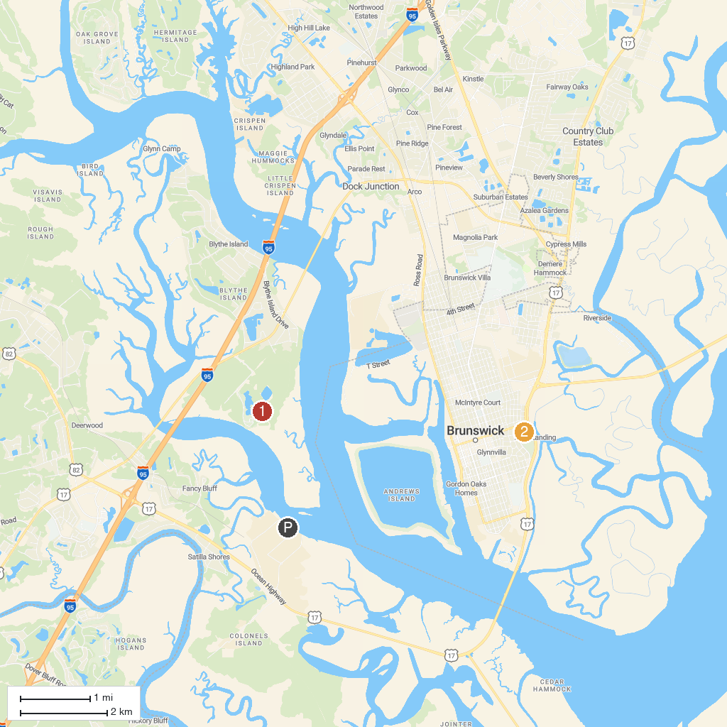
MAP KEY
1. St. Simons Island Lighthouse Museum | 5. City of Brunswick
2. Blythe Island Regional Park | 6. Hamilton Plantation Slave Cabins
3. Mosaic, Jekyll Island Museum | 7. Mallery Park
4. Summer Waves Water Park | 8. Indian Mound Cottage
P. Cruise port / terminal
Map © MapTiler © OpenStreetMap contributors · cruiseports.org

