Bucksport, Maine, USA
A small Maine river town punching above its weight — voted USA Today's #1 Best Coastal Small Town (2021), Bucksport pairs a granite Civil War fort with a cable-stayed bridge observatory and a friendly walkable Main Street.
⚓ Docked (town pier) · 🕒 Typical call: 6-8 hrs · 💵 US Dollar · 🗣️ English · 🏰 History & scenery
✍️ MY DAY IN PORT (FILL IN)
Ship / Date
In port | arrive ______ · all aboard ______
Booked excursion
Notes / meeting point
GETTING ASHORE
- Docking: Alongside at Bucksport Town Dock (400-ft upgraded concrete float, ADA gangway)
- Walk to center: ~5 min along the waterfront walkway to Main Street
- Best For: Fort Knox & Penobscot Narrows Observatory, waterfront strolls, small-town Maine
- Don't Miss: Climbing the Penobscot Narrows Observatory — 420 ft up, the only bridge observatory in the US
GETTING AROUND
- 🚕 Taxi: /hr+ — Sunrise 2 Sunset Taxi serves the Bucksport area. Rates are high for a small town; best reserved for group outings or rea
- 📱 Rideshare: ✅ Uber, Lyft
TOP THINGS TO DO
- Fort Knox State Historic Site — Explore one of the best-preserved Civil War-era granite forts in America.
- Penobscot Narrows Observatory — Ride to the top of the Penobscot Narrows Bridge — 420 feet up — for 360-degree panoramic views of Penobscot Bay, the river, and…
- Fort Knox Nature Cruise — Two-hour boat excursion through Bucksport harbor and the Penobscot River waterways.
- Acadia National Park Day Trip — American Cruise Lines sometimes offers day-trip excursions to Acadia National Park on Mount Desert Island, about an hour away.
- Bucksport Main Street Walk — Stroll the brick waterfront walkway to downtown, browse the Lighthouse Arts Center gallery (100+ Maine artists), catch a film at…
BEST WALKS
- Bucksport Waterfront Walkway: 1 mile | Easy | Paved & flat | 20-30 min — A paved brick path along the Penobscot River from the town dock to downtown.
- Main Street to Alamo Theatre Loop: 0.5 miles | Easy | 15-20 min — From the waterfront, walk up to Main Street to explore the Lighthouse Arts Center, Alamo Theatre…
WEATHER · DAYLIGHT · MONEY
Month | High °F | Low °F | Rainy days
May | 62 | 45 | 10
Jul | 78 | 62 | 11
Sep | 70 | 55 | 9
Daylight: May 5:07AM–7:56PM · Jul 5:04AM–8:17PM · Sep 6:14AM–6:45PM
cruiseports.org/bucksport-me · Confirm terminal & all-aboard time with your ship

Bucksport, Maine, USA — Port Map
Red = walkable sights · Amber = excursions farther out · P = cruise terminal
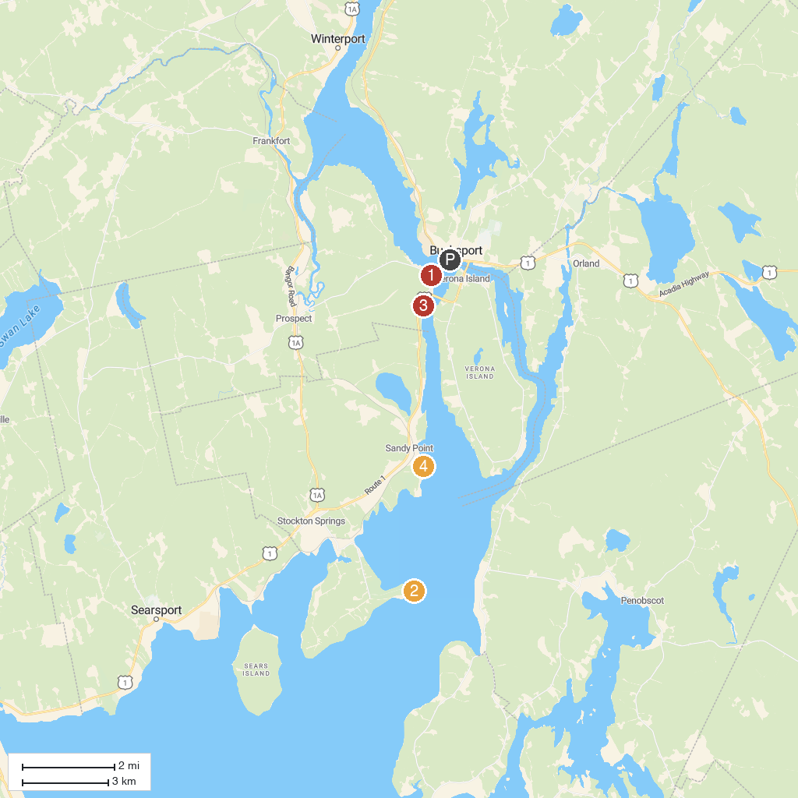
MAP KEY
1. Fort Knox and Penobscot Narrows Observatory | 4. Scenic Turnout
2. Fort Point State Park | 5. Sandy Point Beach
3. Friends of Sears Island | 6. Swan Lake State Park
P. Cruise port / terminal
Map © MapTiler © OpenStreetMap contributors · cruiseports.org

