Buenos Aires, Argentina
The Paris of South America — grand boulevards and faded grandeur, the birthplace of tango, Evita's marble tomb, and the best steak on the continent. A city that runs on passion.
⚓ Docked (cruise terminal) · 🕒 Often overnight call · 💵 Argentine Peso (ARS) · USD prized · 🗣️ Spanish · some English
✍️ MY DAY IN PORT (FILL IN)
Ship / Date
In port | arrive ______ · all aboard ______
Booked excursion
Notes / meeting point
GETTING ASHORE
- Docking: Quinquela Martín terminal
- To center: Shuttle / taxi
- Best For: Tango · Food · Culture
- Don't Miss: Recoleta & La Boca
GETTING AROUND
- 🚕 Taxi: ~$18–25 USD — Metered taxis available at the Benito Quinquela Martín Terminal. About 3 km to city center, 15–30 min drive. Carry small
- 📱 Rideshare: ✅ Uber, Cabify, DiDi
- 🚌 Hop-on hop-off: ✅
TOP THINGS TO DO
- City Highlights & Recoleta Cemetery — The grand tour: Plaza de Mayo and the pink Casa Rosada, the Obelisco on the world's widest avenue, and Recoleta Cemetery's…
- San Telmo & Tango — The cobbled old quarter of antique markets and milongas, where tango was born.
- La Boca & Caminito — The brightly painted tin houses of the Caminito, the immigrant-and-football soul of the city, home to Boca Juniors' La Bombonera…
- Parrilla & Wine Tasting — Argentina on a plate — a proper parrilla feast of asado and bife de chorizo paired with Mendoza Malbec.
BEST WALKS
- Recoleta: cemetery & plazas: ~2 km · 1.5 hrs · easy — The elegant Recoleta district — the famous cemetery, the Basílica del Pilar, and the leafy plazas…
- San Telmo old quarter: ~2 km · 1.5 hrs · easy — Cobbled Defensa street from Plaza de Mayo through the antique shops and cafés to Plaza Dorrego…
- Puerto Madero waterfront: ~2.5 km · 1 hr · easy — The revitalized dockland of converted brick warehouses, the white Puente de la Mujer footbridge…
WEATHER · DAYLIGHT · MONEY
Month | High °F | Low °F | Rainy days
May | 63 | 53 | 7
Jul | 57 | 46 | 9
Sep | 64 | 52 | 7
Daylight: May 7:40AM–5:58PM · Jul 7:58AM–6:01PM · Sep 6:52AM–6:44PM
cruiseports.org/buenos-aires · Confirm terminal & all-aboard time with your ship

Buenos Aires, Argentina — Port Map
Red = walkable sights · Amber = excursions farther out · P = cruise terminal
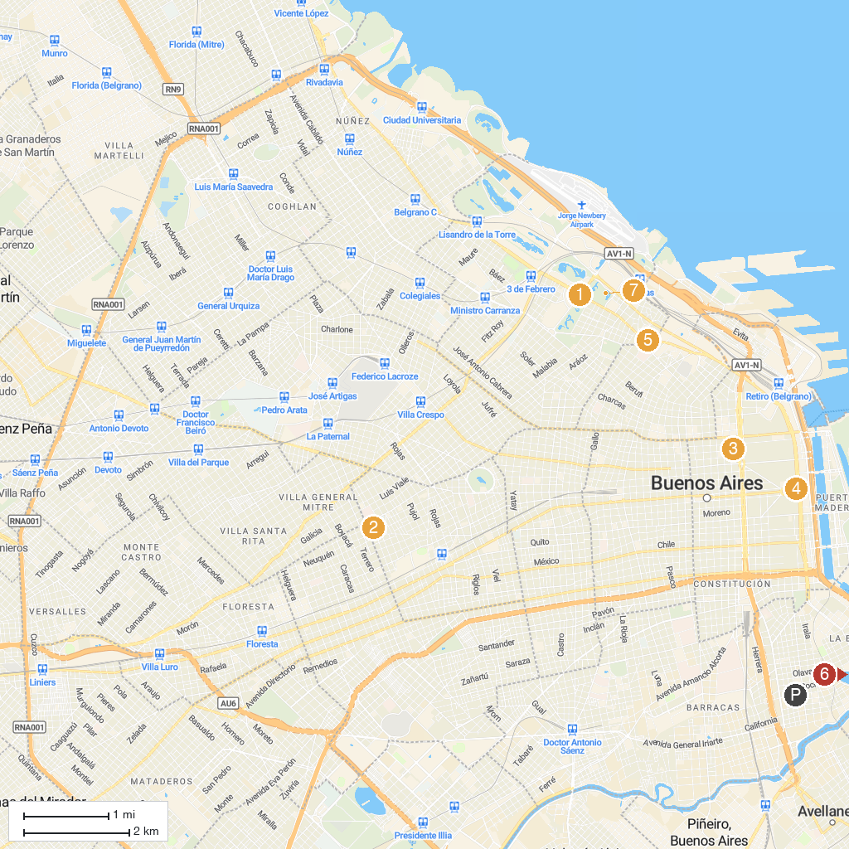
MAP KEY
1. Parque de la Memoria - Monumento a las Víctimas del Terrorismo de Estado | 5. Casa Rosada
2. Monument to the Magna Carta and the Four Regions | 6. Museo Nacional de Arte Decorativo
3. Plaza Irlanda | 7. Fundación Proa
4. Teatro Colón | 8. Jardín Japonés
P. Cruise port / terminal
Map © MapTiler © OpenStreetMap contributors · cruiseports.org

