Bunbury, Western Australia, Australia
Western Australia's second city delivers wild dolphins, a vibrant café strip, and easy access to wine country — all from one of the state's most approachable regional ports.
⚓ Docked (Outer Harbour Berth 1) · 🕒 Typical call: 8-10 hrs · 💵 Australian Dollar (AUD) · 🗣️ English
✍️ MY DAY IN PORT (FILL IN)
Ship / Date
In port | arrive ______ · all aboard ______
Booked excursion
Notes / meeting point
GETTING ASHORE
- Docking: Berth 1, Outer Harbour — 3-4 km from city center; shuttle buses typically provided by cruise lines
- Walk to center: Not walkable from berth; shuttle or taxi ~10 min to Victoria Street
- Best For: Wildlife (dolphins), café culture, regional wine country day trips
- Don't Miss: Dolphin Discovery Centre on Koombana Bay — wild dolphins in the shallows daily
GETTING AROUND
- 🚕 Taxi: Current price unknown — confirm with operator — Bunbury Taxis and 13cabs serve the port. The previous fare and flagfall text was corrupted and cannot be recovered from
- 📱 Rideshare: ✅ Uber
TOP THINGS TO DO
- Dolphin Discovery Centre & Eco-Cruise — Koombana Bay and the surrounding Bunbury waters host a local population of over 100 wild bottlenose dolphins.
- Mangrove Boardwalk & Leschenault Inlet — Stroll elevated boardwalks through Western Australia's southernmost mangrove forest, then loop around the calm Leschenault Inlet…
- CBD Mural Trail & Victoria Street Cafés — Bunbury boasts the largest public mural collection in regional Australia.
- Ferguson Valley Winery Day Trip — A 25-minute drive inland brings you to Bunbury's boutique wine and craft-beer region, with cellar doors, cheese tastings, and the…
- Busselton Jetty Excursion — Forty-five minutes south, the 1.8 km Busselton Jetty is the longest timber-piled jetty in the Southern Hemisphere.
BEST WALKS
- Koombana Bay & Dolphin Centre Loop: 3 km · 45 min · Easy — From the Visitor Centre head south along Koombana Drive to the Dolphin Discovery Centre, walk the…
- Victoria Street Café Strip & Marlston Hill: 2 km · 30 min · Easy (short hill climb) — Walk Victoria Street from end to end, soaking up the café scene and murals, then detour up the…
WEATHER · DAYLIGHT · MONEY
Month | High °F | Low °F | Rainy days
May | 66 | 54 | 10
Jul | 61 | 51 | 16
Sep | 63 | 51 | 10
Daylight: May 7:01AM–5:25PM · Jul 7:19AM–5:27PM · Sep 6:16AM–6:08PM
ESSENTIAL TRAVEL QUALIFICATIONS
Previous taxi/transport fare text was corrupted; current amounts unknown. Confirm operator total, currency and surcharges before boarding; no recovered fare assumed.
cruiseports.org/bunbury-wa · Confirm terminal & all-aboard time with your ship

Bunbury, Western Australia, Australia — Port Map
Red = walkable sights · Amber = excursions farther out · P = cruise terminal
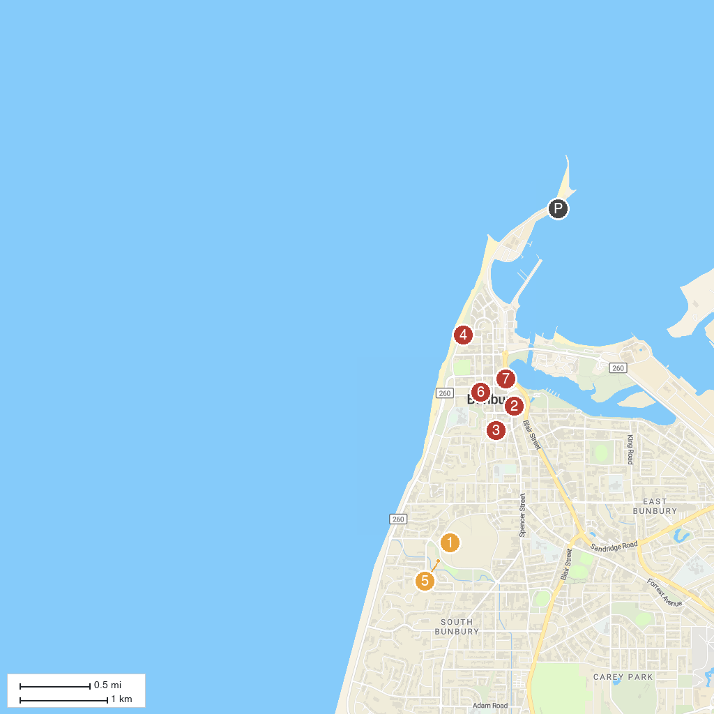
MAP KEY
1. Big Swamp Parkland | 5. Bunbury Wildlife Park
2. Bunbury Museum + Heritage Centre | 6. Bunbury Regional Art Gallery
3. St Patrick's Cathedral | 7. Bicentennial Square
4. Bunbury Lighthouse
P. Cruise port / terminal
Map © MapTiler © OpenStreetMap contributors · cruiseports.org

