Burg bei Magdeburg, Saxony-Anhalt, Germany
A medieval market town on the Elbe-Havel Canal, Burg bei Magdeburg earns its nickname 'City of Towers' with a skyline of centuries-old churches and fortifications — and easy rail access to the Gothic grandeur of Magdeburg.
⚓ Docked (riverside pier) · 🕒 Typical call: 6–8 hrs · 💶 Euro (EUR) · 🗣️ German
✍️ MY DAY IN PORT (FILL IN)
Ship / Date
In port | arrive ______ · all aboard ______
Booked excursion
Notes / meeting point
GETTING ASHORE
- Docking: Riverside pier on the Elbe-Havel Canal; ships dock directly — no tender
- Walk to center: ~5–10 min walk from the pier to the historic Marktplatz
- Best For: Medieval history, quiet river-town atmosphere, day trip to Magdeburg
- Don't Miss: Hexenturm (Witch's Tower), the Carl von Clausewitz birthplace museum, and Germany's oldest cinema
GETTING AROUND
- 🚕 Taxi: Varies (meter) — Local taxis are available in Burg bei Magdeburg for getting around town or reaching nearby attractions. Pre-book private
- 📱 Rideshare: ✅ Uber
TOP THINGS TO DO
- Magdeburg Cathedral & Old Town — Take the short train ride to Magdeburg and explore one of Germany's largest Gothic cathedrals, then stroll through the historic…
- Burg Town Walk — City of Towers — Join the daily guided town tour to visit the 11th-century Hexenturm (Witch's Tower), the 16th-century Freiheitsturm, the…
- Clausewitz Birthplace Museum — Carl von Clausewitz, author of the military classic 'On War', was born in Burg.
- Magdeburg Water Bridge — See the remarkable navigable aqueduct that carries the Elbe-Havel Canal over the Elbe River — an engineering marvel and one of…
- Burg Theater — Germany's Oldest Cinema — Dating to 1911, the Burg Theater is Germany's oldest continuously operating cinema — a charming slice of early film history right…
BEST WALKS
- Towers & Marktplatz Loop: ~2 km · 45 min · Easy — From the riverside pier, walk into town past the Roland Statue on Marktplatz, then loop through the…
- Canal Embankment Stroll: ~1.5 km · 30 min · Easy — A relaxed out-and-back walk along the Elbe-Havel Canal embankment, watching river traffic and…
WEATHER · DAYLIGHT · MONEY
Month | High °F | Low °F | Rainy days
May | 66 | 49 | 10
Jul | 76 | 60 | 10
Sep | 69 | 54 | 8
Daylight: May 5:17AM–9:01PM · Jul 5:09AM–9:26PM · Sep 6:47AM–7:26PM
cruiseports.org/burg-bei-magdeburg · Confirm terminal & all-aboard time with your ship

Burg bei Magdeburg, Saxony-Anhalt, Germany — Port Map
Red = walkable sights · Amber = excursions farther out · P = cruise terminal
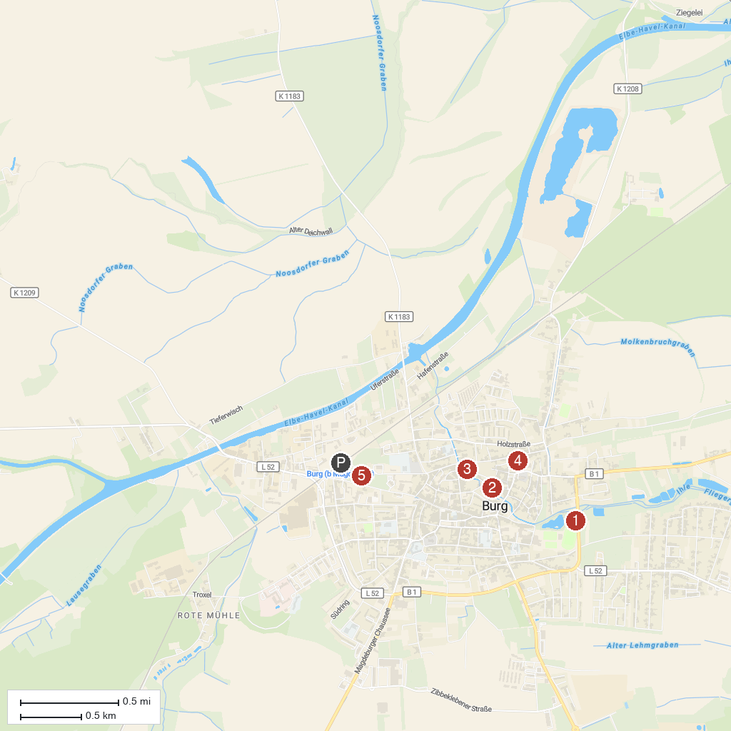
MAP KEY
1. Flickschupark - Tor zur Landschaft | 4. Hexenturm
2. Historische Gerberei | 5. Goethe Park
3. Am Weinberg - Grüner Stadtbalkon
P. Cruise port / terminal
Map © MapTiler © OpenStreetMap contributors · cruiseports.org

