Burgas, Black Sea Coast, Bulgaria
Bulgaria's gateway to the Black Sea puts you steps from a palm-lined Sea Garden, a pink salt lake, and medieval towns that predate Rome. Ships dock right in the city — no tender, no hassle.
⚓ Docked (city pier) · 🕒 Typical call: 8-10 hrs · 💶 Currency: Euro (EUR) since Jan 2026 · 🗣️ Language: Bulgarian · 🌊 Black Sea
✍️ MY DAY IN PORT (FILL IN)
Ship / Date
In port | arrive ______ · all aboard ______
Booked excursion
Notes / meeting point
GETTING ASHORE
- Docking: Alongside at Magazia 1 or East Terminal — no tender
- Walk to center: 5-10 min on foot to Sea Garden and pedestrian streets
- Best For: History day-trips (Nessebar, Sozopol), beaches, easy city walks
- Don't Miss: Lake Atanasovsko — the otherworldly pink salt lake north of town
GETTING AROUND
- 🚕 Taxi: 5–15 BGN (~€3–€8) — Taxis are available at the port and run on fixed fares into the city center. Metered cabs are also widely available; con
- 📱 Rideshare: ❌ not available
TOP THINGS TO DO
- Nessebar Old Town (UNESCO) — A rocky peninsula packed with Byzantine churches, medieval ruins, and 19th-century wooden houses.
- Sozopol Old Town & Bay — Cobbled lanes, ancient Apollonia ruins, and a pretty harbour about 34 km south of Burgas.
- Lake Atanasovsko Pink Salt Lake — Just north of the port, this hypersaline lake turns vivid pink in summer — a wild, photogenic landscape.
- St. Anastasia Island Boat Trip — A short ferry from Burgas harbour takes you to a small island with a medieval monastery (founded in the 10th century, restored in…
- Burgas City Highlights Walk — Stroll from the port through the Sea Garden to the Aleksandrovska pedestrian street, the Archaeological Museum, and Saints Cyril…
BEST WALKS
- Sea Garden & Central Beach Loop: 2 km • 30-40 min • Easy — From the pier, walk north into the Sea Garden (Morska Gradina) — Bulgaria's largest coastal park.
- Old Town Pedestrian Streets: 1.5 km • 20-30 min • Easy — Head west from the port along Bulair Street into the city centre.
WEATHER · DAYLIGHT · MONEY
Month | High °F | Low °F | Rainy days
May | 71 | 55 | 11
Jul | 83 | 67 | 6
Sep | 78 | 62 | 5
Daylight: May 5:48AM–8:25PM · Jul 5:46AM–8:45PM · Sep 6:50AM–7:19PM
cruiseports.org/burgas · Confirm terminal & all-aboard time with your ship

Burgas, Black Sea Coast, Bulgaria — Port Map
Red = walkable sights · Amber = excursions farther out · P = cruise terminal
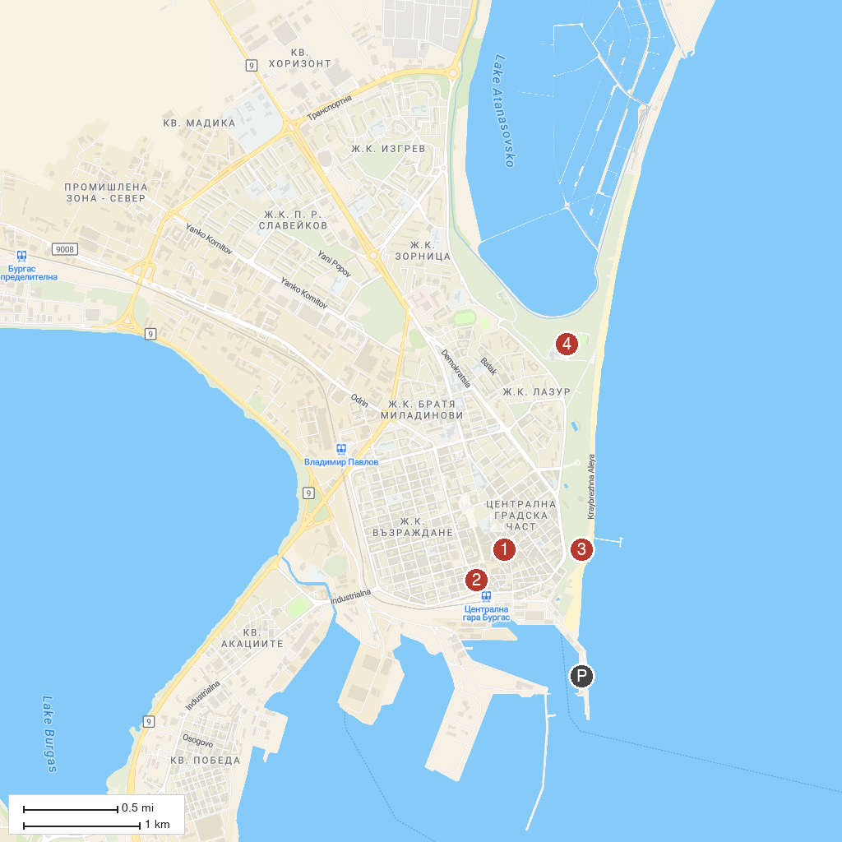
MAP KEY
1. History Museum Burgas | 5. "Saint George" Monastery
2. Biserica Fecioară Maria | 6. Salt Museum
3. The Sea Garden | 7. Yacht "Messalina"
4. Mineral Waters Park | 8. Sand Sculptures
P. Cruise port / terminal
Map © MapTiler © OpenStreetMap contributors · cruiseports.org

