Busuanga Island, Palawan, Philippines
Dramatic limestone cliffs, crystal-clear lakes, and a fleet of World War II Japanese shipwrecks make Busuanga Island one of Southeast Asia's most rewarding cruise calls. The town of Coron is your gateway — compact and easy to navigate on foot.
⚓ Tender port (anchor in Coron Bay) · 🕒 Typical call: 7-9 hrs · 💵 Philippine Peso (PHP) · 🗣️ Filipino / English widely spoken · 🤿 Top-rated dive & snorkel destination
✍️ MY DAY IN PORT (FILL IN)
Ship / Date
In port | arrive ______ · all aboard ______
Booked excursion
Notes / meeting point
GETTING ASHORE
- Docking: Tender — ships anchor in Coron Bay; 15-30 min tender ride to Coron Town Pier (Lualhati Park Pier)
- Walk to center: Coron Town Pier is right in the heart of town — market, shops and tricycles are steps away
- Best For: Snorkeling, WWII wreck diving, island hopping, scenic lake hikes
- Don't Miss: Kayangan Lake viewpoint and Twin Lagoon — both reached on the same island-hopping bangka tour
GETTING AROUND
- 📱 Rideshare: ❌ not available
TOP THINGS TO DO
- Kayangan Lake & Twin Lagoon Tour — The quintessential Coron day.
- WWII Shipwreck Diving & Snorkeling — Coron Bay holds one of the world's best collections of WWII Japanese shipwrecks, sunk in 1944.
- Siete Pecados Marine Park Snorkel — Seven limestone islets just off Coron Town harbor some of the richest coral reefs in the area.
- Maquinit Hot Springs — A rare saltwater hot spring about 20 minutes from town by tricycle.
- Mt. Tapyas Viewpoint Hike — A short tricycle ride from the pier, then roughly 700 steps to the summit.
BEST WALKS
- Coron Town Center Stroll: 1 km · 20 min · Easy · No elevation — From the pier, walk through Lualhati Park along the waterfront, past the wet market to Coron…
- Mt. Tapyas Steps: ~700 steps each way · 45-60 min round trip · Moderate · Bring water — A short tricycle ride from the pier drops you at the base of Mt.
WEATHER · DAYLIGHT · MONEY
Month | High °F | Low °F | Rainy days
May | 88 | 81 | 19
Jul | 84 | 78 | 28
Sep | 84 | 78 | 27
Daylight: May 5:35AM–6:15PM · Jul 5:42AM–6:27PM · Sep 5:48AM–6:00PM
cruiseports.org/busuanga-island-philippines · Confirm terminal & all-aboard time with your ship

Busuanga Island, Palawan, Philippines — Port Map
Red = walkable sights · Amber = excursions farther out · P = cruise terminal
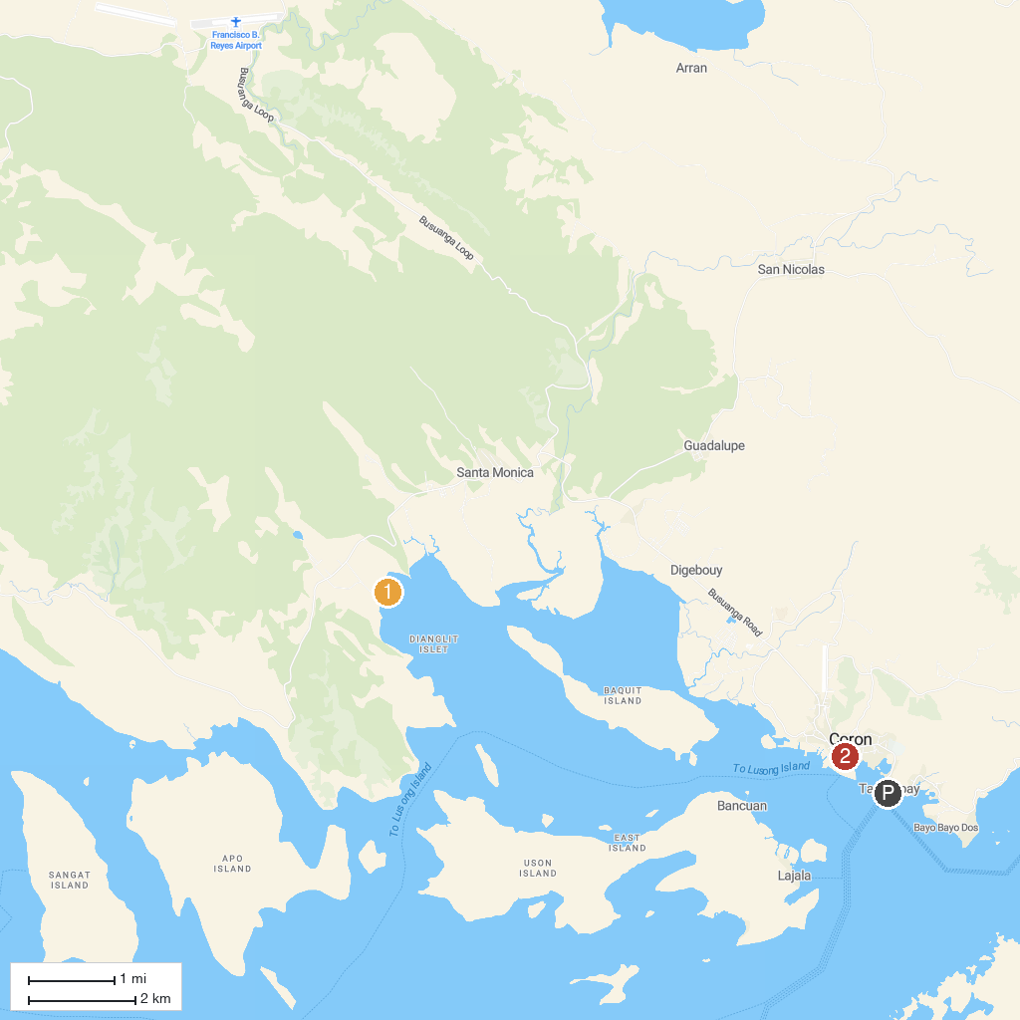
MAP KEY
1. Kingfisher Park | 2. Cinco Niños Leisure Corp
P. Cruise port / terminal
Map © MapTiler © OpenStreetMap contributors · cruiseports.org

