Cabo Frio, Rio de Janeiro, Brazil
Swept by constant Atlantic breezes and framed by 7.5 km of fine white sand, Cabo Frio earns its nickname as the "Wind City" — a laid-back resort town where a 400-year-old fort guards one end of the beach and boat trips to turquoise Arraial do Cabo fill the other.
⚓ Tender port (anchor offshore) · 🕒 Typical call: 7-9 hrs · 💵 Brazilian Real (BRL) · 🗣️ Portuguese · 🌊 Beaches & boat trips
✍️ MY DAY IN PORT (FILL IN)
Ship / Date
In port | arrive ______ · all aboard ______
Booked excursion
Notes / meeting point
GETTING ASHORE
- Docking: Tender — ships anchor; boats land near Praia do Forte
- Walk to center: ~5 min from tender dock to waterfront
- Best For: Beach days, diving, colonial history, Arraial day trip
- Don't Miss: Forte São Mateus and a schooner tour to Ilha do Japonês
GETTING AROUND
- 🚕 Taxi: ~R$10–20 (short rides) — Street taxis have a base fare of ~R$3 plus ~R$3/km. A short hop within central Cabo Frio typically runs R$10–20 (~$2–4 U
- 📱 Rideshare: ✅ Uber, 99
TOP THINGS TO DO
- Schooner Tour to Arraial do Cabo — Sail south to Arraial do Cabo — the "Brazilian Caribbean" — and stop at Ilha do Japonês for snorkeling in crystalline shallows…
- Forte São Mateus & Passagem Quarter — Walk the 7 km Praia do Forte to reach the 1620 Fort São Mateus, then loop back through the Passagem neighborhood's cobblestone…
- Diving at Ilha dos Papagaios — Cabo Frio is one of Brazil's top diving destinations — cold upwellings create exceptional visibility and rich marine life around…
- Buggy & ATV along the Coast — Rent a dune buggy or join a guided ATV tour across the sand dunes linking Cabo Frio's beaches, with stops at Praia do Peró and…
- Praia do Forte Beach Day — Seven and a half kilometers of white sand, clear water, and brisk Atlantic wind — rent a beach chair, eat fresh grilled fish at a…
BEST WALKS
- Praia do Forte Promenade to Forte São Mateus: 3 km one way · Easy · ~1 hr each way — Start at the Praça das Águas waterfront near the tender dock and walk the full length of Praia do…
- Passagem Historic Neighborhood Loop: 1.5 km loop · Easy · ~45 min — Cross the small canal bridge into the Passagem neighborhood for cobblestone alleys, 19th-century…
WEATHER · DAYLIGHT · MONEY
Month | High °F | Low °F | Rainy days
May | 78 | 68 | 10
Jul | 76 | 66 | 7
Sep | 78 | 69 | 7
Daylight: May 6:14AM–5:14PM · Jul 6:28AM–5:19PM · Sep 5:44AM–5:42PM
cruiseports.org/cabo-frio · Confirm terminal & all-aboard time with your ship

Cabo Frio, Rio de Janeiro, Brazil — Port Map
Red = walkable sights · Amber = excursions farther out · P = cruise terminal
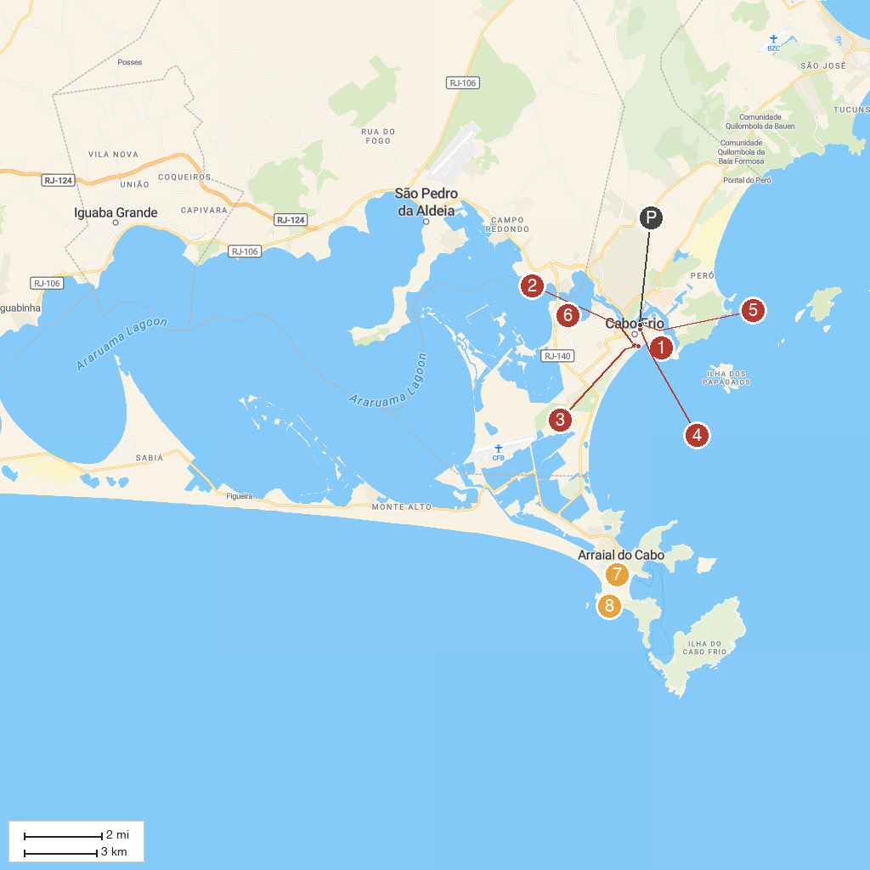
MAP KEY
1. Forte de São Mateus | 5. Carlos Scliar Atelier House
2. Surf Museum | 6. Santo Samba
3. Praça das Águas | 7. Centro Cultural Manoel Camargo
4. Charitas | 8. Mirante do Pontal do Atalaia
P. Cruise port / terminal
Map © MapTiler © OpenStreetMap contributors · cruiseports.org

