Cabo Pulmo, Baja California Sur, Mexico
One of North America's last living coral reefs, tucked into a sleepy fishing village on Baja's wild East Cape. Expedition ships anchor offshore; what waits below the surface is worth every minute.
⚓ Tender / beach landing · 🕒 Typical call: 5–7 hrs · 💵 Mexican Peso (USD widely accepted) · 🗣️ Spanish · 🌊 UNESCO World Heritage Site
✍️ MY DAY IN PORT (FILL IN)
Ship / Date
In port | arrive ______ · all aboard ______
Booked excursion
Notes / meeting point
GETTING ASHORE
- Docking: Tender or Zodiac beach landing — no pier
- Walk to village: Beachfront — small fishing village within steps of landing
- Best For: Snorkeling, scuba diving, kayaking, wildlife
- Don't Miss: Guided snorkel over the living reef; massive schools of jacks and groupers
GETTING AROUND
- 📱 Rideshare: ❌ not available
TOP THINGS TO DO
- Guided Reef Snorkel — Snorkel over a 20,000-year-old living coral reef with a certified guide.
- Scuba Diving the Marine Park — Nearly 20 dive sites within the park, from shallow reefs at 15 m to the El Vencedor shipwreck (a sunken tuna trawler).
- Sea Kayak & SUP Along the Coast — Paddle the calm inshore waters of the Sea of Cortez.
- Tide Pool & Beach Walk — Walk north or south from the landing beach to explore tide pools, watch frigatebirds and ospreys, and take in the stark…
BEST WALKS
- Beach Stroll Along Playa Los Arbolitos: ~1–2 km | Easy | Flat sand & rocky coves — Walk south along the shore from the main beach toward the coves below Cabo Pulmo, passing tide…
- Village Loop: ~1 km | Easy | 20 min — A short loop through the tiny fishing village to see local dive shops, a handful of restaurants…
WEATHER · DAYLIGHT · MONEY
Month | High °F | Low °F | Rainy days
May | 88 | 72 | 0
Jul | 93 | 81 | 7
Sep | 89 | 79 | 12
Daylight: May 5:36AM–6:52PM · Jul 5:40AM–7:06PM · Sep 6:04AM–6:20PM
cruiseports.org/cabo-pulmo-beach-resort · Confirm terminal & all-aboard time with your ship

Cabo Pulmo, Baja California Sur, Mexico — Port Map
Red = walkable sights · Amber = excursions farther out · P = cruise terminal
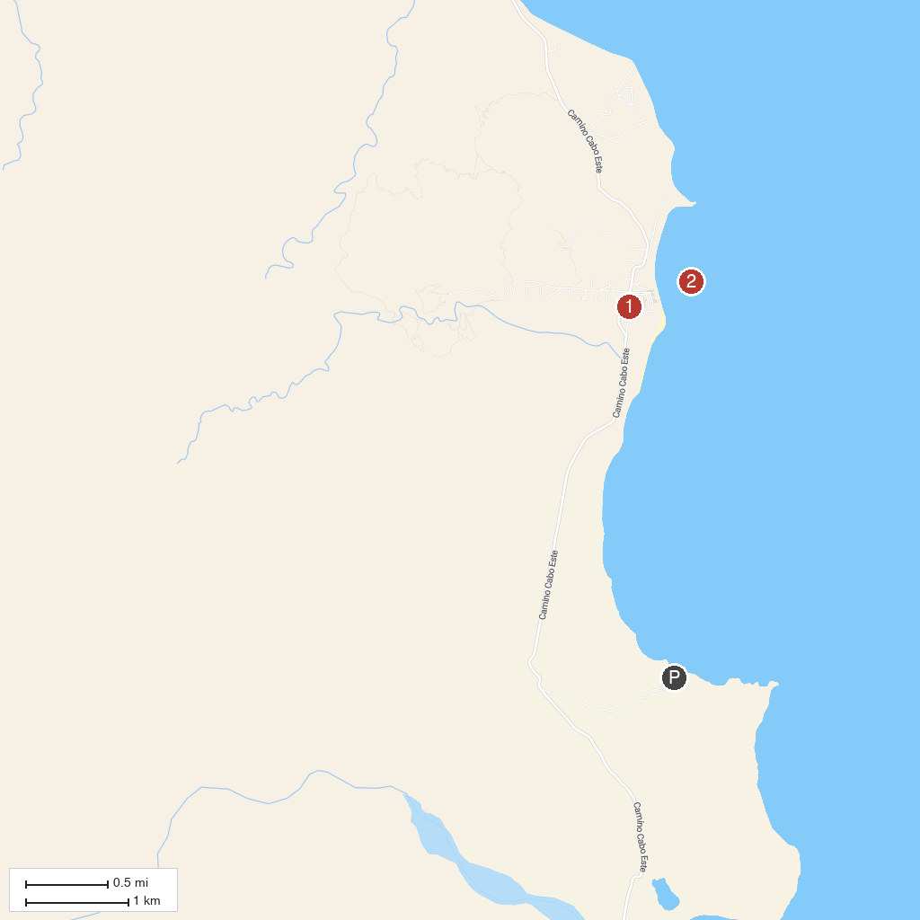
MAP KEY
1. Cabo Pulmo National Park | 3. Playa Los Arbolitos
2. Cabo Pulmo Reef
P. Cruise port / terminal
Map © MapTiler © OpenStreetMap contributors · cruiseports.org

