Cabo Rojo, Pedernales, Dominican Republic
A brand-new pier on the Dominican Republic's wild southwestern coast puts you steps from one of the Caribbean's most pristine beaches and some of its richest wildlife habitat — with Jaragua National Park right outside the port gates.
⚓ Docked (modern pier, no tender) · 🕒 Typical call: 8-10 hrs · 💵 Dominican Peso (USD widely accepted) · 🗣️ Spanish · 🌿 Eco-tourism destination
✍️ MY DAY IN PORT (FILL IN)
Ship / Date
In port | arrive ______ · all aboard ______
Booked excursion
Notes / meeting point
GETTING ASHORE
- Docking: Ships dock directly at Cabo Rojo pier — no tender required. Port opened Jan 2024.
- Distance to Pedernales: ~15 miles (24 km) from the port; 20–30 min by road.
- Best For: Pristine beaches, birdwatching, snorkeling, eco-adventures, larimar shopping.
- Don't Miss: Bahía de las Águilas — 8 km of untouched white sand, one of the Caribbean's most beautiful beaches.
GETTING AROUND
- 🚕 Taxi: $15–$30 USD — Taxis wait outside the port gates for the ~20 km drive to Pedernales town (25–30 min). No meters—negotiate and confirm t
- 📱 Rideshare: ❌ not available
TOP THINGS TO DO
- Bahía de las Águilas (Eagles Bay) — Frequently ranked among the Caribbean's most beautiful beaches, this 8 km stretch of untouched white sand sits inside Jaragua…
- Laguna de Oviedo Flamingo Tour — This large saltwater lagoon inside Jaragua National Park hosts Caribbean flamingos, rhinoceros iguanas, and dozens of bird species.
- ATV & Buggy Bauxite Adventure — Ride ATVs or dune buggies through the dramatic rust-red bauxite mining landscape around Cabo Rojo, finishing at a beach club.
- Hoyo de Pelempito Panorama — A 700-meter-deep geological depression in the Sierra de Bahoruco mountains, visible from a clifftop observatory.
- Pedernales Town & Larimar Shopping — Larimar — a rare blue variety of the mineral pectolite — is found only in the Dominican Republic, mined in the nearby Bahoruco…
BEST WALKS
- Port Complex Beach & Coastal Walk: 1-2 km • Easy • 30-60 min — Walk the port's own shoreline from the terminal along Cabo Rojo Beach, known for white sand, clear…
- Faro de Cabo Rojo (Lighthouse Walk): ~1 km • Easy • 20-30 min — A short walk or quick drive from the port brings you to the Cabo Rojo lighthouse on its clifftop…
WEATHER · DAYLIGHT · MONEY
Month | High °F | Low °F | Rainy days
May | 90 | 75 | 8
Jul | 93 | 77 | 5
Sep | 90 | 77 | 11
Daylight: May 6:14AM–7:12PM · Jul 6:20AM–7:25PM · Sep 6:35AM–6:48PM
cruiseports.org/cabo-rojo-pedernales · Confirm terminal & all-aboard time with your ship

Cabo Rojo, Pedernales, Dominican Republic — Port Map
Red = walkable sights · Amber = excursions farther out · P = cruise terminal
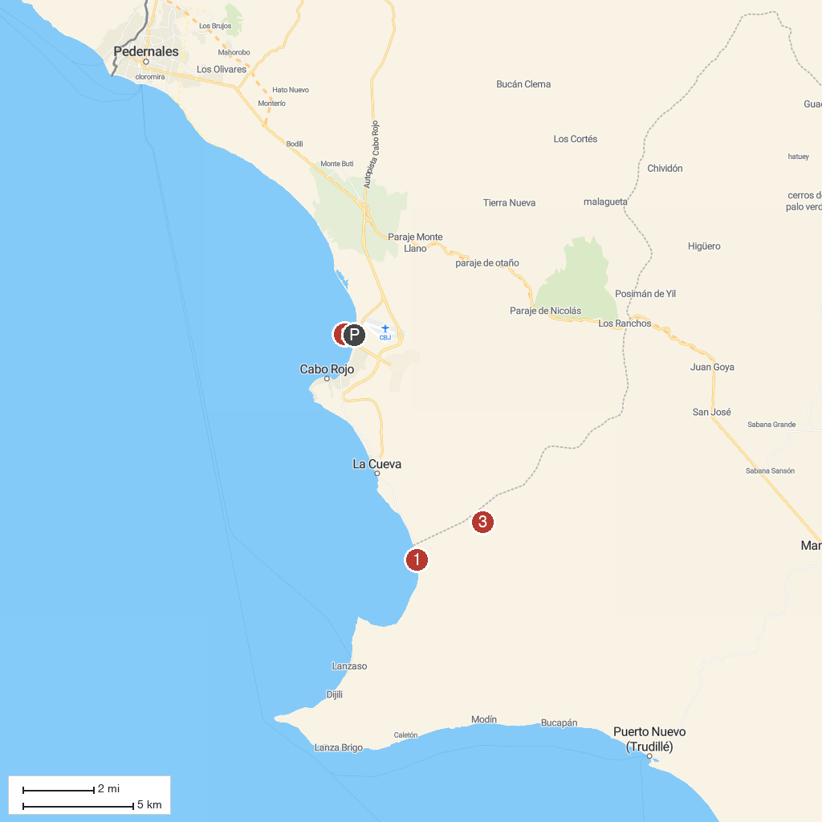
MAP KEY
1. Bahia de las Aguilas | 3. Jaragua National Park
2. Faro de Cabo Rojo
P. Cruise port / terminal
Map © MapTiler © OpenStreetMap contributors · cruiseports.org

