Cabo San Lucas, Baja California Sur, Mexico
Where the Pacific crashes into the Sea of Cortez beneath a famous stone arch. Cabo delivers dramatic scenery, lively beaches, and Baja adventure — all within reach of a short tender ride.
⚓ Tender port (anchor in bay) · 🕒 Typical call: 7-9 hrs · 💵 USD widely accepted / Mexican Peso · 🗣️ Spanish (English common in tourist zone)
✍️ MY DAY IN PORT (FILL IN)
Ship / Date
In port | arrive ______ · all aboard ______
Booked excursion
Notes / meeting point
GETTING ASHORE
- Docking: Tender only — ships anchor in Cabo Bay; 5–10 min ride to Marina Cabo San Lucas
- Walk to center: Immediate — marina shops, restaurants, and tour desks are steps from the tender pier
- Best For: Snorkeling, El Arco boat tours, beach days, ATV desert rides
- Don't Miss: Glass-bottom boat to El Arco and Lover's Beach at Land's End
GETTING AROUND
- 🚕 Taxi: $10–$12 USD/person round-trip — The primary way to get from the tender pier (cruise ships anchor offshore) to Medano Beach, Lovers Beach, and El Arco. F
- 📱 Rideshare: ✅ Uber
TOP THINGS TO DO
- El Arco & Land's End Boat Tour — Glass-bottom boats and catamarans cruise to Cabo's signature stone arch where the Pacific meets the Sea of Cortez, passing…
- Lover's Beach & Medano Beach Day — Water taxis from the marina drop you at Playa del Amor (Lover's Beach) near El Arco for swimming and snorkeling, or at Medano…
- Snorkeling at Santa Maria & Chileno Bay — These protected marine sanctuaries 20 minutes east of Cabo offer calm, clear water and abundant reef fish, rays, and sea turtles.
- ATV / UTV Baja Desert Tour — Ride quad bikes or side-by-side UTVs through the Baja desert and along coastal dirt tracks.
- San José del Cabo Day Trip — A 30-minute taxi ride leads to the quieter sister city with an 18th-century mission church, cobblestone art district, and a…
BEST WALKS
- Marina Boardwalk Stroll: 30–45 min • Flat • Easy — From the tender pier, walk the length of Blvd.
- Downtown & Mercado: 20–30 min • Flat • Easy — Head inland from the marina along Blvd.
WEATHER · DAYLIGHT · MONEY
Month | High °F | Low °F | Rainy days
May | 85 | 70 | 0
Jul | 90 | 80 | 4
Sep | 88 | 79 | 9
Daylight: May 5:38AM–6:53PM · Jul 5:43AM–7:07PM · Sep 6:06AM–6:22PM
cruiseports.org/cabo-san-lucas · Confirm terminal & all-aboard time with your ship

Cabo San Lucas, Baja California Sur, Mexico — Port Map
Red = walkable sights · Amber = excursions farther out · P = cruise terminal
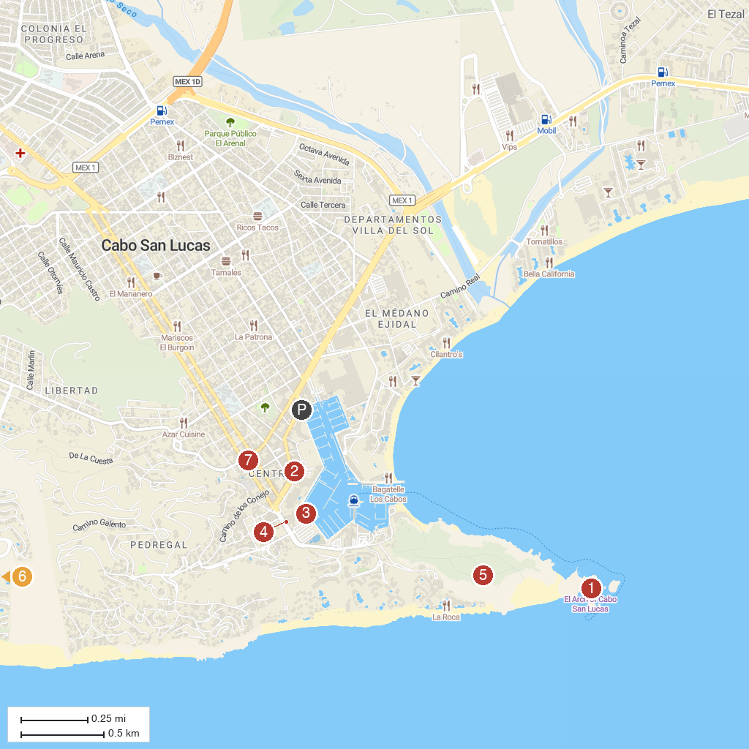
MAP KEY
1. The Arch of Cabo San Lucas | 5. Mt. Solmar
2. Playwin Casino | 6. Quivira Los Cabos
3. Cabo Shark Dive | 7. Museum of Natural History in Cabo San Lucas
4. Cultural Pavilion of the Republic
P. Cruise port / terminal
Map © MapTiler © OpenStreetMap contributors · cruiseports.org

