Cabrits, Portsmouth, Dominica
Dominica's northern cruise berth puts you inside a national park the moment you step ashore — 18th-century fort ruins, hand-rowed river tours, and volcanic rainforest all within easy reach of Portsmouth.
⚓ Docked pier · 🕒 Typical call: 7-9 hrs · 💵 Eastern Caribbean dollar / USD widely accepted · 🗣️ English (official)
✍️ MY DAY IN PORT (FILL IN)
Ship / Date
In port | arrive ______ · all aboard ______
Booked excursion
Notes / meeting point
GETTING ASHORE
- Docking: Timber wharf inside Cabrits National Park, ~5 min walk to Portsmouth town
- Walk to Fort Shirley: 10–15 min on foot from the pier
- Best For: History, nature hikes, Indian River boat tour
- Don't Miss: Hand-rowed Indian River tour with a stop at the riverside bush bar
GETTING AROUND
- 🚕 Taxi: $5–$15 USD — Licensed taxis wait at the pier for short trips around Portsmouth. Agree on fare in advance — meters are not standard.
- 📱 Rideshare: ❌ not available
TOP THINGS TO DO
- Fort Shirley & Cabrits National Park — Walk 10 minutes from the pier to explore the restored 18th-century British garrison at Fort Shirley.
- Indian River Rowboat Tour — Glide through Dominica's widest river in a hand-oared wooden boat — no motors allowed.
- Titou Gorge Swim — Swim through a narrow volcanic canyon to a hidden waterfall — a surreal spot also used in Pirates of the Caribbean.
- Emerald Pool & Morne Trois Pitons — A grotto waterfall inside the UNESCO World Heritage rainforest, reached by an easy 15-minute trail.
- Whale Watching off Dominica — Dominica is one of the best places in the Caribbean to spot sperm whales year-round.
BEST WALKS
- Pier to Fort Shirley Loop: 1.5 km · 30–45 min · Easy — Walk the park trail from the cruise terminal north to Fort Shirley's restored garrison ruins.
- Portsmouth Waterfront Stroll: 1.5 km · 25 min · Easy — Head south along the Prince Rupert Bay waterfront into Portsmouth town.
WEATHER · DAYLIGHT · MONEY
Month | High °F | Low °F | Rainy days
May | 87 | 75 | 12
Jul | 88 | 76 | 16
Sep | 89 | 76 | 18
Daylight: May 5:36AM–6:27PM · Jul 5:43AM–6:40PM · Sep 5:54AM–6:07PM
Representative sunrise/sunset — 2025, 15th of each month; local civil time including DST (America/Dominica). Source: Astral; not a forecast or climate average.
cruiseports.org/cabrits-dominica · Confirm terminal & all-aboard time with your ship

Cabrits, Portsmouth, Dominica — Port Map
Red = walkable sights · Amber = excursions farther out · P = cruise terminal
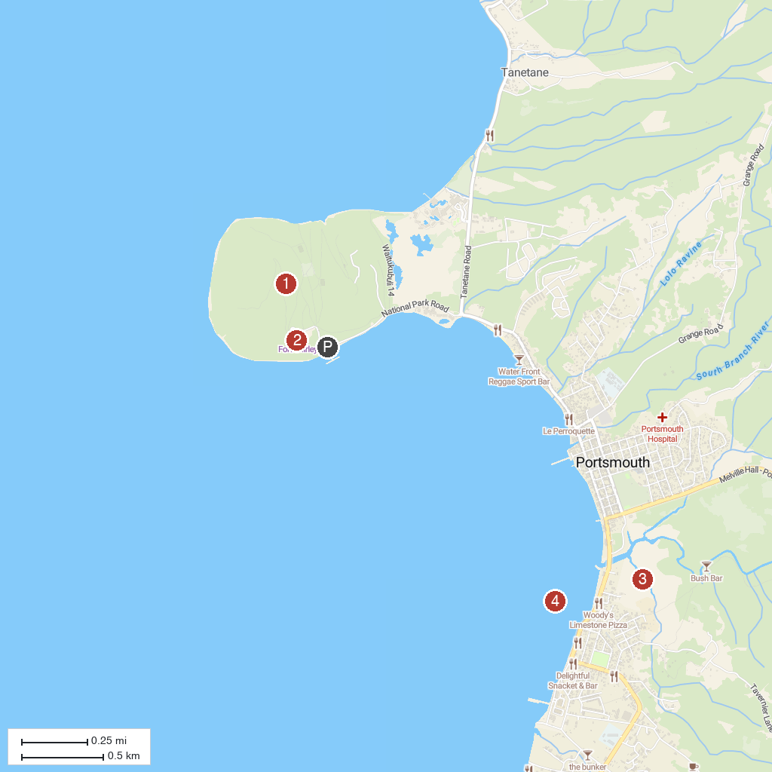
MAP KEY
1. Cabrits National Park | 3. Indian River
2. Fort Shirley | 4. Prince Rupert Bay
P. Cruise port / terminal
Map © MapTiler © OpenStreetMap contributors · cruiseports.org

