Cadillac-sur-Garonne, Gironde, France
A jewel of the Garonne Valley, Cadillac-sur-Garonne pairs a magnificent 17th-century ducal château with world-class sweet wines and centuries-old bastide streets—all within steps of the riverside dock.
⚓ Docked (river quay) · 🕒 Typical call: 6-8 hrs · 💶 Euro (€) · 🗣️ French · 🍷 Wine country
✍️ MY DAY IN PORT (FILL IN)
Ship / Date
In port | arrive ______ · all aboard ______
Booked excursion
Notes / meeting point
GETTING ASHORE
- Docking: River quay on the Garonne; vessels up to 135 m dock alongside, town is a short walk
- Walk to center: 5 min from quay to Château Ducal and old town gates
- Best For: Wine lovers, history buffs, leisurely bastide town strolling
- Don't Miss: Château Ducal de Cadillac and a Cadillac AOC sweet wine tasting
GETTING AROUND
- 🚕 Taxi: €8–€15 — Local taxis serve Cadillac with Gironde department rates (€8 base fare + €2.08/km). Useful for reaching nearby vineyards
- 📱 Rideshare: ✅ Uber
TOP THINGS TO DO
- Château Ducal de Cadillac — Built in the early 17th century for the Duke of Épernon, this royal monument is famous for its monumental fireplaces, painted…
- Cadillac AOC Wine Tasting — Cadillac's appellation produces luscious sweet white wines made from Sémillon and Sauvignon Blanc.
- Sauternes Vineyard Tour — Cross the Garonne to the world-famous Sauternes appellation, home of Château d'Yquem.
- Château de Roquetaillade — One of France's best-preserved medieval castles, Roquetaillade has been occupied by the same family for 700 years.
- Fortified Town Walk & Collegiate Church — Wander the bastide grid to the Porte de l'Horloge, the rampart walls, and the 15th-century Collegiate Church of…
BEST WALKS
- Bastide Town & Château Loop: ~2 km | 45 min | Easy | Self-guided — From the quay, pass through the Porte de la Mer into the old town.
- Garonne Greenway Riverside Stroll: ~3 km one-way | 1 hr | Easy | Flat path — Head south from the quay along the Voie Verte (greenway) that follows the Garonne riverside.
WEATHER · DAYLIGHT · MONEY
Month | High °F | Low °F | Rainy days
May | 68 | 51 | 12
Jul | 81 | 62 | 8
Sep | 75 | 57 | 8
Daylight: May 6:33AM–9:22PM · Jul 6:30AM–9:43PM · Sep 7:40AM–8:11PM
cruiseports.org/cadillac-sur-garonne · Confirm terminal & all-aboard time with your ship

Cadillac-sur-Garonne, Gironde, France — Port Map
Red = walkable sights · Amber = excursions farther out · P = cruise terminal
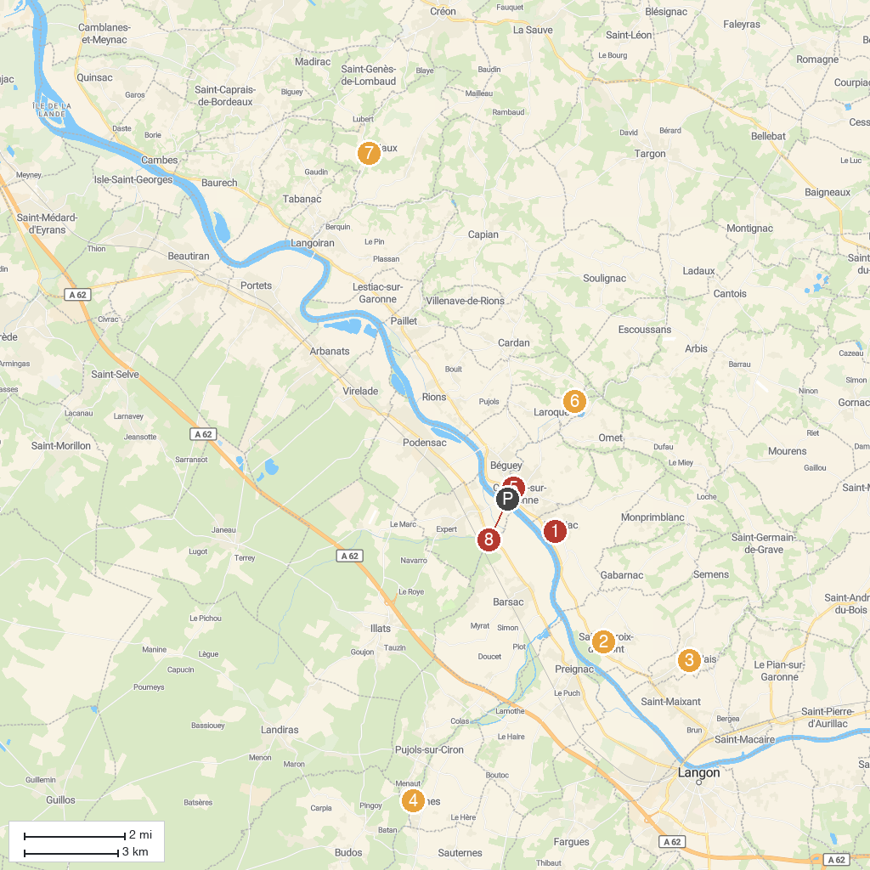
MAP KEY
1. Gallo-Roman Villa Saint-Romain Loupiac | 5. Cadillac Ducal Castle
2. Huitres Fossiles | 6. Lac aux Branches.
3. Basilique Notre-Dame de Verdelais | 7. Château Lamothe de Haux
4. Au Fil du Ciron | 8. Cadillac Port
P. Cruise port / terminal
Map © MapTiler © OpenStreetMap contributors · cruiseports.org

