Cairns, Queensland, Australia
Two UNESCO World Heritage sites, one port call. Cairns puts the outer Great Barrier Reef and ancient Wet Tropics rainforest within easy reach of the cruise terminal.
⚓ Docked (most ships) or tender at Yorkeys Knob (large vessels) · 🕒 Typical call: 8–10 hrs · 💵 Australian Dollar (AUD) · 🗣️ English
✍️ MY DAY IN PORT (FILL IN)
Ship / Date
In port | arrive ______ · all aboard ______
Booked excursion
Notes / meeting point
GETTING ASHORE
- Docking: Most ships dock at Trinity Wharf in the city centre; very large vessels anchor in Trinity Bay and tender to Yorkeys Knob (~20 min shuttle to town)
- Walk to centre: 5 min on foot to Esplanade; 7 min to Reef Fleet Terminal (reef tour departures)
- Best For: Great Barrier Reef snorkel/dive, Kuranda Scenic Railway, wildlife parks
- Don't Miss: Full-day outer reef tour — departures are steps from the pier at Reef Fleet Terminal
GETTING AROUND
- 🚕 Taxi: AU$15–25 — Taxis are available at the terminal. The city center is extremely close; most rides stay well under AU$25. Regulated far
- 📱 Rideshare: ✅ Uber, DiDi
- 🚌 Hop-on hop-off: ✅
TOP THINGS TO DO
- Outer Great Barrier Reef Day Tour — Sail 90 minutes to the outer reef pontoon for snorkelling, semi-submersible rides, underwater viewing chambers, and optional…
- Kuranda Scenic Railway & Skyrail Cableway — Ride the historic 1891 Kuranda Scenic Railway through rainforest gorges and waterfalls to the village of Kuranda, then glide back…
- Green Island Day Trip — A 45-minute catamaran ride from Cairns reaches this coral cay on the inner reef — snorkel off the beach, take a glass-bottom…
- Mossman Gorge & Daintree Rainforest — Head north to Mossman Gorge for a guided Kuku Yalanji Aboriginal walk through ancient rainforest, then continue into the Daintree…
- Whitewater Rafting on the Tully River — Grade 3–4 rapids through tropical gorges on the Tully River, one of Australia's top whitewater runs.
BEST WALKS
- Esplanade Lagoon & Waterfront Walk: 2 km · Flat · 30–45 min · Free — Head north from Trinity Wharf along the Esplanade to the famous free saltwater swimming lagoon…
- City Centre & Night Markets Stroll: 1.5 km loop · Flat · 20–30 min — From the terminal, walk through The Pier shopping centre and into the Cairns CBD.
WEATHER · DAYLIGHT · MONEY
Month | High °F | Low °F | Rainy days
May | 79 | 70 | 11
Jul | 75 | 65 | 7
Sep | 79 | 67 | 7
Daylight: May 6:33AM–5:52PM · Jul 6:46AM–5:59PM · Sep 6:12AM–6:11PM
cruiseports.org/cairns · Confirm terminal & all-aboard time with your ship

Cairns, Queensland, Australia — Port Map
Red = walkable sights · Amber = excursions farther out · P = cruise terminal
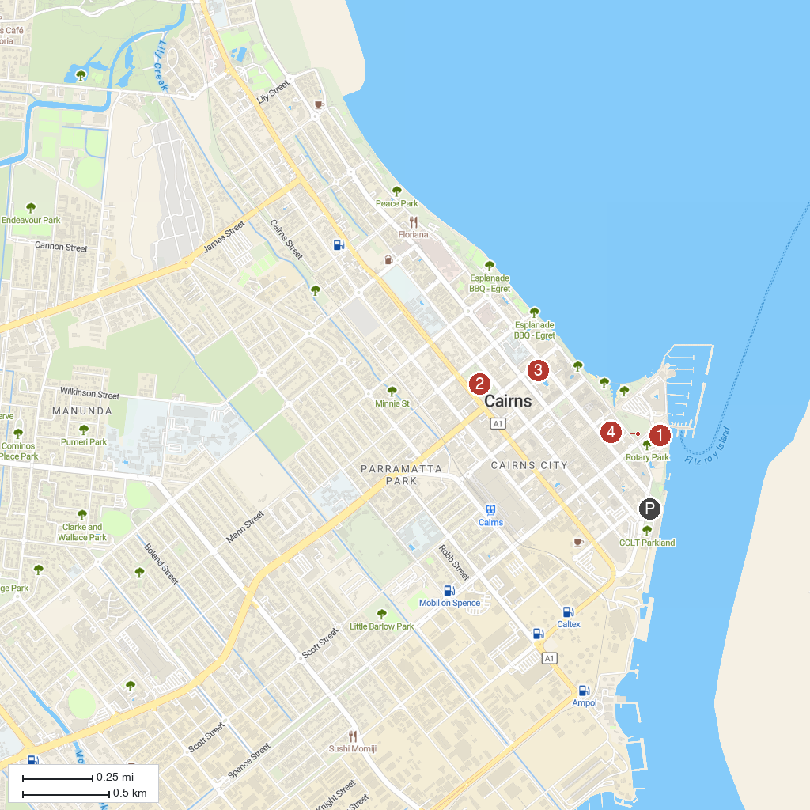
MAP KEY
1. Sugarworld Parklands | 4. Munro Martin Parklands
2. Skyrail Rainforest Cableway | 5. Cairns Aquarium
3. Down Under Cruise & Dive - Evolution Outer Reef Cruise | 6. Fogarty Park Sound Shell
P. Cruise port / terminal
Map © MapTiler © OpenStreetMap contributors · cruiseports.org

