Cairo, Cairo Governorate, Egypt
The only remaining Wonder of the Ancient World awaits. Cruise itineraries labeled 'Cairo' dock at Port Said or Ain Sokhna — both require a dedicated shore day to reach the Pyramids, but few destinations on earth deliver a bigger payoff.
⚓ Docked (Port Said or Ain Sokhna — long drive to Cairo) · 🕒 Typical call: 10-12 hrs (full day required) · 💵 Egyptian Pound (USD/EUR widely accepted at tourist sites) · 🗣️ Arabic (English spoken at major tourist sites)
✍️ MY DAY IN PORT (FILL IN)
Ship / Date
In port | arrive ______ · all aboard ______
Booked excursion
Notes / meeting point
GETTING ASHORE
- Docking: Port Said (Mediterranean, ~200 km from Cairo, 3-4 hrs) or Ain Sokhna (Red Sea, ~120 km, 90 min)
- Walk to center: Cairo is a full-day drive — book a ship tour or private guide; no walk-off option
- Best For: The Pyramids of Giza and Great Sphinx; Grand Egyptian Museum; Khan el-Khalili bazaar
- Don't Miss: Tutankhamun's treasures at the Grand Egyptian Museum (opened 2025 at the Giza Plateau)
GETTING AROUND
- 🚕 Taxi: EGP 100–200 (~$2–4 USD) within Cairo — Metered taxis are widely available in Cairo. Agree on a fare in advance for unmetered cabs; apps like Uber or Careem can
- 📱 Rideshare: ✅ Uber, Careem, Bolt
TOP THINGS TO DO
- Pyramids of Giza & Great Sphinx — The three great pyramids of Cheops, Chephren, and Mykerinus plus the iconic Great Sphinx dominate the plateau just outside Cairo.
- Grand Egyptian Museum (GEM) — Opened in 2025, the GEM sits at the edge of the Giza Plateau and holds the complete Tutankhamun collection — over 5,000 artifacts…
- Saqqara Step Pyramid — Egypt's oldest large-scale stone monument, the Step Pyramid of Djoser at Saqqara is 4,700 years old and surrounded by tombs with…
- Khan el-Khalili Bazaar & Islamic Cairo — Cairo's 14th-century bazaar is a labyrinth of spice stalls, jewelry, textiles, and street food in the heart of Islamic Cairo.
- Coptic Cairo & Old Cairo District — The Hanging Church, Cavern Church of Abu Serga, and the Ben Ezra Synagogue are clustered in this ancient enclave on the site of…
BEST WALKS
- Giza Plateau Self-Guided Loop: 2-3 km · 1-2 hrs · Flat sandy plateau — From the main entrance, walk the road past the Great Pyramid of Cheops south to Chephren and…
- Khan el-Khalili Wander: 1-1.5 km · 1-2 hrs · Flat pedestrian lanes — Enter from Al-Hussein Mosque square and zigzag through the covered lanes of the bazaar toward…
WEATHER · DAYLIGHT · MONEY
Month | High °F | Low °F | Rainy days
May | 93 | 66 | 0
Jul | 100 | 73 | 0
Sep | 96 | 72 | 0
Daylight: May 6:01AM–7:41PM · Jul 6:04AM–7:57PM · Sep 6:39AM–7:00PM
cruiseports.org/cairo · Confirm terminal & all-aboard time with your ship

Cairo, Cairo Governorate, Egypt — Port Map
Red = walkable sights · Amber = excursions farther out · P = cruise terminal
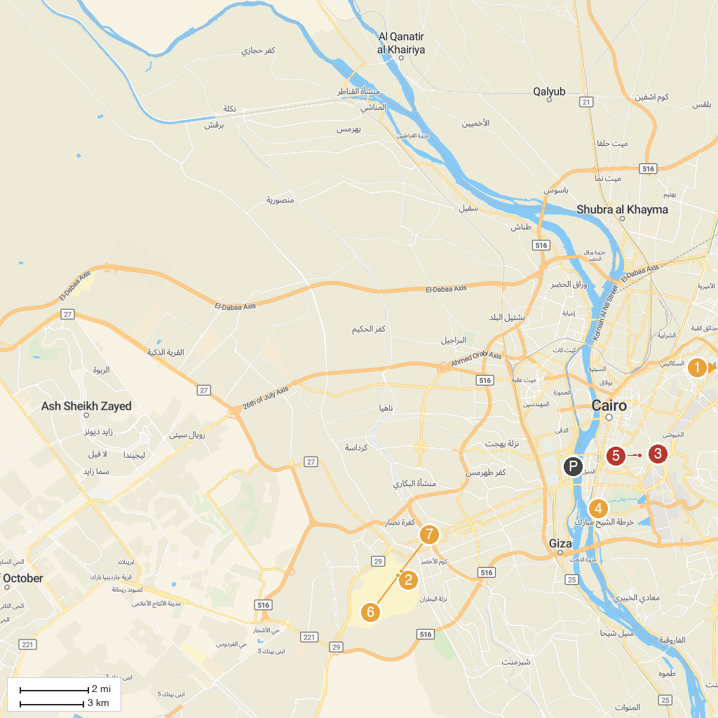
MAP KEY
1. Monument to the Unknown Soldier | 5. Gayer-Anderson Museum
2. Great Sphinx of Giza | 6. Giza Necropolis
3. Saladin Citadel | 7. The Great Pyramid of Giza
4. Coptic Museum
P. Cruise port / terminal
Map © MapTiler © OpenStreetMap contributors · cruiseports.org

