Cais da Lixa, Covelo, Portugal
A quiet marina on the Douro River, Cais da Lixa is your gateway to Portugal's famous wine country, the golden city of Porto, and Gondomar's centuries-old filigree craft tradition.
⚓ Docked (river pier) · 🕒 Typical call: 4–6 hrs · 💶 Currency: Euro (€) · 🗣️ Language: Portuguese
✍️ MY DAY IN PORT (FILL IN)
Ship / Date
In port | arrive ______ · all aboard ______
Booked excursion
Notes / meeting point
GETTING ASHORE
- Docking: River pier — ships dock directly at Marina da Lixa, no tender needed
- Walk to Centre: Covelo village ~5 min on foot; Gondomar town ~20 min by taxi/Uber
- Best For: River scenery, Port wine excursions, filigree jewelry, Porto day trips
- Don't Miss: A glass of Port at Restaurante O Lixa with Douro views
GETTING AROUND
- 🚕 Taxi: €15–€35 — Local taxis serve the marina. Expect roughly €15–€20 to Gondomar town and €25–€35 to central Porto, depending on traffic
- 📱 Rideshare: ✅ Uber, Bolt
TOP THINGS TO DO
- Porto City & Port Wine Cellars — Head downstream to Porto — one of Europe's most photogenic cities.
- Douro Valley Quinta Wine Tour — Drive east into the Douro Valley UNESCO wine region to visit a historic quinta (wine estate), walk the terraced vineyards, and…
- Gondomar Filigree Artisan Workshop — Gondomar is Portugal's capital of filigree jewellery.
- Serras do Porto Park — Buggy or Hike — The hilly Serras do Porto park is a short drive from the marina.
- Douro River Kayak or Paddleboard — Marina da Lixa offers kayak and paddleboard rentals and guided river tours directly from the dock.
BEST WALKS
- Marina Promenade & Covelo Riverfront: 1–2 km · 20–30 min · Easy · Flat riverside path — A leisurely out-and-back along the Douro bank from the marina.
- Covelo Riverside to Serras do Porto Foothills: 3–4 km · 1–1.5 hrs · Moderate · Uphill paths — Follow trails up from the riverbank near Covelo into the wooded lower slopes of the Serras do Porto…
WEATHER · DAYLIGHT · MONEY
Month | High °F | Low °F | Rainy days
May | 68 | 51 | 11
Jul | 78 | 59 | 5
Sep | 73 | 57 | 9
Daylight: May 7:12AM–9:47PM · Jul 7:10AM–10:07PM · Sep 8:13AM–8:42PM
cruiseports.org/cais-da-lixa · Confirm terminal & all-aboard time with your ship

Cais da Lixa, Covelo, Portugal — Port Map
Red = walkable sights · Amber = excursions farther out · P = cruise terminal
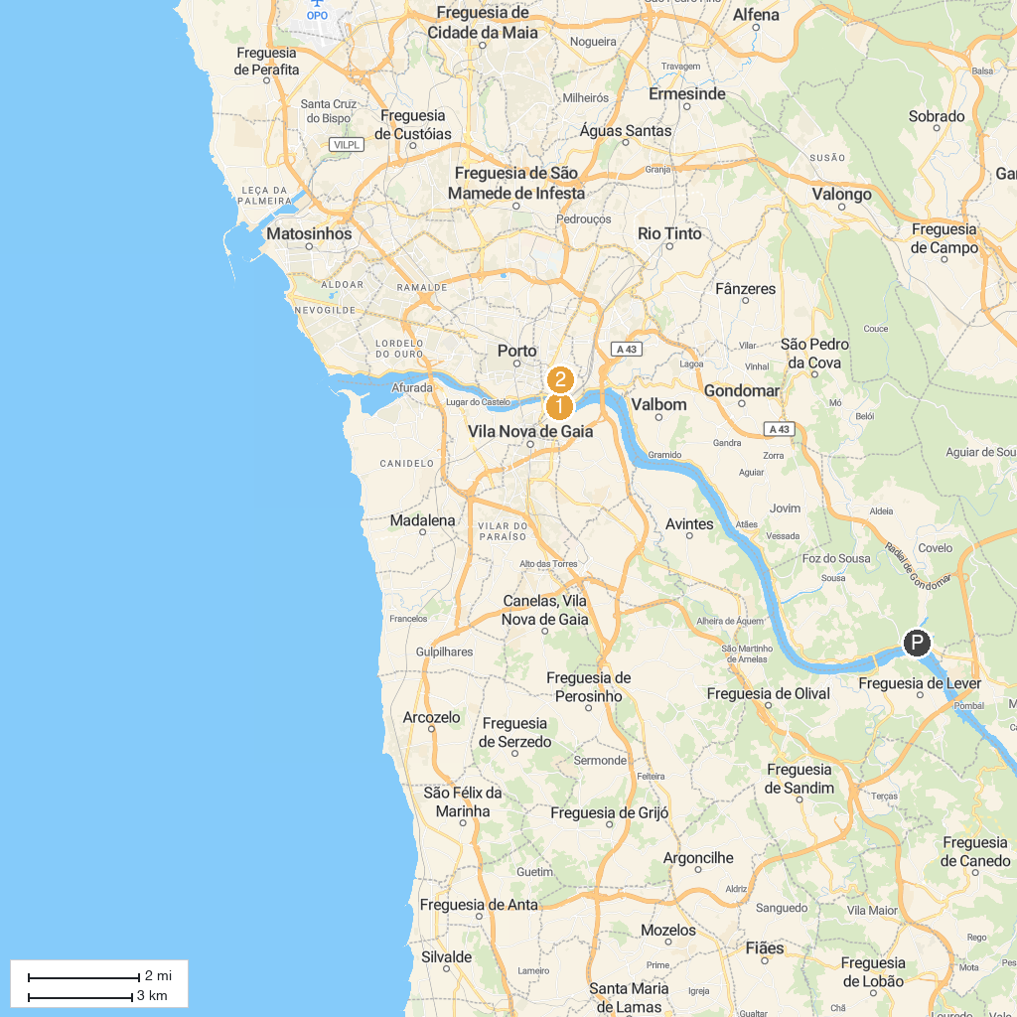
MAP KEY
1. Ageas Porto Coliseum | 5. Palácio da Bolsa
2. Ponte de São João | 6. Saint Lawrence Church
3. Porto Cathedral | 7. Mosteiro Santo Agostinho da Serra do Pilar
4. Torre dos Clérigos | 8. Military Museum Porto
P. Cruise port / terminal
Map © MapTiler © OpenStreetMap contributors · cruiseports.org

