Caldas de Aregos, Douro Valley, Portugal
A quiet riverside spa town on the Douro, Caldas de Aregos has been drawing visitors to its therapeutic hot springs since the 12th century. River cruise ships dock right in town, putting thermal baths, Douro wine estates, and medieval Portuguese history within easy reach.
⚓ Docked (river pier) · 🕒 Typical call: 6-8 hrs · 💵 Euro (EUR) · 🗣️ Portuguese
✍️ MY DAY IN PORT (FILL IN)
Ship / Date
In port | arrive ______ · all aboard ______
Booked excursion
Notes / meeting point
GETTING ASHORE
- Docking: Cais Turístico-Fluvial de Caldas de Aregos — dedicated river cruise pier, inaugurated 2009
- Walk to center: ~2 min — pier is steps from the spa and town center
- Best For: Thermal spa relaxation, Douro wine tasting, Portuguese history day trips
- Don't Miss: Termas Caldas de Aregos thermal baths and a Douro Valley wine estate tour
GETTING AROUND
- 🚕 Taxi: €10–20 est. — Local taxis can be hailed or arranged through your ship for day trips to Resende (8 km) or Lamego (25 km). Prices are un
TOP THINGS TO DO
- Termas Caldas de Aregos Thermal Soak — The Rainha Dona Mafalda spa has been channelling the town's sulphurous mineral springs since the 12th century.
- Douro Valley Wine Estate & Tasting — The terraced vineyards of the Douro Valley begin right outside town.
- Guimarães — Birthplace of Portugal — A UNESCO World Heritage medieval town about an hour away, Guimarães is where Portugal's first king, Afonso Henriques, was born in…
- Braga — Portugal's Religious Capital — Braga, about 75 minutes away, is one of Iberia's oldest cities, home to the stunning Bom Jesus do Monte sanctuary, Roman-era…
- Monastery of Santo André de Ancede — Across the Douro in nearby Baião, this medieval monastery — founded by the Canons Regular of St.
BEST WALKS
- Riverside Promenade & Town Center: ~1 km · 20 min · Easy — Walk the Douro riverfront promenade from the pier north toward the marina, then cut up into the…
- Miradouro da Portela do Gôve Viewpoint: ~3 km return · 60 min · Moderate — A hillside walk or short taxi ride above town brings you to this viewpoint for panoramic views over…
WEATHER · DAYLIGHT · MONEY
Month | High °F | Low °F | Rainy days
May | 74 | 55 | 10
Jul | 85 | 65 | 4
Sep | 80 | 61 | 8
Daylight: May 6:14AM–8:43PM · Jul 6:12AM–9:02PM · Sep 7:12AM–7:40PM
cruiseports.org/caldas-de-aregos · Confirm terminal & all-aboard time with your ship

Caldas de Aregos, Douro Valley, Portugal — Port Map
Red = walkable sights · Amber = excursions farther out · P = cruise terminal
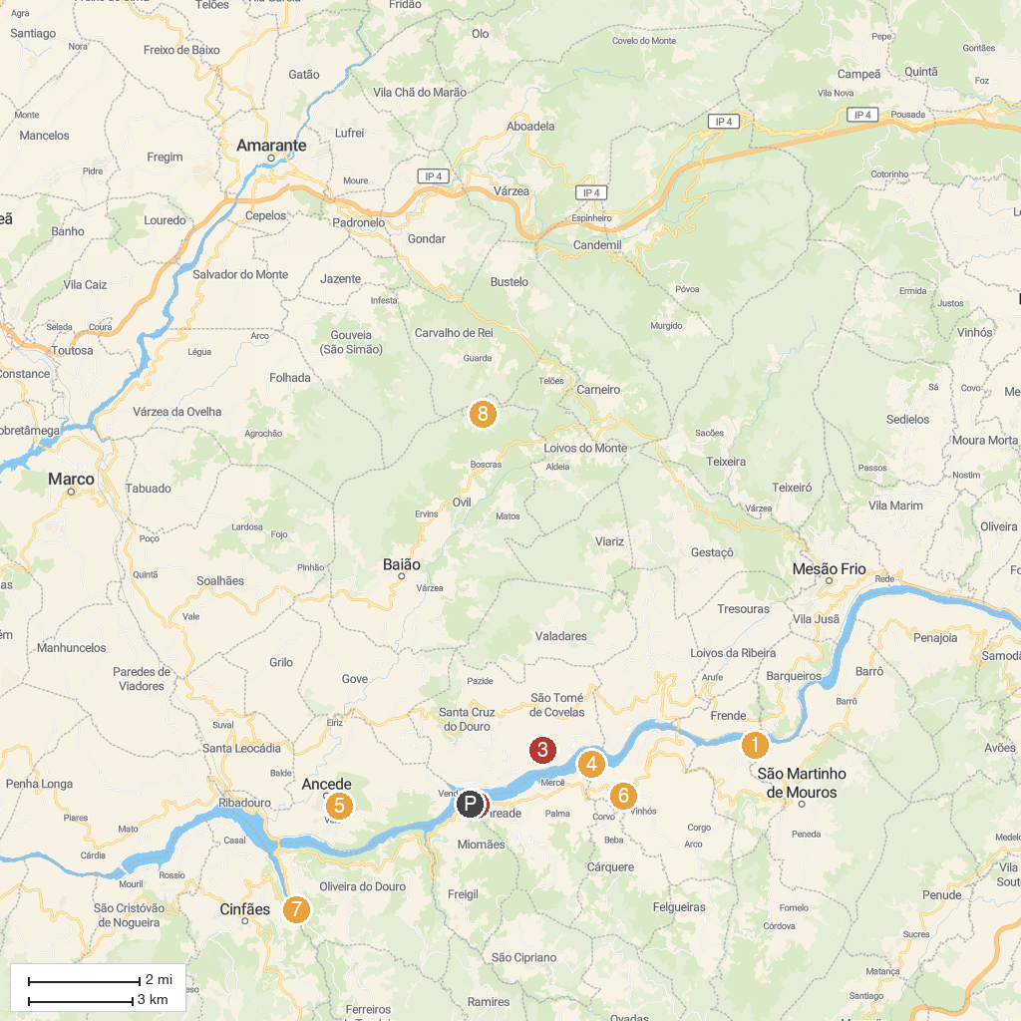
MAP KEY
1. Parque Fluvial de Porto de Rei | 5. Mosteiro de Santo André de Ancede e Capela do Bom Despacho (Centro Cultural)
2. Caldas de aregos | 6. Museu Municipal de Resende
3. Quinta de Covela | 7. Parque de Lazer de Pias
4. Quinta da Porta Caseira | 8. Dolmen Chã de Parada
P. Cruise port / terminal
Map © MapTiler © OpenStreetMap contributors · cruiseports.org

