Callao, Lima Region, Peru
Peru's main port opens the door to Lima — a city that punches above its weight in history, art, and gastronomy. Expect colonial grandeur, pre-Columbian gold, clifftop parks, and ceviche so good you'll plan your return trip around it.
⚓ Docked (Muelle Norte pier) · 🕒 Typical call: 8–12 hrs · 💵 Peruvian Sol (USD widely accepted) · 🗣️ Spanish
✍️ MY DAY IN PORT (FILL IN)
Ship / Date
In port | arrive ______ · all aboard ______
Booked excursion
Notes / meeting point
GETTING ASHORE
- Docking: Muelle Norte terminal, Port of Callao — multipurpose berths, large ships docked directly
- Walk to centre: Port area is industrial — taxi/Uber 30–60 min to Lima's Miraflores or Historic Centre
- Best For: History lovers, foodies, museum enthusiasts, and culture seekers
- Don't Miss: Larco Museum's pre-Columbian collection and a proper ceviche lunch in Miraflores
GETTING AROUND
- 🚕 Taxi: ~$20–35 USD — Official port taxis are available dockside. Fares to Lima's Plaza de Armas run ~$25–35; Miraflores costs ~$20–30 dependi
- 📱 Rideshare: ✅ Uber, Cabify, DiDi
- 🚌 Hop-on hop-off: ✅ Turibus
TOP THINGS TO DO
- UNESCO Historic Centre of Lima — The Plaza de Armas, Lima Cathedral (with Francisco Pizarro's tomb), and the San Francisco Monastery with its haunting underground…
- Larco Museum — One of South America's finest museums, housed in an 18th-century viceregal mansion.
- Miraflores & Barranco Districts — Miraflores offers clifftop Malecón parks with sweeping Pacific views, the ancient Huaca Pucllana pyramid rising from the modern…
- Lima Food & Pisco Sour Experience — Lima is consistently ranked among the world's top food cities.
- Fortress of Real Felipe & Callao Monumental — Built in 1747 to defend against pirate raids, the star-shaped Fortress of Real Felipe now houses the Army Museum with panoramic…
BEST WALKS
- Miraflores Cliff Walk: 2–3 km · Easy · Ocean views — From Larcomar shopping centre, stroll north along the Malecón de Miraflores clifftop promenade past…
- Barranco Neighbourhood Stroll: 1–2 km · Easy · Bohemian vibe — Wander from the Puente de los Suspiros (Bridge of Sighs) down to Bajada de Baños, passing…
- Plaza Mayor Loop — Lima Centro: ~2 km · 1.5 hrs · Flat — Start at Plaza Mayor (Plaza de Armas), take in the Government Palace (watch the changing of the…
WEATHER · DAYLIGHT · MONEY
Month | High °F | Low °F | Rainy days
May | 72 | 64 | 0
Jul | 67 | 59 | 0
Sep | 67 | 59 | 0
Daylight: May 6:18AM–5:51PM · Jul 6:30AM–5:58PM · Sep 6:02AM–6:04PM
cruiseports.org/callao-lima · Confirm terminal & all-aboard time with your ship

Callao, Lima Region, Peru — Port Map
Red = walkable sights · Amber = excursions farther out · P = cruise terminal
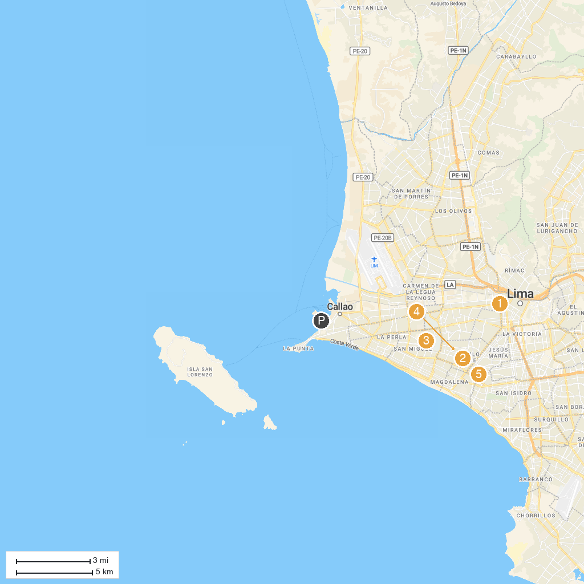
MAP KEY
1. Plaza Dos de Mayo | 5. Larco Museum
2. La Cruz del Viajero Park | 6. Lima Cathedral
3. Park of the Legends Zoo | 7. Magic Water Circuit of the Reserve Park
4. Park of the Exposition | 8. Peruvian-Japanese Cultural Center
P. Cruise port / terminal
Map © MapTiler © OpenStreetMap contributors · cruiseports.org

