Calvörde, Saxony-Anhalt, Germany
A peaceful canal-town pause on the Mittellandkanal beside the Ohre, Calvörde trades cruise-ship bustle for cycling paths through wetland reserves, the weathered ruins of a medieval fortress, and the unhurried rhythm of rural Saxony-Anhalt.
⚓ Canal mooring (Mittellandkanal) · 🕒 Typical call: 4–6 hrs · 💶 Currency: Euro (€) · 🗣️ Language: German · 🌿 Best for: Nature & cycling
✍️ MY DAY IN PORT (FILL IN)
Ship / Date
In port | arrive ______ · all aboard ______
Booked excursion
Notes / meeting point
GETTING ASHORE
- Docking: Mooring on the Mittellandkanal; gangway to shore
- Walk to centre: ~5 min stroll to Flecken Calvörde market area
- Best For: Cycling the Drömling, castle ruins, bird-watching wetlands
- Don't Miss: Burg Calvörde castle site at the historic Ohre crossing
GETTING AROUND
- 🚕 Taxi: €5–15 per trip — Taxis serve the area but must usually be pre-booked by phone; there is no taxi rank at the quay. Ask your cruise directo
TOP THINGS TO DO
- Drömling Nature Park Cycling — The Drömling — a vast lowland wetland of canals, reed beds, and floodplain forest — begins on the town's doorstep.
- Burg Calvörde Ruins — Burg Calvörde, first recorded in the late 13th century, controlled the historic Ohre crossing for centuries before being…
- Altenhausen Castle — About 18 km south, Schloss Altenhausen is a moated manor documented since 1303, now operating as a hotel and event venue.
- Drömling Bird Hide & Wetland Walk — The Drömling shallow-water zone near Mannhausen features a dedicated bird observation hut.
- Magdeburg Day Excursion — The state capital lies ~37 km southeast and is reachable by bus or taxi.
BEST WALKS
- Riverside to Burg Calvörde Ruins: 1.2 km · 20 min · Easy — From the mooring, follow the path into the old town, continuing up to the castle site for a view…
- Ohre Cycle Path into the Drömling: 5–15 km · 1–3 hrs · Easy flat — The signed Ohre cycle path heads west from Calvörde directly into the Drömling Nature Park.
WEATHER · DAYLIGHT · MONEY
Month | High °F | Low °F | Rainy days
May | 65 | 48 | 10
Jul | 76 | 59 | 11
Sep | 68 | 53 | 8
Daylight: May 5:19AM–9:03PM · Jul 5:11AM–9:29PM · Sep 6:49AM–7:29PM
cruiseports.org/calvorde · Confirm terminal & all-aboard time with your ship

Calvörde, Saxony-Anhalt, Germany — Port Map
Red = walkable sights · Amber = excursions farther out · P = cruise terminal
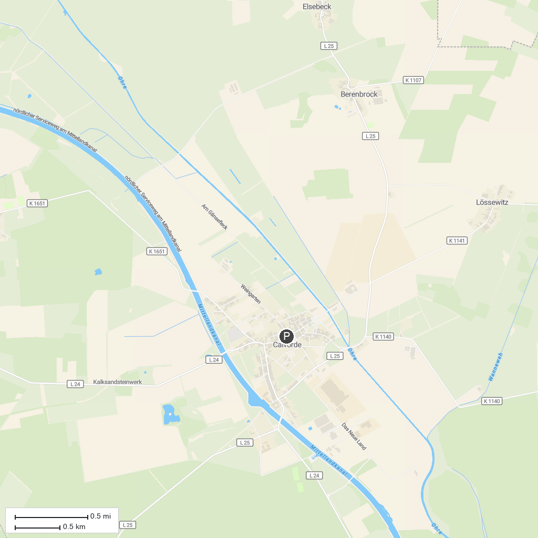
MAP KEY
1. Schloss Kunrau | 4. Zonengrenzmuseum
2. Technisches Denkmal Ziegelei Hundisburg | 5. Drömling
3. Kreis- und Universitätsmuseum Helmstedt | 6. Der Canyon
P. Cruise port / terminal
Map © MapTiler © OpenStreetMap contributors · cruiseports.org

