Cambridge, Maryland, USA
One of Maryland's oldest colonial towns, Cambridge sits at the confluence of the Choptank River and Chesapeake Bay — where skipjacks once dredged oysters and Harriet Tubman charted freedom through the marshes.
⚓ Docked (Cambridge Harbor / Long Wharf) · 🕒 Typical call: 6-8 hrs · 💵 USD · 🗣️ English · 🦅 Wildlife & History
✍️ MY DAY IN PORT (FILL IN)
Ship / Date
In port | arrive ______ · all aboard ______
Booked excursion
Notes / meeting point
GETTING ASHORE
- Docking: Small-ship lines dock at Cambridge Harbor or Long Wharf on the Choptank River; no large cruise terminal
- Walk to center: Downtown Cambridge is 5-10 min walk from the waterfront piers
- Best For: History lovers, birdwatchers, Chesapeake Bay culture and maritime heritage
- Don't Miss: Harriet Tubman Museum & Education Center and Skipjack Nathan public sails
GETTING AROUND
- 🚕 Taxi: Varies — Elliott's Cab Service is a local option. Rates are metered; contact directly for current fares.
- 📱 Rideshare: ✅ Uber, Lyft
TOP THINGS TO DO
- Harriet Tubman Museum & Education Center — Explore the life of Harriet Tubman, born in Dorchester County and one of the most important figures of the Underground Railroad.
- Blackwater National Wildlife Refuge — One of the East Coast's premier birdwatching destinations — 28,000 acres of tidal marshes and wetlands hosting bald eagles…
- Sail Aboard Skipjack Nathan of Dorchester — Step onto a working traditional oyster-dredging skipjack — Maryland's state boat — for a public sail from Long Wharf.
- Choptank River Lighthouse & Long Wharf Park — A faithful replica of the original screwpile-style lighthouse sits at the end of Long Wharf, offering river views and a small…
- Historic High Street Walking Tour — Cambridge's downtown historic district features 18th- and 19th-century homes in Federal, Queen Anne, and French Second Empire…
BEST WALKS
- Waterfront to Historic Downtown Loop: 1.5 miles · ~45 min · Easy · Flat — Start at Long Wharf Park, stroll past the Choptank River Lighthouse, then walk north on Water…
- Sailwinds Park Waterfront Stroll: 1 mile · ~30 min · Easy · Waterfront path — Head toward Sailwinds Park, Cambridge's visitor gateway with its landmark sail-shaped Dorchester…
WEATHER · DAYLIGHT · MONEY
Month | High °F | Low °F | Rainy days
May | 62 | 47 | 12
Jul | 72 | 57 | 12
Sep | 67 | 53 | 9
Daylight: May 5:52AM–8:09PM · Jul 5:52AM–8:27PM · Sep 6:46AM–7:11PM
Representative sunrise/sunset — 2025, 15th of each month; local civil time including DST (America/New_York). Source: Astral; not a forecast or climate average.
cruiseports.org/cambridge-md · Confirm terminal & all-aboard time with your ship

Cambridge, Maryland, USA — Port Map
Red = walkable sights · Amber = excursions farther out · P = cruise terminal
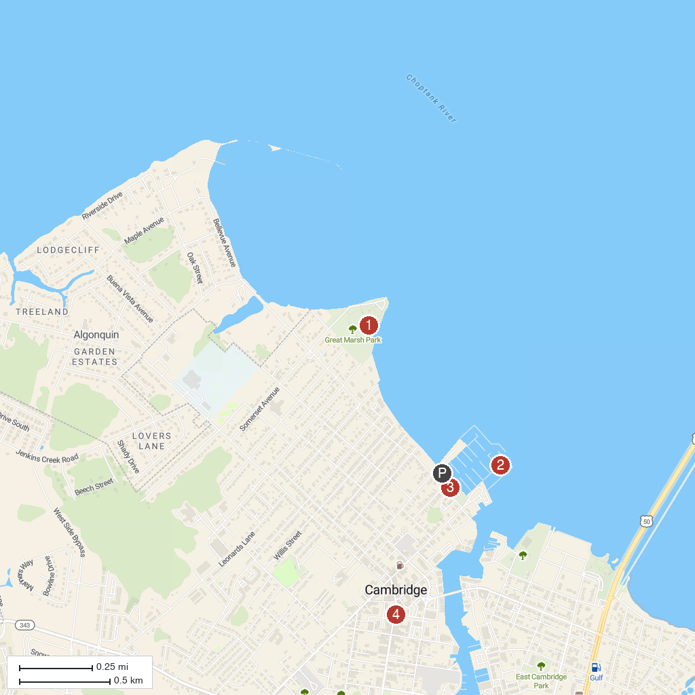
MAP KEY
1. Gerry Boyle Park at Great Marsh | 4. Harriet Tubman Museum and Educational Center
2. Choptank River Lighthouse | 5. Site of Harriet Tubman Childhood Home
3. Long Wharf Park
P. Cruise port / terminal
Map © MapTiler © OpenStreetMap contributors · cruiseports.org

