Campeche, Campeche, Mexico
Mexico's only fully walled city is a living museum — pastel-painted mansions, pirate-proof bastions, and Mayan treasures all within easy walking distance of the waterfront.
⚓ Tender / small pier (no large cruise terminal) · 🕒 Typical call: 6-8 hrs · 💵 Mexican Peso (MXN); USD widely accepted · 🗣️ Spanish; limited English in tourist areas · 🏛️ UNESCO World Heritage Site
✍️ MY DAY IN PORT (FILL IN)
Ship / Date
In port | arrive ______ · all aboard ______
Booked excursion
Notes / meeting point
GETTING ASHORE
- Docking: Small pier or tender; no deep-water cruise terminal. Mostly boutique and expedition ships call here.
- Walk to Center: ~10-15 min walk or short taxi ride from the waterfront to the historic walled city.
- Best For: Colonial history, UNESCO architecture, pirate fortifications, Mayan archaeology.
- Don't Miss: Strolling the Baluartes (bastions), Calle 59, and the panoramic views from Fuerte de San Miguel.
GETTING AROUND
- 🚕 Taxi: MXN $75–150 (~$4–8 USD) — Metered or zone-based taxis available outside the port to the historic city center (~4 min). Agree on the fare before bo
- 📱 Rideshare: ✅ Uber, DiDi
TOP THINGS TO DO
- UNESCO Walled City Walking Tour — Walk the circuit of 17th-century bastions (Baluartes) built to repel pirates, pass through the Puerta de Mar and Puerta de Tierra…
- Edzná Mayan Ruins — About 55 km from the city, Edzná is one of the Yucatán Peninsula's most impressive — and least crowded — Mayan sites.
- Fuerte de San Miguel & Archaeological Museum — This hilltop 18th-century fort southwest of the city houses the Museo Arqueológico de Campeche, displaying extraordinary Mayan…
- Malecón Stroll & Calle 59 — Walk the breezy Gulf waterfront promenade past sculptures and monuments, then head into the walled city via Calle 59 — the iconic…
- Los Petenes Biosphere Reserve Boat Tour — North of the city, the Los Petenes reserve protects one of Mexico's most unusual ecosystems — freshwater springs (petenes)…
BEST WALKS
- Baluartes Circuit Walk: 2 km loop | ~45 min | Easy, flat — Walk the full circuit of Campeche's 17th-century defensive bastions that ring the historic center.
- Calle 59 to the Malecón: 1.5 km one-way | ~20 min | Very easy — Enter the walled city through the inland Puerta de Tierra (Land Gate), walk the length of Calle 59…
WEATHER · DAYLIGHT · MONEY
Month | High °F | Low °F | Rainy days
May | 96 | 77 | 9
Jul | 94 | 77 | 16
Sep | 90 | 76 | 21
Daylight: May 5:26AM–6:30PM · Jul 5:31AM–6:44PM · Sep 5:49AM–6:04PM
cruiseports.org/campeche · Confirm terminal & all-aboard time with your ship

Campeche, Campeche, Mexico — Port Map
Red = walkable sights · Amber = excursions farther out · P = cruise terminal
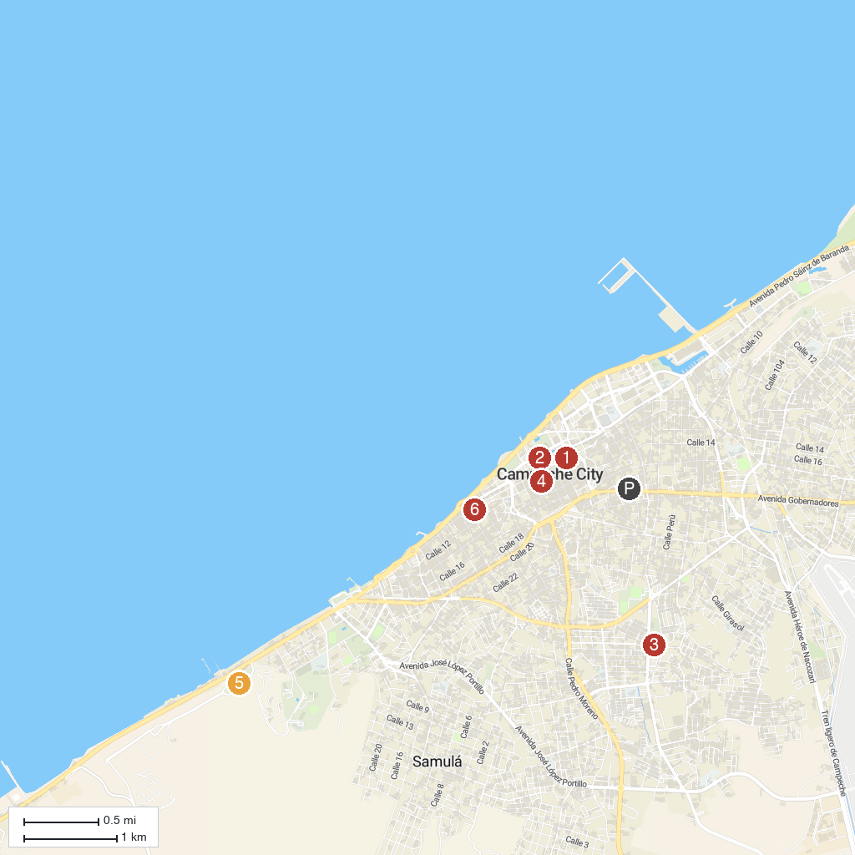
MAP KEY
1. Mansión Carvajal | 5. Campeche Archaeological Museum, Fort San Miguel
2. Baluarte de la Soledad | 6. Playa Bonita
3. Ximbal Parque Recreativo | 7. Iglesia San Román / Santuario del Santo Cristo
4. Iglesia de San Roque y San Francisquito
P. Cruise port / terminal
Map © MapTiler © OpenStreetMap contributors · cruiseports.org

