Çanakkale, Marmara, Turkey
Two of history's most dramatic stories — the Trojan War and WWI's Gallipoli campaign — converge at this Dardanelles port. Step ashore into 3,000 years of myth and memory.
⚓ Docked (Kepez port or city pier) · 🕒 Typical call: 8-10 hrs · 💵 Turkish Lira (TRY) · 🗣️ Turkish (English in tourist areas)
✍️ MY DAY IN PORT (FILL IN)
Ship / Date
In port | arrive ______ · all aboard ______
Booked excursion
Notes / meeting point
GETTING ASHORE
- Docking: Kepez Cruise Port (4 km south of center) or city-center pier; shuttle bus from Kepez
- Walk to Center: 5 min from city pier; 10-min shuttle from Kepez to Kordon promenade
- Best For: Ancient history, WWI memorials, archaeology, cultural day trips
- Don't Miss: Ancient city of Troy (UNESCO) + Troy Museum — allow 3-4 hrs combined
GETTING AROUND
- 🚕 Taxi: ~₺60–100 (about US$1–2) — Taxis queue at the port exit. The ride to central Çanakkale takes about 10 minutes; confirm the fare or use the meter be
- 📱 Rideshare: ✅ Uber
TOP THINGS TO DO
- Ancient Troy & Troy Museum — Walk the 9-layer archaeological site at Hisarlık — UNESCO World Heritage — and visit the state-of-the-art Troy Museum next door.
- Gallipoli Battlefields & Memorials — Cross the Dardanelles by ferry to the Gallipoli Peninsula and walk ANZAC Cove, Lone Pine Australian Memorial, Chunuk Bair New…
- Troy + Gallipoli Full-Day Combo — The classic Çanakkale shore day: morning at Troy, afternoon on the Gallipoli Peninsula, with a ferry crossing of the Dardanelles…
- Çanakkale Waterfront & Naval Museum — Stay local and explore the Kordon promenade, snap photos with the movie Trojan Horse prop, visit Çimenlik Castle and the adjacent…
- Dardanelles Strait Cruise — Short scenic boat tours depart from the Kordon and navigate the narrow strait, offering views of the Çanakkale Martyrs' Memorial…
BEST WALKS
- Kordon Waterfront Promenade: 1.5 km · flat · 20-30 min — Walk the Dardanelles-facing promenade from the city pier north to the ferry docks.
- Old Town & Çimenlik Castle Loop: 2.5 km · easy · 45-60 min — From the Kordon, walk south to 15th-century Çimenlik Castle and its outdoor Naval Museum, then…
WEATHER · DAYLIGHT · MONEY
Month | High °F | Low °F | Rainy days
May | 75 | 58 | 8
Jul | 89 | 70 | 2
Sep | 81 | 65 | 4
Daylight: May 5:58AM–8:23PM · Jul 5:58AM–8:42PM · Sep 6:55AM–7:22PM
cruiseports.org/canakkale · Confirm terminal & all-aboard time with your ship

Çanakkale, Marmara, Turkey — Port Map
Red = walkable sights · Amber = excursions farther out · P = cruise terminal
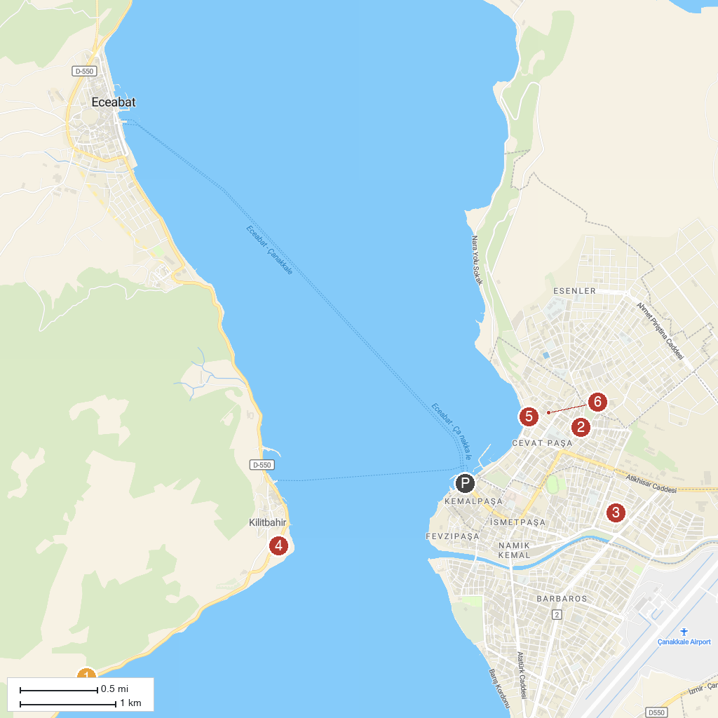
MAP KEY
1. Lone Pine Monument | 5. Mecidiye Cami
2. Havuzlar Şehitliği ve Anıtı | 6. Namazgah Bastion
3. Respect to Mehmetçik Monument | 7. Necip Paşa Cami
4. Rotary Parkı | 8. Çanakkale Seramik Müzesi
P. Cruise port / terminal
Map © MapTiler © OpenStreetMap contributors · cruiseports.org

