Canda, Veneto, Italy
A sleepy Polesine village where the Tartaro becomes the Canalbianco — river cruise ships dock overnight, and centuries of Venetian noble life linger in the villas along the bank.
⚓ River dock (moored overnight) · 🕒 Typical call: overnight · 💶 Currency: Euro (€) · 🗣️ Language: Italian
✍️ MY DAY IN PORT (FILL IN)
Ship / Date
In port | arrive ______ · all aboard ______
Booked excursion
Notes / meeting point
GETTING ASHORE
- Docking: River mooring on the Tartaro-Canalbianco; ships tie up directly at the bank
- Walk to center: Canda village center is steps from the mooring — flat, easy walk
- Best For: Venetian villa architecture, cycling the Po plain, quiet Veneto countryside
- Don't Miss: Villa Nani Mocenigo and its garden of stone statues
GETTING AROUND
- 🚕 Taxi: €30–€50 to Rovigo (~20 km); confirm in advance — There is no taxi stand in Canda. Arrange a transfer through your cruise line or book an NCC (Noleggio Con Conducente) pr
TOP THINGS TO DO
- Villa Nani Mocenigo & Historic Mansions — The 16th-century Villa Nani Mocenigo (also known as Villa Bertetti) is Canda's star attraction — a sprawling manor with large…
- Day Trip to Rovigo — The provincial capital Rovigo (~20 km east) is well worth a half-day.
- Cycling the Po Plain — The flat Polesine landscape around Canda is perfect cycling country.
- Churches of Canda — Two churches make a short walking loop: the parish Chiesa di San Michele Arcangelo on Piazza Dante Alighieri (consecrated 1486…
- Po Delta Regional Park — About 30-40 km southeast, the Po Delta is one of Italy's most important wetland reserves — a UNESCO candidate ecosystem of…
BEST WALKS
- Canda Village Mansions Walk: ~1 km | 20-30 mins | Easy | Flat riverbank town — From the ship mooring, walk along the Canalbianco towpath into the village center.
WEATHER · DAYLIGHT · MONEY
Month | High °F | Low °F | Rainy days
May | 73 | 56 | 14
Jul | 88 | 69 | 9
Sep | 78 | 61 | 9
Daylight: May 5:45AM–8:36PM · Jul 5:41AM–8:57PM · Sep 6:53AM–7:24PM
cruiseports.org/canda · Confirm terminal & all-aboard time with your ship

Canda, Veneto, Italy — Port Map
Red = walkable sights · Amber = excursions farther out · P = cruise terminal
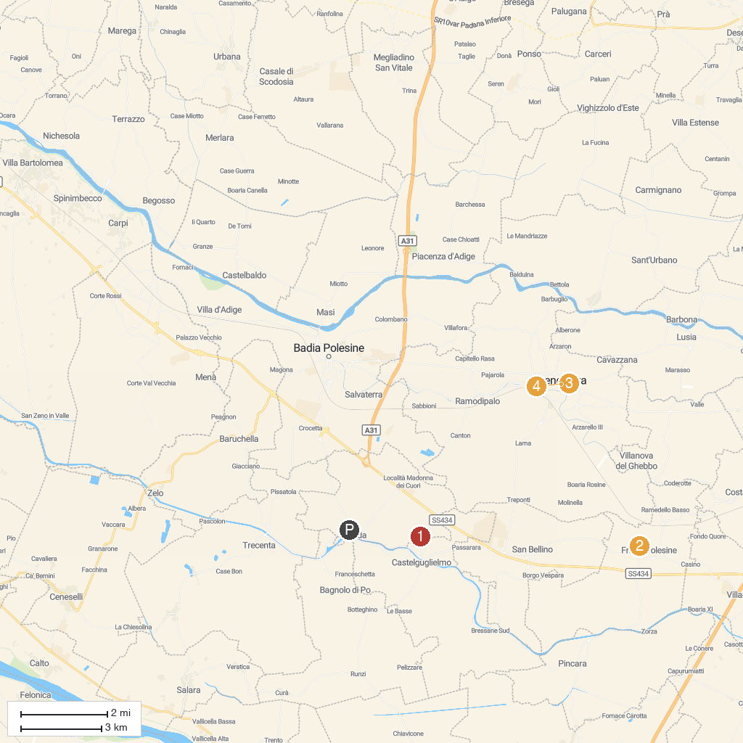
MAP KEY
1. Castelbeach | 4. Santa Maria Assunta
2. Museo Archeologico Nazionale di Fratta Polesine | 5. Duomo di Santa Sofia
3. Basilica Abbaziale e Santuario S. Maria del Pilastrello
P. Cruise port / terminal
Map © MapTiler © OpenStreetMap contributors · cruiseports.org

