Canouan Island, Saint Vincent and the Grenadines
One of the Grenadines' most unspoiled stops — turquoise coves, reef-fringed snorkel spots, and a quick speedboat ride to the world-famous Tobago Cays. Small island, big payoff.
⚓ Tender port · 🕒 Typical call: 6–8 hrs · 💵 EC Dollar / USD accepted · 🗣️ English
✍️ MY DAY IN PORT (FILL IN)
Ship / Date
In port | arrive ______ · all aboard ______
Booked excursion
Notes / meeting point
GETTING ASHORE
- Docking: Tender to Charlestown Jetty — no cruise pier
- Walk to center: Charlestown village is steps from the jetty
- Best For: Beaches, snorkeling, Tobago Cays day trip
- Don't Miss: Speedboat excursion to Tobago Cays Marine Park
GETTING AROUND
- 🚕 Taxi: Negotiated (no meter) — Local taxis meet tenders at Charlestown Jetty on port days. Fares must be negotiated in advance in EC$ or USD — cash onl
- 📱 Rideshare: ❌ not available
TOP THINGS TO DO
- Tobago Cays Marine Park Boat Trip — A 20–30-minute speedboat ride drops you into a protected lagoon where sea turtles graze on sea grass and coral gardens swarm with…
- Grand Bay Beach Day — The long white-sand arc of Grand Bay is a short walk or taxi ride from the jetty.
- Snorkeling Canouan's Reefs — Canouan is ringed by extensive coral reefs — its Atlantic side holds one of the Caribbean's longest barrier reefs.
- Mount Royal Hike — The island's highest point rewards the climb with sweeping views across the Grenadines — Mustique, Mayreau, and Union Island all…
- Golf at the Jim Fazio Championship Course — Canouan's 18-hole course was designed by Jim Fazio and sits above the Caribbean with dramatic sea views on every hole.
BEST WALKS
- Charlestown Village Stroll: 30 min · Flat · Paved — A short loop from the jetty through the village.
- Jetty to Grand Bay Beach: 20–25 min walk · Flat — Head north from the jetty along the road to reach the long sandy arc of Grand Bay.
WEATHER · DAYLIGHT · MONEY
Month | High °F | Low °F | Rainy days
May | 81 | 79 | 9
Jul | 82 | 79 | 20
Sep | 83 | 80 | 18
Daylight: May 5:40AM–6:23PM · Jul 5:47AM–6:35PM · Sep 5:54AM–6:05PM
cruiseports.org/canouan-island · Confirm terminal & all-aboard time with your ship

Canouan Island, Saint Vincent and the Grenadines — Port Map
Red = walkable sights · Amber = excursions farther out · P = cruise terminal
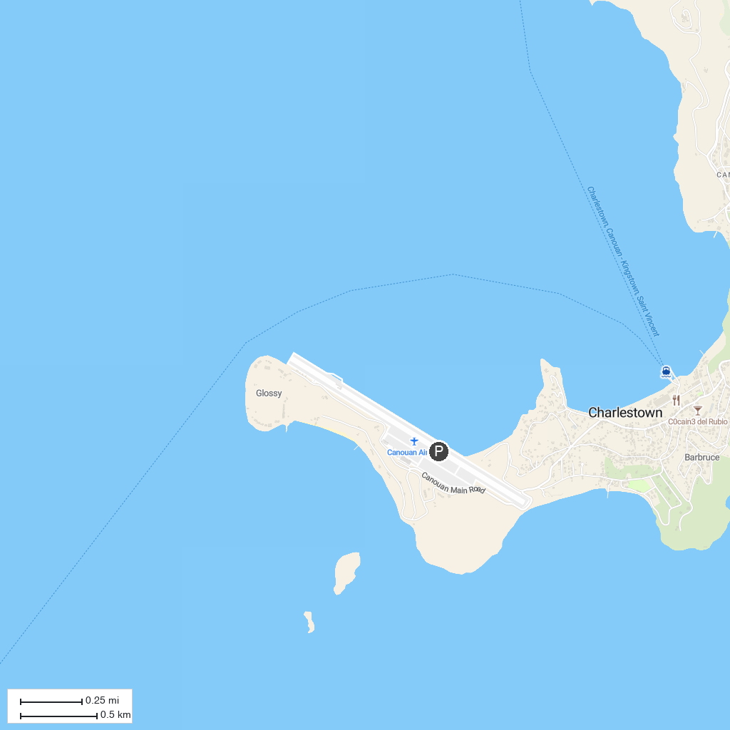
MAP KEY
1. Kiteboarding Cruise - Caribbean | 2. Anse La Roche Bay
P. Cruise port / terminal
Map © MapTiler © OpenStreetMap contributors · cruiseports.org

