Cape Liberty, New Jersey, USA
New York City's home port with front-row views of the Manhattan skyline and Lady Liberty herself. You're 20 minutes from Midtown and steps from the greatest city on earth.
⚓ Docked (pier) · 🕒 Home port (embark/debark) · 💵 USD · 🗣️ English · 🗽 New York City gateway
✍️ MY DAY IN PORT (FILL IN)
Ship / Date
In port | arrive ______ · all aboard ______
Booked excursion
Notes / meeting point
GETTING ASHORE
- Docking: Drive-on pier; no tendering. Ships dock directly at the Cape Liberty terminal on the Peninsula at Bayonne Harbor.
- To Manhattan: Taxi/rideshare to Manhattan: obtain a destination-specific quote and allow for traffic; Light Rail + PATH standard adult fares $5.90, plus transfer to station (checked 3 Oct 2026)
- Best For: NYC sightseeing, Statue of Liberty ferry, Liberty State Park, pre- or post-cruise city time.
- Don't Miss: Liberty State Park views and the ferry to Ellis Island and the Statue of Liberty — reachable in under an hour.
GETTING AROUND
- 🚕 Taxi: Destination-specific quote; confirm included charges — For Cape Liberty to Midtown Manhattan, obtain a quote for your exact destination and travel time; confirm whether tolls,
- 📱 Rideshare: ✅ Uber, Lyft
TOP THINGS TO DO
- Statue of Liberty & Ellis Island — Take a Statue Cruises ferry from Liberty State Park in Jersey City to the Statue of Liberty National Monument and Ellis Island…
- Manhattan Highlights Tour — Times Square, Central Park, 9/11 Memorial, the High Line, Rockefeller Center — countless tour operators run NYC highlights tours…
- 9/11 Memorial & Museum — The National September 11 Memorial & Museum at the World Trade Center site in Lower Manhattan is a powerful, unmissable experience.
- Liberty State Park Walk — A short taxi or rideshare from Cape Liberty, Liberty State Park in Jersey City offers sweeping views of the Manhattan skyline…
- NYC Food Tour — From Brooklyn pizza to Lower East Side delis to Chelsea Market — New York's food scene is world-class.
BEST WALKS
- Liberty State Park Waterfront Walk: ~2 miles | Easy | Free — From the park's main waterfront promenade, enjoy uninterrupted views of the Manhattan skyline…
- Bayonne Harbor Stroll: ~1 mile | Easy | Terminal area — The Peninsula at Bayonne Harbor offers harbor views just outside the terminal.
WEATHER · DAYLIGHT · MONEY
Month | High °F | Low °F | Rainy days
May | 67 | 54 | 14
Jul | 75 | 64 | 10
Sep | 74 | 61 | 11
Daylight: May 5:39AM–8:06PM · Jul 5:38AM–8:25PM · Sep 6:37AM–7:04PM
Representative sunrise/sunset — 2025, 15th of each month; local civil time including DST (America/New_York). Source: Astral; not a forecast or climate average.
ESSENTIAL TRAVEL QUALIFICATIONS
Light Rail + PATH adult rail fares $5.90, terminal–station transfer extra (checked 3 October 2026). Manhattan taxi/rideshare requires destination-specific quote with included tolls/charges; confirm berth on boarding documents.
cruiseports.org/cape-liberty-bayonne · Confirm terminal & all-aboard time with your ship

Cape Liberty, New Jersey, USA — Port Map
Red = walkable sights · Amber = excursions farther out · P = cruise terminal
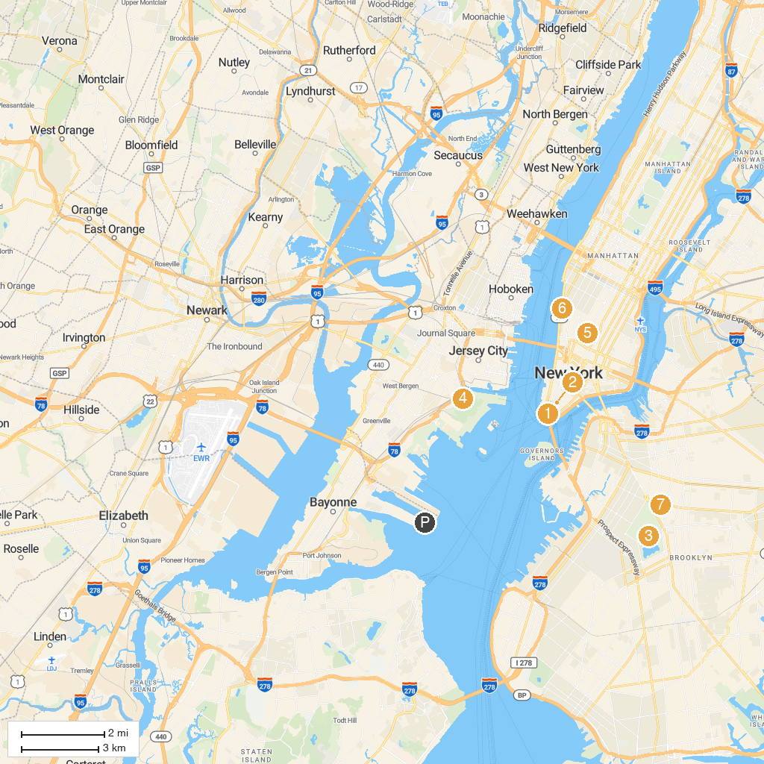
MAP KEY
1. Times Square | 5. Liberty Science Center
2. The Battery | 6. Washington Square Park
3. New York Stock Exchange | 7. Whitney Museum of American Art
4. Prospect Park | 8. Brooklyn Museum
P. Cruise port / terminal
Map © MapTiler © OpenStreetMap contributors · cruiseports.org

