Capri Island, Campania, Italy
A jewel of the Tyrrhenian Sea, Capri delivers dramatic limestone cliffs, luminous sea caves, and a hilltop piazza that feels like the center of the world. Every moment ashore earns its legend.
⚓ Tender port (no cruise pier) · 🕒 Typical call: 6–8 hrs · 💶 Currency: Euro (€) · 🗣️ Language: Italian · ☀️ Best Apr–Oct
✍️ MY DAY IN PORT (FILL IN)
Ship / Date
In port | arrive ______ · all aboard ______
Booked excursion
Notes / meeting point
GETTING ASHORE
- Docking: Tender only — all ships anchor offshore and tender to Marina Grande
- Walk to center: Funicular or bus from Marina Grande to Capri Town (5 min / €2)
- Best For: Iconic scenery, boat tours, Roman ruins, luxury shopping
- Don't Miss: Blue Grotto, Faraglioni rock arch, Gardens of Augustus
GETTING AROUND
- 🚕 Taxi: €17–€25 fixed fare — Capri's iconic convertible taxis run fixed fares — roughly €17 for up to 4 passengers from Marina Grande to Capri town.
- 📱 Rideshare: ❌ not available
TOP THINGS TO DO
- Blue Grotto (Grotta Azzurra) — Row into this sea cave to experience its otherworldly electric-blue glow, caused by sunlight refracting through an underwater…
- Boat Tour Around the Island — Circumnavigate Capri by motorboat to see the Faraglioni sea stacks, the White and Green grottos, and the dramatic cliffs of the…
- Villa Jovis & Roman Ruins — Hike 45 minutes from the Piazzetta along Via Tiberio to Emperor Tiberius's largest imperial villa (1st century AD).
- Monte Solaro Chairlift, Anacapri — Ride the single-seat chairlift from Anacapri's Piazza Vittoria to the island's highest point (589 m) for 360° views stretching to…
- Capri Town & Gardens of Augustus — Stroll the iconic Piazzetta, wander Via Camerelle's boutiques, then slip into the Gardens of Augustus for tiered terraces…
BEST WALKS
- Piazzetta to Villa Jovis: 4 km round trip | ~2 hrs | Moderate (uphill) | Mostly paved — From the Piazzetta, follow Via Longano → Via Sopramonte → Via Tiberio up to the Roman ruins.
- Gardens of Augustus & Via Krupp Viewpoint: 1 km | 30–45 min | Easy | Paved — A short stroll from the Piazzetta through the Giardini di Augusto to the panoramic belvedere…
- Sentiero dei Fortini (Coastal Trail): 5 km one-way | ~2.5 hrs | Moderate | Rocky coastal path — Capri's most scenic hike connects three Napoleonic-era forts (Orrico, Mesola, and Pino) along the…
WEATHER · DAYLIGHT · MONEY
Month | High °F | Low °F | Rainy days
May | 66 | 61 | 8
Jul | 79 | 74 | 2
Sep | 76 | 70 | 8
Daylight: May 5:46AM–8:12PM · Jul 5:45AM–8:32PM · Sep 6:44AM–7:11PM
cruiseports.org/capri-island · Confirm terminal & all-aboard time with your ship

Capri Island, Campania, Italy — Port Map
Red = walkable sights · Amber = excursions farther out · P = cruise terminal
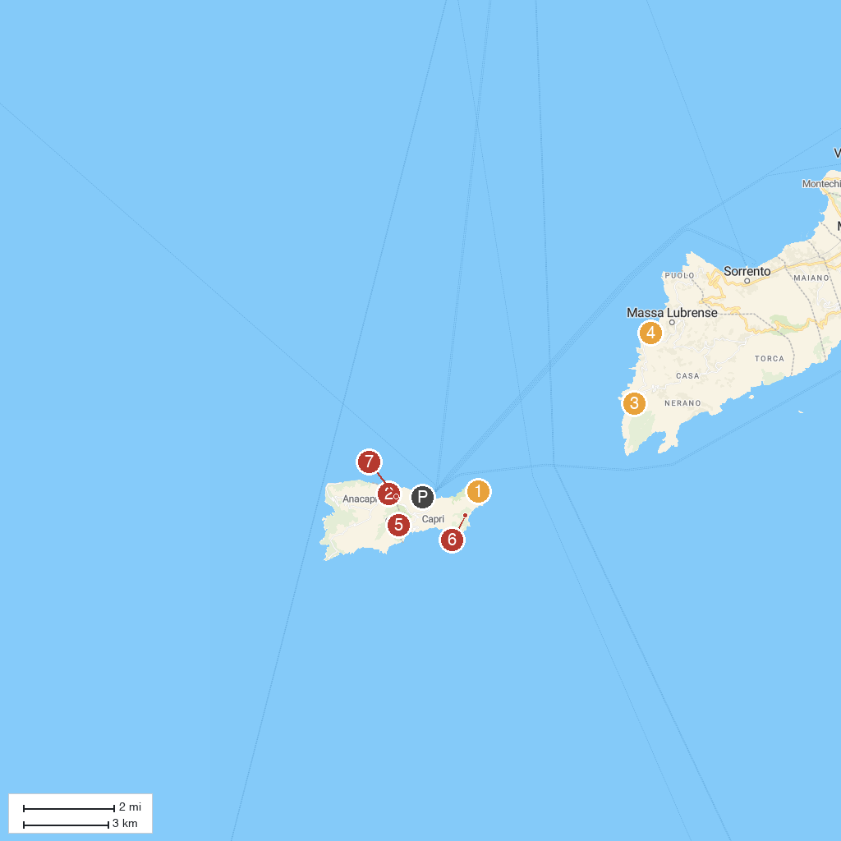
MAP KEY
1. Church of Santi Felice and Baccolo | 5. Marina Lobra
2. Villa Jovis | 6. Hermitage of Santa Maria of Cetrella
3. Villa San Michele | 7. Natural Arch
4. Cala di Mitigliano | 8. Scala Fenicia
P. Cruise port / terminal
Map © MapTiler © OpenStreetMap contributors · cruiseports.org

