Carriacou Island, Grenada
The 'Isle of Reefs' delivers turquoise water, deserted sandbar islands, and a living tradition of wooden boatbuilding — all within 13 square miles of genuine Caribbean.
⚓ Tender port (Hillsborough Bay) · 🕒 Typical call: 6-8 hrs · 💵 Eastern Caribbean Dollar (USD accepted) · 🗣️ English
✍️ MY DAY IN PORT (FILL IN)
Ship / Date
In port | arrive ______ · all aboard ______
Booked excursion
Notes / meeting point
GETTING ASHORE
- Docking: Tender only — ships anchor in Hillsborough Bay; tenders land at Hillsborough Pier
- Walk to center: Steps from the tender dock into Hillsborough town
- Best For: Snorkeling, island-hopping, beaches, cultural heritage
- Don't Miss: Sandy Island day trip and the Windward boatbuilding village
GETTING AROUND
- 🚕 Taxi: EC$35 (~US$13) to Tyrell Bay; EC$200 (~US$74) for 2–3 hr island tour — Regulated taxis wait at the Hillsborough pier and tourist office. Fares for common routes are posted — drivers are gener
- 📱 Rideshare: ❌ not available
TOP THINGS TO DO
- Sandy Island Day Trip — A short water-taxi hop delivers you to this powder-white sandbar surrounded by shallow turquoise water.
- Snorkeling & Island-Hopping Boat Tour — Half-day tours combine Sandy Island, White Island, and Saline Island — the latter known for turtle sightings and a dramatic reef.
- Windward Boatbuilding Village — In the village of Windward on the island's northeast coast, master craftsmen build wooden sailing vessels using techniques…
- Paradise Beach — Carriacou's signature beach is a calm, palm-lined stretch on the western coast with views of Sandy Island.
- Carriacou Museum & Hillsborough Walk — The small Carriacou Museum on Paterson Street chronicles the island's African, European, and indigenous Arawak heritage…
BEST WALKS
- Hillsborough Town Stroll: 45 min · Flat · Easy — From the pier, walk along the waterfront past local shops, the market, and the post office.
- Hillsborough to Paradise Beach: 20 min each way · Mostly flat · Easy — Follow the main road south from the pier along the coast to Paradise Beach.
WEATHER · DAYLIGHT · MONEY
Month | High °F | Low °F | Rainy days
May | 87 | 77 | 9
Jul | 87 | 77 | 16
Sep | 89 | 78 | 14
Daylight: May 6:21AM–8:41PM · Jul 6:21AM–8:59PM · Sep 7:16AM–7:42PM
cruiseports.org/carriacou-island · Confirm terminal & all-aboard time with your ship

Carriacou Island, Grenada — Port Map
Red = walkable sights · Amber = excursions farther out · P = cruise terminal
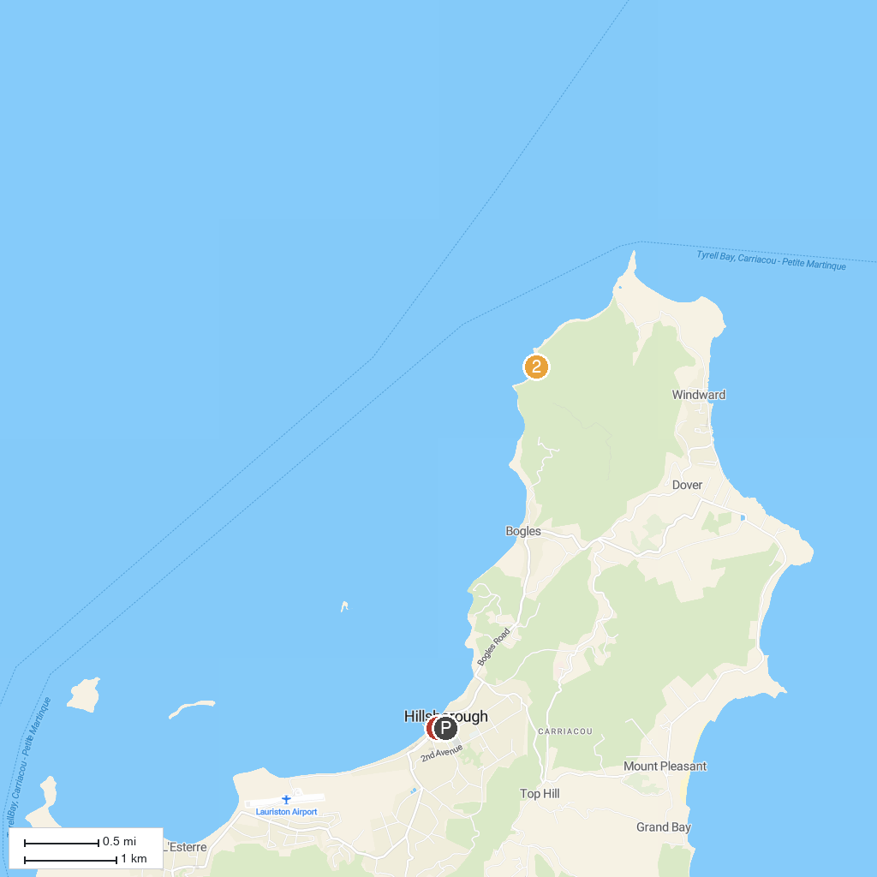
MAP KEY
1. Carriacou Museum | 2. Anse La Roche Bay
P. Cruise port / terminal
Map © MapTiler © OpenStreetMap contributors · cruiseports.org

