Cartagena, Bolívar, Colombia
Cartagena's UNESCO-listed walled city packs centuries of Spanish colonial history into pastel-painted streets, while Castillo San Felipe stands sentinel over a harbour that once sheltered a fortune in New World gold.
⚓ Docked (cruise terminal) · 🕒 Typical call: 8-10 hrs · 💵 Colombian Peso (USD widely accepted) · 🗣️ Spanish
✍️ MY DAY IN PORT (FILL IN)
Ship / Date
In port | arrive ______ · all aboard ______
Booked excursion
Notes / meeting point
GETTING ASHORE
- Docking: Cartagena de Indias Cruise Terminal, Manga — 4 km from Old City
- Walk to center: Not walkable — taxi or minibus ~15-20 min to Walled City
- Best For: Colonial history, colorful streets, beach escapes, street food
- Don't Miss: Castillo San Felipe de Barajas and sunset on the city walls
GETTING AROUND
- 🚕 Taxi: $8–10 USD (per taxi, not per person) — Official taxis wait at the cruise terminal stand with posted rates (~32,700 COP) to the Old Town. Agree on price before
- 📱 Rideshare: ✅ Uber, DiDi, InDriver
- 🚌 Hop-on hop-off: ✅ City Sightseeing Cartagena
TOP THINGS TO DO
- Castillo San Felipe de Barajas — One of the largest Spanish fortifications in the New World, this 17th-century hilltop fortress features an impressive network of…
- Walled City Walking Tour — Wander the cobbled lanes of Ciudad Amurallada past Plaza Santo Domingo, the Torre del Reloj, and the colourful Getsemaní…
- Rosario Islands Catamaran — A 45-minute speedboat or catamaran ride delivers you to the Islas del Rosario, an archipelago of white-sand beaches and…
- El Totumo Mud Volcano — Soak in a natural mud volcano about 50 km northeast of Cartagena.
- Street Food and Market Tour — Sample arepas de huevo, fresh tropical fruit, Colombian coffee, and Caribbean ceviche through the markets and side streets of the…
BEST WALKS
- Walled City Loop: 2-3 km · Easy · 1-2 hrs — Enter through the Torre del Reloj gate and walk clockwise along the inner streets to Plaza Santo…
- Getsemaní Street Art Walk: 1 km · Easy · 45 min — Cross through the Puerta del Reloj into the Getsemaní neighbourhood and follow the mural-lined…
- The Walled City Circuit: 2.5 km · 60-75 min · Easy — Enter at the Clock Tower (Puerta del Reloj), cross Plaza de los Coches, and wind through to Plaza…
WEATHER · DAYLIGHT · MONEY
Month | High °F | Low °F | Rainy days
May | 87 | 78 | 23
Jul | 87 | 78 | 21
Sep | 86 | 78 | 24
Daylight: May 5:40AM–6:16PM · Jul 5:48AM–6:27PM · Sep 5:51AM–6:02PM
cruiseports.org/cartagena-colombia · Confirm terminal & all-aboard time with your ship

Cartagena, Bolívar, Colombia — Port Map
Red = walkable sights · Amber = excursions farther out · P = cruise terminal
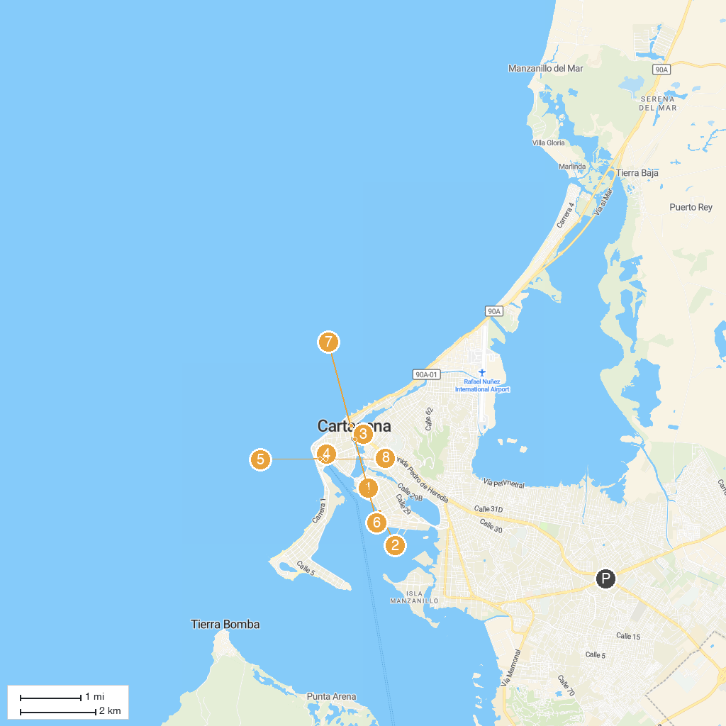
MAP KEY
1. Casa Román | 5. Plaza de Santa Teresa
2. Bendita Beach | 6. Monumento India Catalina
3. Espíritu Del Manglar Park | 7. Walls of Cartagena
4. Emerald Museum. Joyeria CARIBE | 8. Santuario de San Pedro Claver
P. Cruise port / terminal
Map © MapTiler © OpenStreetMap contributors · cruiseports.org

