Cartagena, Murcia, Spain
Three millennia of Mediterranean ambition packed into one walkable harbor city — Roman ruins, Moorish battlements, and a modernist main street all within a short stroll of the cruise pier.
⚓ Docked (Alfonso XII Terminal) · 🕒 Typical call: 7-9 hrs · 💶 Euro (EUR) · 🗣️ Spanish
✍️ MY DAY IN PORT (FILL IN)
Ship / Date
In port | arrive ______ · all aboard ______
Booked excursion
Notes / meeting point
GETTING ASHORE
- Docking: Pier docked at Alfonso XII Cruise Terminal — historic center is a 5-min walk
- Walk to center: ~5 min on foot to Plaza del Ayuntamiento and Roman Theatre
- Best For: Roman archaeology, modernist architecture, panoramic views
- Don't Miss: The Roman Theatre — one of Spain's largest and best-preserved, discovered only in 1988
GETTING AROUND
- 🚕 Taxi: €5 base + €1.25/km — Official white taxis queue directly outside the terminal. Metered fares; city-center rides are very short and inexpensiv
- 📱 Rideshare: ✅ Bolt
TOP THINGS TO DO
- Roman Theatre & Museum — Cartagena's crown jewel — a 1st-century BC Roman theatre seating 7,000, only uncovered in 1988.
- Castillo de la Concepción — A 13th-century hilltop fortress reached by a free panoramic elevator.
- Calle Mayor Modernist Walk — Cartagena's pedestrian main street is lined with extravagant Art Nouveau buildings — the Gran Hotel, Aguirre Palace, and Casa…
- Punic & Roman Cartagena — Combine the Punic Wall Interpretation Centre (3rd-century BC Carthaginian defences) and the Foro Romano Molinete museum (Roman…
- ARQUA — National Museum of Underwater Archaeology — Spain's only national museum dedicated to underwater archaeology, showcasing Phoenician, Punic, Roman, and Spanish-colonial…
BEST WALKS
- Old Town Grand Loop: ~2.5 km · 2 hrs · Easy — From the cruise terminal, walk the harbour promenade to Plaza del Ayuntamiento, then visit the…
- Waterfront & Harbour Stroll: ~1 km · 30 min · Easy — A flat, leisurely walk along the harbour promenade from the cruise terminal to ARQUA and the Naval…
WEATHER · DAYLIGHT · MONEY
Month | High °F | Low °F | Rainy days
May | 73 | 57 | 3
Jul | 84 | 69 | 1
Sep | 79 | 64 | 3
Daylight: May 6:54AM–9:06PM · Jul 6:54AM–9:24PM · Sep 7:46AM–8:11PM
Representative sunrise/sunset — 2025, 15th of each month; local civil time including DST (Europe/Madrid). Source: Astral; not a forecast or climate average.
cruiseports.org/cartagena-spain · Confirm terminal & all-aboard time with your ship

Cartagena, Murcia, Spain — Port Map
Red = walkable sights · Amber = excursions farther out · P = cruise terminal
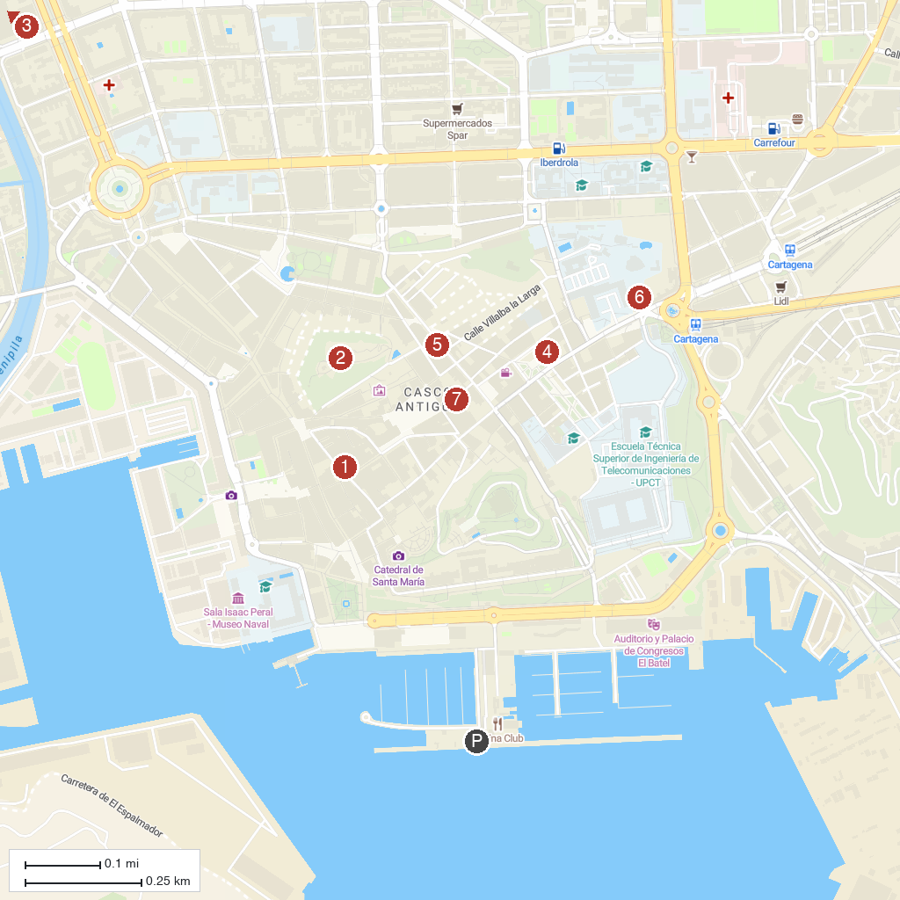
MAP KEY
1. Iglesia de Santa María de Gracia | 5. Basilica of Nuestra Señora de la Caridad
2. Arqueológico Cerro del Molinete Park | 6. The Punic Wall
3. Vallejo Alberola Park | 7. Augusteum
4. MURAM
P. Cruise port / terminal
Map © MapTiler © OpenStreetMap contributors · cruiseports.org

