Cartwright, Labrador, Canada
One of Atlantic Canada's most remote cruise calls, Cartwright opens a door to raw boreal wilderness, Viking-named beaches stretching 56 km, and a small-town warmth that few travellers ever encounter.
⚓ Tender port · 🕒 Typical call: 6-8 hrs · 💵 Canadian Dollar (CAD) · 🗣️ English · 🌿 Wilderness destination
✍️ MY DAY IN PORT (FILL IN)
Ship / Date
In port | arrive ______ · all aboard ______
Booked excursion
Notes / meeting point
GETTING ASHORE
- Docking: Tender to small craft harbour — no cruise pier
- Walk to centre: 5 min from tender dock to town centre
- Best For: Wilderness hiking, Viking history, seabird watching
- Don't Miss: Flagstaff Hill trail and views to the Wonderstrands
GETTING AROUND
- 🚕 Taxi: Varies — confirm on arrival — Limited local taxi service may be available; supply is very small in this remote community. Ask at the pier or check wit
TOP THINGS TO DO
- Flagstaff Hill Trail & Viking Views — A short but rewarding hike to the historic cannons atop Flagstaff Hill, with panoramic views over Sandwich Bay and a distant…
- Experience Labrador History & Culture Tour — A locally-guided tour exploring Cartwright's Inuit, Métis, and settler heritage, including the Mealy Mountain Gallery craft shop…
- Boat Tour to Gannet Islands Ecological Reserve — About 40 km northeast of Cartwright, the Gannet Islands host the largest seabird colony in Labrador — Atlantic puffins, common…
- Kayaking Sandwich Bay — Paddle the sheltered waters of Sandwich Bay surrounded by boreal forest and dramatic Labrador coastline.
- Mealy Mountains National Park Reserve Day Hike — Canada's newest national park reserve (10,700 km²) is accessible from Cartwright by boat or outfitter.
BEST WALKS
- Town & Flagstaff Hill Loop: 2.5 km | ~1 hr | Easy-Moderate — From the tender dock, walk through Cartwright's small centre past the Mealy Mountain Gallery, then…
- Waterfront Stroll: 1 km | 20 min | Easy — A short, flat walk along the Cartwright waterfront for views of the anchored ship, fishing boats…
WEATHER · DAYLIGHT · MONEY
Month | High °F | Low °F | Rainy days
May | 42 | 30 | 14
Jul | 65 | 50 | 14
Sep | 56 | 43 | 14
Daylight: May 4:46AM–8:43PM · Jul 4:37AM–9:09PM · Sep 6:22AM–7:02PM
Representative sunrise/sunset — 2025, 15th of each month; local civil time including DST (America/Goose_Bay). Source: Astral; not a forecast or climate average.
cruiseports.org/cartwright-nl · Confirm terminal & all-aboard time with your ship

Cartwright, Labrador, Canada — Port Map
Red = walkable sights · Amber = excursions farther out · P = cruise terminal
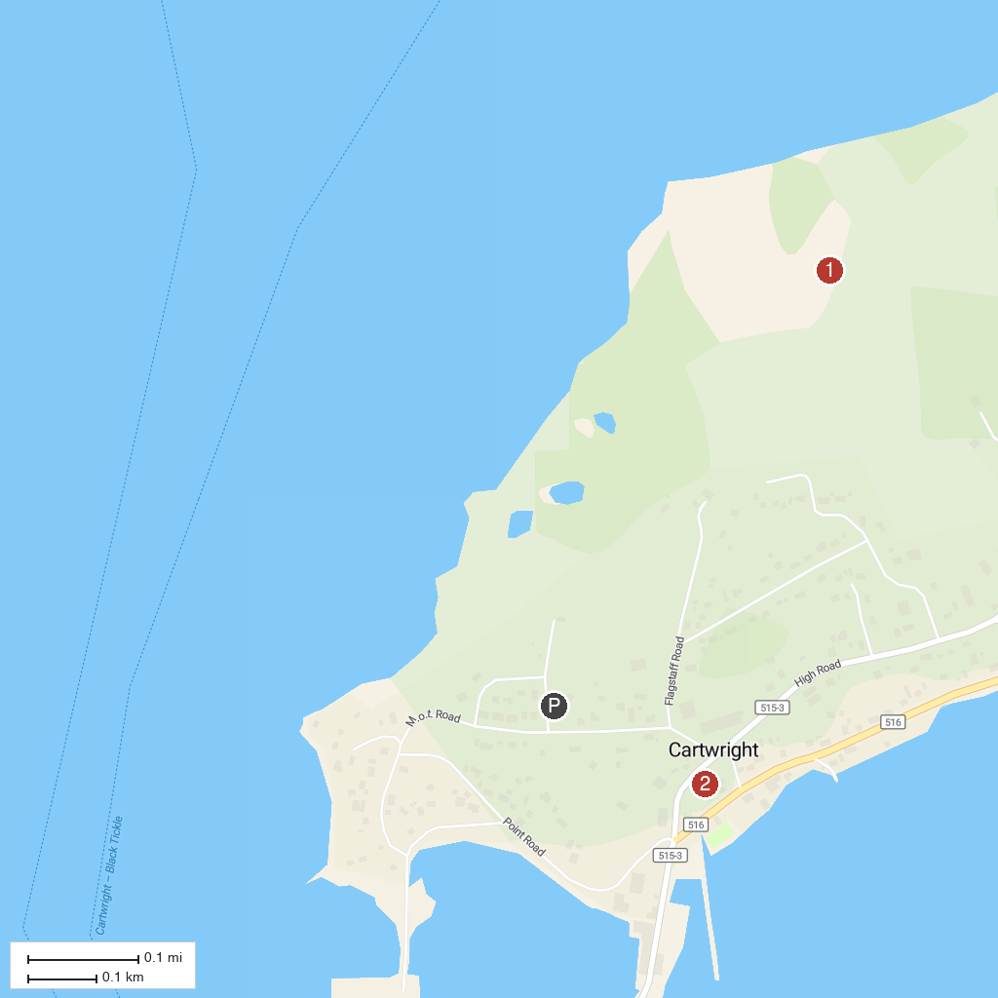
MAP KEY
1. Flagstaff Hill | 3. Fishing Point Municipal Park
2. Wonderstrands (Porcupine Strand)
P. Cruise port / terminal
Map © MapTiler © OpenStreetMap contributors · cruiseports.org

