Cascais, Lisbon Region, Portugal
The jewel of the Portuguese Riviera, Cascais blends royal palaces, Atlantic sea cliffs, and pastel-tiled streets — all steps from the marina. Day-trip to Sintra or Lisbon, or simply stroll to Hell's Mouth.
⚓ Tender or marina berth · 🕒 Typical call: 8-10 hrs · 💵 Euro (€) · 🗣️ Portuguese
✍️ MY DAY IN PORT (FILL IN)
Ship / Date
In port | arrive ______ · all aboard ______
Booked excursion
Notes / meeting point
GETTING ASHORE
- Docking: Larger ships anchor in Cascais Bay and tender; smaller vessels berth at Cascais Marina. Town center is a 5–10 min walk from the marina
- Walk to center: 5 min to Largo Luís de Camões; 20 min to Boca do Inferno
- Best For: Beach days, Sintra day trips, seafood, scenic coastal walks
- Don't Miss: Boca do Inferno sea arch, Museu Condes de Castro Guimarães, Praia da Rainha
GETTING AROUND
- 🚕 Taxi: €5–10 — Taxis queue near the port. The short distance to town keeps fares low; a luggage surcharge of ~€1.60 may apply if bags g
- 📱 Rideshare: ✅ Uber, Bolt
- 🚌 Hop-on hop-off: ✅
TOP THINGS TO DO
- Sintra UNESCO Day Trip — A 30–40 min bus or taxi ride brings you to Sintra's fairy-tale hilltop palaces.
- Boca do Inferno Walk — A 20-minute clifftop walk west of the marina leads to Hell's Mouth, a dramatic sea arch eroded from the Atlantic-facing limestone.
- Cascais Citadel & Museums — The 17th-century Citadel of Cascais served as a royal summer residence and now houses a boutique art hotel and exhibition spaces.
- Bike to Guincho Beach — Rent an e-bike or standard bicycle in town and follow the 10 km coastal cycle path through Sintra-Cascais Natural Park to Praia…
- Lisbon by Train — Hop the Linha de Cascais from Cascais station to Cais do Sodré in central Lisbon (40 min, ~€2.30).
BEST WALKS
- Marina to Boca do Inferno: 4 km round trip · Easy · ~1 hr — From the marina gate, follow the coastal road (Avenida Rei Humberto II de Itália) west past Santa…
- Cascais to Estoril Promenade: 3 km one way · Easy · ~45 min — A flat, paved seafront promenade runs east from Cascais past beaches and gardens to Estoril.
- Old Town Stroll: 1–2 km · Easy · ~1 hr — Wander from the marina into Largo Luís de Camões, the main square, then thread through pedestrian…
WEATHER · DAYLIGHT · MONEY
Month | High °F | Low °F | Rainy days
May | 67 | 59 | 6
Jul | 73 | 64 | 2
Sep | 73 | 64 | 5
Daylight: May 6:25AM–8:42PM · Jul 6:25AM–9:01PM · Sep 7:19AM–7:45PM
cruiseports.org/cascais · Confirm terminal & all-aboard time with your ship

Cascais, Lisbon Region, Portugal — Port Map
Red = walkable sights · Amber = excursions farther out · P = cruise terminal
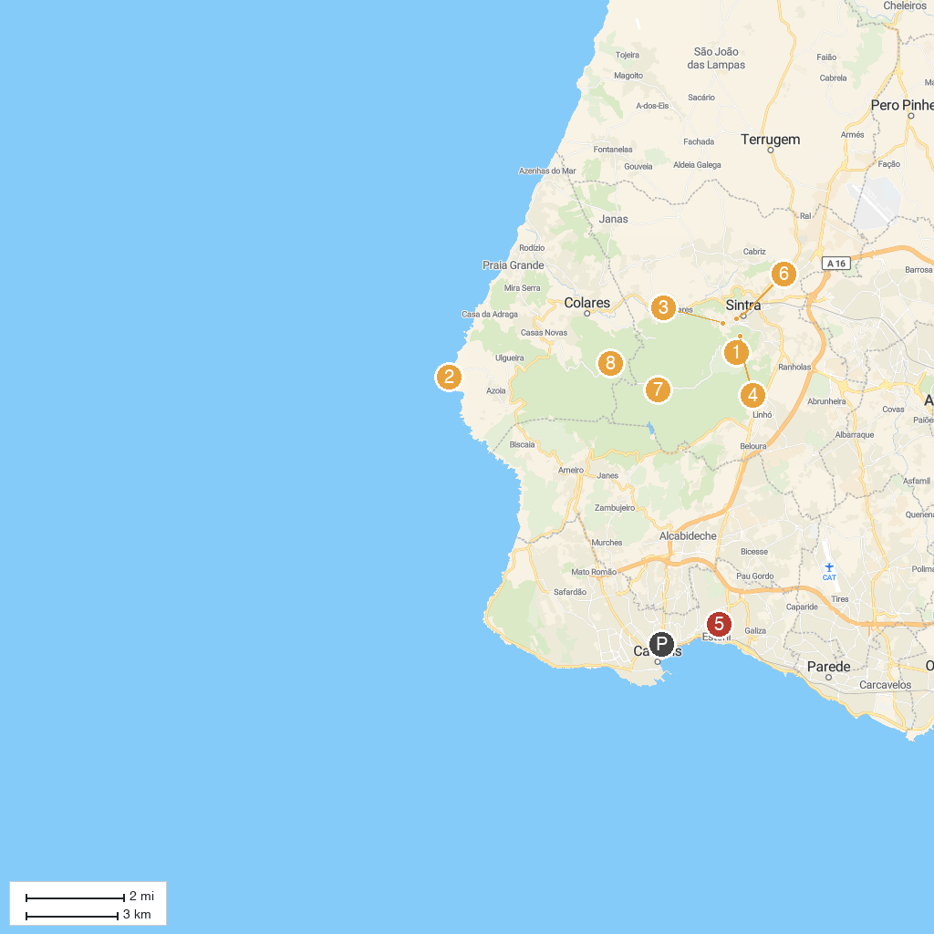
MAP KEY
1. National Palace of Pena | 5. Casino Estoril
2. Cape Roca | 6. National Palace of Sintra
3. Quinta da Regaleira | 7. Parque Natural de Sintra-Cascais
4. The Moorish Castle | 8. Capuchos Convent
P. Cruise port / terminal
Map © MapTiler © OpenStreetMap contributors · cruiseports.org

