Casilda, Sancti Spíritus, Cuba
A humble fishing harbor 5 km from one of Cuba's most beautiful colonial cities, Casilda opens the door to Trinidad's cobblestone plazas, the Valle de los Ingenios, and the white-sand stretch of Playa Ancón.
⚓ Tender port · 🕒 Typical call: 7-9 hrs · 💵 Cuban Peso (CUP) / USD accepted at tourist sites · 🗣️ Spanish · 🏖️ Beach & colonial history
✍️ MY DAY IN PORT (FILL IN)
Ship / Date
In port | arrive ______ · all aboard ______
Booked excursion
Notes / meeting point
GETTING ASHORE
- Docking: Tender — ships anchor in Casilda Bay; boats run to the small pier
- Walk to Trinidad: ~5 km by road; taxis and shared cabs meet tenders
- Best For: Colonial architecture, Caribbean beaches, catamaran day sails
- Don't Miss: Plaza Mayor in Trinidad & Manaca Iznaga Tower in the Valley of Sugar Mills
GETTING AROUND
- 🚕 Taxi: $6–8 USD — State or private taxis wait at the port and make the short 5 km run into Trinidad town center in about 6 minutes. Negoti
- 📱 Rideshare: ❌ not available
TOP THINGS TO DO
- Trinidad Colonial Walking Tour — Wander the cobblestone streets of UNESCO-listed Trinidad, pausing at Plaza Mayor, the Iglesia Parroquial de la Santísima…
- Valle de los Ingenios & Manaca Iznaga Tower — The Valley of the Sugar Mills — a second UNESCO site — spreads east of Trinidad.
- Playa Ancón Beach Day — One of Cuba's finest Caribbean beaches lies just minutes from the tender dock.
- Catamaran Sail & Snorkel — Depart from Marina Puerto de Casilda on a catamaran cruise along the Ancón Peninsula.
- Topes de Collantes Waterfall Hike — A truck or jeep takes you into the Sierra del Escambray mountains to Parque el Cubano, where a forest trail leads to the Caburní…
BEST WALKS
- Trinidad Historic Center Loop: 2-3 hrs · Flat cobblestones · Hire a taxi to the start — From Plaza Mayor, walk east to the Convento de San Francisco (bell tower museum), then loop through…
- Casilda Waterfront Stroll: 30 min · Flat · Starts at the tender dock — A short, casual walk along Casilda's harbor front past fishing boats and the small Marina Puerto de…
WEATHER · DAYLIGHT · MONEY
Month | High °F | Low °F | Rainy days
May | 87 | 74 | 18
Jul | 90 | 77 | 14
Sep | 88 | 77 | 17
Daylight: May 6:41AM–7:51PM · Jul 6:46AM–8:05PM · Sep 7:07AM–7:22PM
Representative sunrise/sunset — 2025, 15th of each month; local civil time including DST (America/Havana). Source: Astral; not a forecast or climate average.
cruiseports.org/casilda · Confirm terminal & all-aboard time with your ship

Casilda, Sancti Spíritus, Cuba — Port Map
Red = walkable sights · Amber = excursions farther out · P = cruise terminal
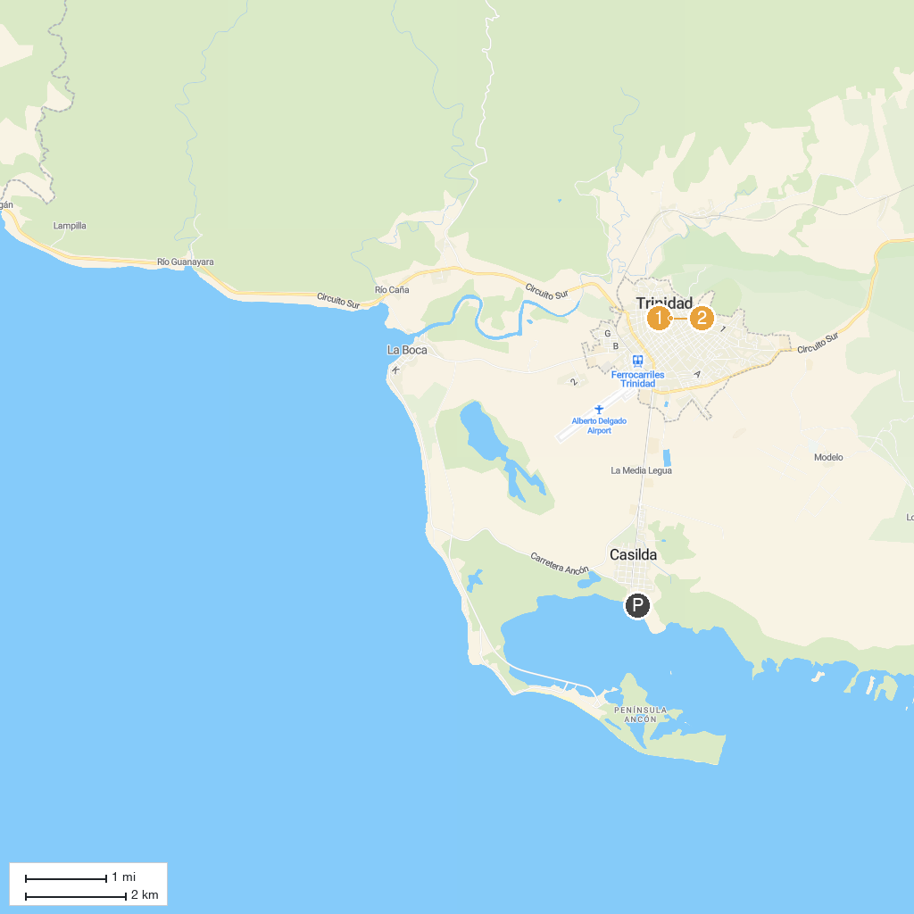
MAP KEY
1. Museo de Historia Municipal | 2. Casa de la Trova
P. Cruise port / terminal
Map © MapTiler © OpenStreetMap contributors · cruiseports.org

