Castellammare di Stabia, Campania, Italy
Perched at the foot of Mount Faito on the Gulf of Naples, Castellammare di Stabia hides Roman villas buried by Vesuvius, mineral springs prized since antiquity, and a waterfront that launches ferries straight to Capri and the Amalfi Coast.
⚓ Docked (Stabia Main Port) · 🕒 Typical call: 8-10 hrs · 💶 Euro (€) · 🗣️ Italian
✍️ MY DAY IN PORT (FILL IN)
Ship / Date
In port | arrive ______ · all aboard ______
Booked excursion
Notes / meeting point
GETTING ASHORE
- Docking: Docked at Stabia Main Port; pier is a short walk or taxi ride from the town center
- Walk to Center: ~15 min walk to Lungomare and Piazza Fontana Grande
- Best For: Roman archaeology, thermal baths, day trips to Pompeii, Capri ferry
- Don't Miss: Free Roman villas at Scavi di Stabia — Villa Arianna and Villa San Marco
GETTING AROUND
- 🚕 Taxi: €7–€12 — Taxis available at stands near Piazza Municipio, the Circumvesuviana station, and seasonally at Porto di Stabia ferry pi
- 📱 Rideshare: ❌ not available
TOP THINGS TO DO
- Scavi di Stabia — Free Roman Villas — Villa Arianna and Villa San Marco are lavishly frescoed Roman resort villas buried by Vesuvius in 79 AD.
- Mount Faito by Cable Car — The funivia (cable car) climbs from the town center to the forested summit of Monte Faito at 1,100 m, rewarding you with sweeping…
- Pompeii Day Trip — Castellammare di Stabia is one stop from Pompeii on the Circumvesuviana train — a 15-minute ride puts you at the UNESCO World…
- Terme Stabiane Thermal Baths — Castellammare's mineral springs have been bottled since Roman times.
- Capri Ferry Day Trip — Fast ferries to Capri depart year-round from the port, making it one of the closer embarkation points for the island.
BEST WALKS
- Lungomare & Historic Center Stroll: 2 km · 45 min · Easy · Flat — Walk north from the port along the Lungomare waterfront to Villa Comunale (public gardens with the…
- Cable Car to Monte Faito Summit: Funivia ride · 2-3 hrs round trip · Easy (cable car) · Best Apr–Oct — From the funivia station near Piazza Vittorio Veneto, the cable car lifts you to Monte Faito's…
WEATHER · DAYLIGHT · MONEY
Month | High °F | Low °F | Rainy days
May | 70 | 59 | 11
Jul | 84 | 72 | 4
Sep | 79 | 68 | 8
Daylight: May 5:45AM–8:12PM · Jul 5:44AM–8:31PM · Sep 6:43AM–7:10PM
cruiseports.org/castellammare-di-stabia · Confirm terminal & all-aboard time with your ship

Castellammare di Stabia, Campania, Italy — Port Map
Red = walkable sights · Amber = excursions farther out · P = cruise terminal
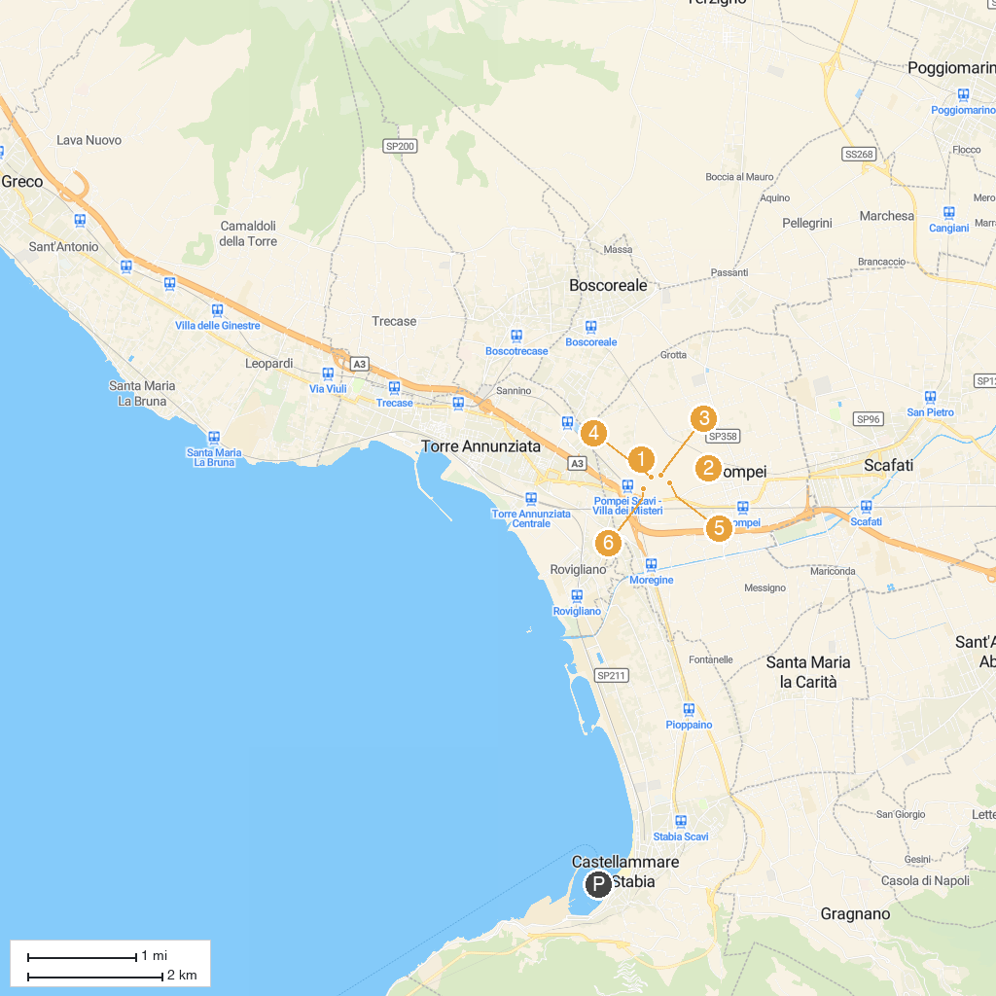
MAP KEY
1. House of Meleager | 5. Macellum
2. Amphitheatre of Pompeii | 6. Temple of Isis
3. The brothel of Pompeii | 7. Temple of Venus in Pompeii
4. Castello del Parco Fienga
P. Cruise port / terminal
Map © MapTiler © OpenStreetMap contributors · cruiseports.org

