Cayenne, French Guiana, France
France's slice of the Amazon: a sun-baked colonial capital where Creole spice markets share space with the European Space Agency's rocket pads, and the infamous Devil's Island sits just offshore.
⚓ Docked (Degrad des Cannes pier) · 🕒 Typical call: 8-10 hrs · 💶 Currency: Euro · 🗣️ Language: French · 🌧️ Tropical climate — pack light rain gear
✍️ MY DAY IN PORT (FILL IN)
Ship / Date
In port | arrive ______ · all aboard ______
Booked excursion
Notes / meeting point
GETTING ASHORE
- Docking: Degrad des Cannes commercial port, ~13 km from city center on the Mahury River estuary
- Walk to center: Not walkable from port — taxis or ship shuttles required; ~15-20-min ride to Place des Palmistes
- Best For: History buffs, space enthusiasts, wildlife seekers, and anyone curious about French overseas territories
- Don't Miss: A boat tour to the Salvation Islands (Île Royale ruins) or the Guiana Space Centre in Kourou
GETTING AROUND
- 🚕 Taxi: $65–$80 — Private taxis run from Dégrad des Cannes port to Cayenne city center (~13 min). Agree on the fare before departure as me
- 📱 Rideshare: ❌ not available
TOP THINGS TO DO
- Salvation Islands — Île Royale & Devil's Island — The most iconic excursion from this region.
- Cayenne City & Creole Market Walk — Explore Place des Palmistes — the palm-lined central square — then browse the lively Place du Coq market on Rue du Lieutenant…
- Guiana Space Centre (Centre Spatial Guyanais), Kourou — Tour the European Space Agency's primary launch facility, one of the best spaceports open to visitors worldwide.
- Rorota Trail — Jungle Hike — A 2.5-hour circular hike through dense Amazonian rainforest just 10 km from Cayenne.
- Montjoly Beach — A long, wild Atlantic beach about 10 km east of Cayenne — sandy, uncrowded, and backed by palms.
BEST WALKS
- Place des Palmistes to Fort Cépérou: ~2 km • 1.5 hrs • Easy–moderate — Start at Place des Palmistes, Cayenne's grand central square framed by royal palms.
- Montabo Coastal Trail: ~3 km • 1 hr • Easy — A leafy coastal trail west of Cayenne city, winding through secondary forest along the shoreline.
WEATHER · DAYLIGHT · MONEY
Month | High °F | Low °F | Rainy days
May | 82 | 75 | 30
Jul | 84 | 74 | 28
Sep | 88 | 76 | 14
Daylight: May 6:15AM–6:35PM · Jul 6:24AM–6:46PM · Sep 6:20AM–6:28PM
cruiseports.org/cayenne · Confirm terminal & all-aboard time with your ship

Cayenne, French Guiana, France — Port Map
Red = walkable sights · Amber = excursions farther out · P = cruise terminal
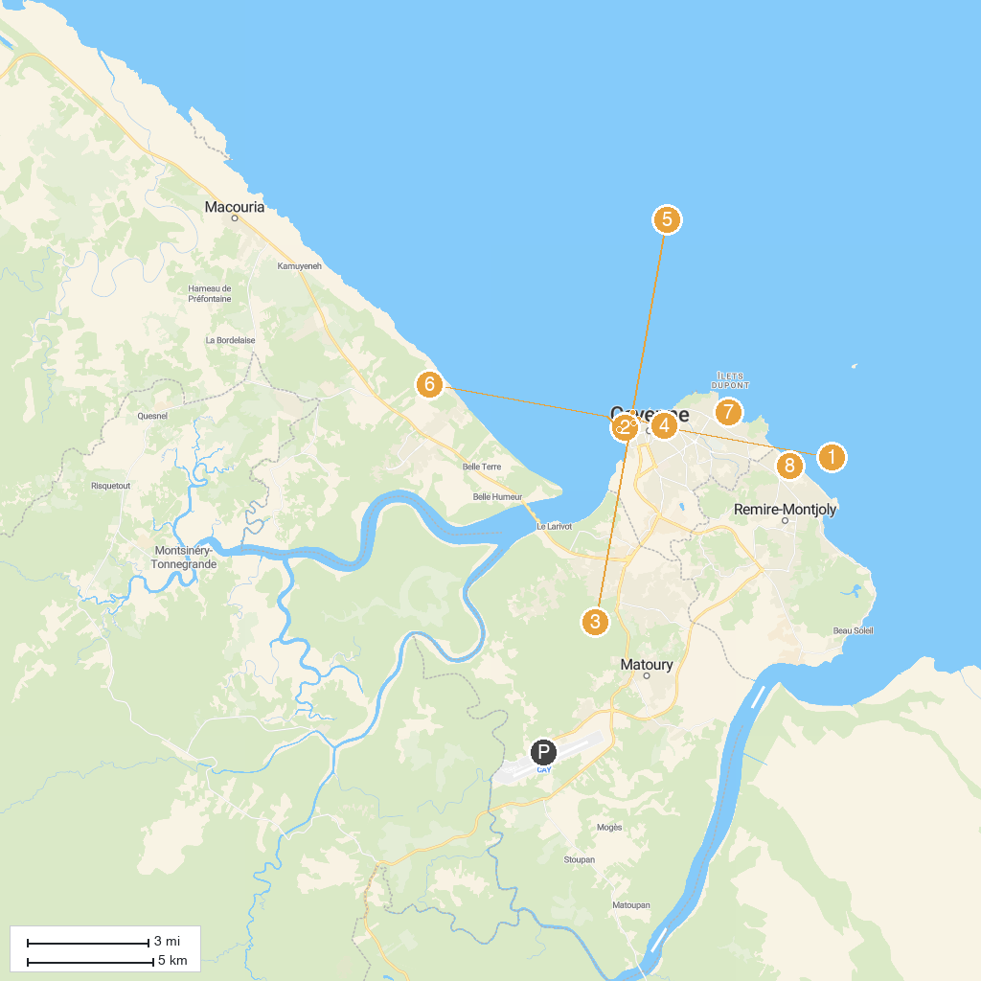
MAP KEY
1. Museum of Guyanese Cultures | 5. Place des Amandiers
2. Musée Alexandre-Franconie | 6. Phare de Fort Cépérou
3. Cathédrale Saint-Sauveur | 7. Plage de Montabo
4. Jardin Botanique | 8. Salines de Montjoly
P. Cruise port / terminal
Map © MapTiler © OpenStreetMap contributors · cruiseports.org

