Cebu City, Cebu, Philippines
The Queen City of the South packs 500 years of Spanish colonial history into a walkable downtown — then throws in whale sharks, Bohol's Chocolate Hills, and some of the Philippines' clearest island waters just a short ride away.
⚓ Docked (Port of Cebu) · 🕒 Typical call: 8-12 hrs · 💵 Philippine Peso (PHP) · 🗣️ Filipino / Cebuano
✍️ MY DAY IN PORT (FILL IN)
Ship / Date
In port | arrive ______ · all aboard ______
Booked excursion
Notes / meeting point
GETTING ASHORE
- Docking: Ships berth at the Port of Cebu, Pier 1 or Pier 2, North Reclamation Area — fort and heritage core within easy walking distance.
- Walk to center: Fort San Pedro is steps from Pier 1; Magellan's Cross and the Basilica are ~700 m (10-min walk).
- Best For: Colonial history, Bohol day trips (Chocolate Hills, tarsiers), whale shark encounters, island hopping
- Don't Miss: Basilica Minore del Santo Niño — the Philippines' oldest church, founded 1565
GETTING AROUND
- 🚕 Taxi: PHP 100–130 — Metered taxis wait at Pier 1 and nearby piers. Base fare is ~PHP 40 with ~PHP 13.50/km; the city center is only a few km
- 📱 Rideshare: ✅ Grab
TOP THINGS TO DO
- Cebu Heritage Walking Tour — Hit the colonial core on foot: Fort San Pedro (oldest fort in the Philippines), Magellan's Cross in its octagonal chapel, the…
- Whale Shark Encounter at Oslob — About 3 hours south of Cebu City, Oslob is one of the world's most reliable spots to swim alongside whale sharks.
- Bohol Day Trip — Chocolate Hills & Tarsiers — A fast ferry to Tagbilaran or Tubigon opens up Bohol's greatest hits: the otherworldly Chocolate Hills, the Philippine Tarsier…
- Kawasan Falls Canyoneering — Cliff-jump and wade through the turquoise gorge of Kawasan Falls in Badian, 3 hours southwest of Cebu City.
- Island Hopping — Hilutungan & Nalusuan — Quick boat tours out of Mactan Island visit the marine sanctuary at Hilutungan, snorkel over coral gardens, stop at the…
BEST WALKS
- Colonial Cebu Heritage Loop: ~1.5 km | 45-60 min | Easy | Mostly flat — Walk directly from Pier 1 to Fort San Pedro, then north to Plaza Independencia, Magellan's Cross…
- Colon Street Stroll: ~1 km | 30 min | Easy — Head up to Colon Street — the oldest street in the Philippines — for a taste of Cebu's chaotic…
WEATHER · DAYLIGHT · MONEY
Month | High °F | Low °F | Rainy days
May | 86 | 79 | 27
Jul | 85 | 78 | 27
Sep | 85 | 78 | 26
Daylight: May 5:23AM–5:58PM · Jul 5:30AM–6:10PM · Sep 5:34AM–5:44PM
cruiseports.org/cebu-city · Confirm terminal & all-aboard time with your ship

Cebu City, Cebu, Philippines — Port Map
Red = walkable sights · Amber = excursions farther out · P = cruise terminal
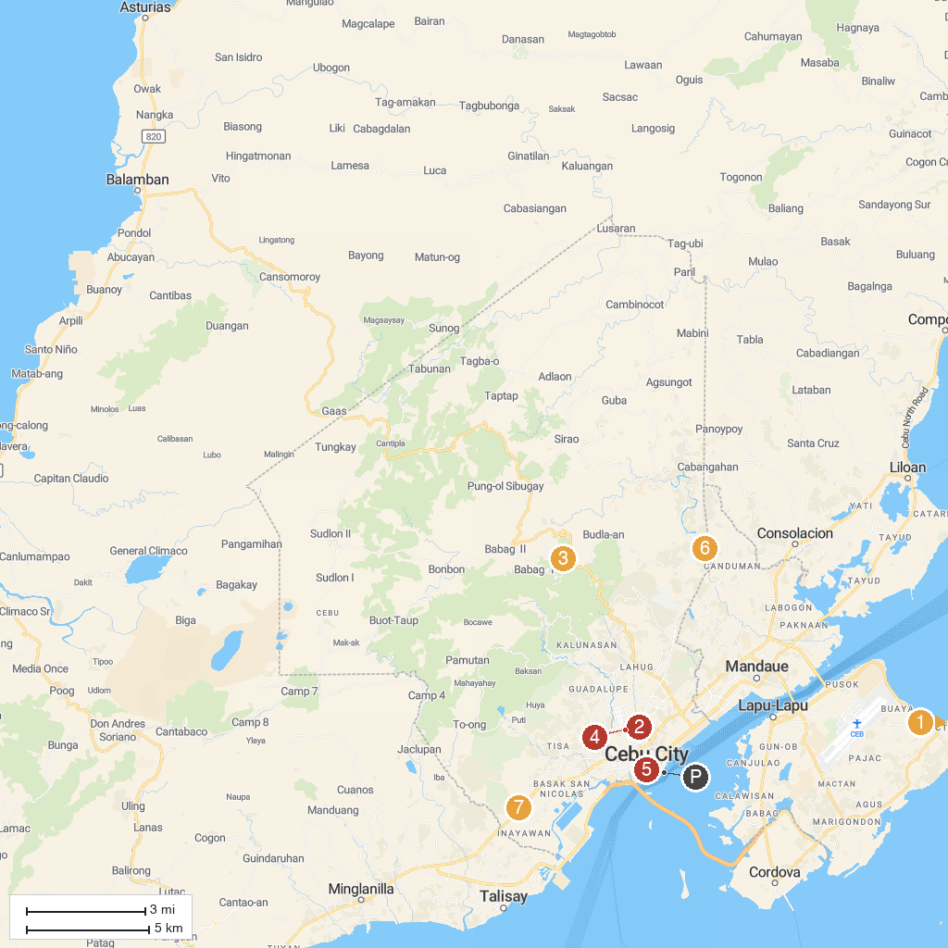
MAP KEY
1. Magellan's Marker | 5. Sky Experience Adventure
2. The Archdiocesan Shrine of the Most Sacred Heart of Jesus | 6. Magellan's Cross
3. Papa Kit's Marina and Fishing Lagoon | 7. Archival's Eco-House
4. TOPS Cebu | 8. Santo Tomas de Villanueva Parish
P. Cruise port / terminal
Map © MapTiler © OpenStreetMap contributors · cruiseports.org

