Celebration Key, Grand Bahama, Bahamas
Carnival's purpose-built $600 million private destination on Grand Bahama's southern shore opened July 2025 — five distinct portals spread across 65 acres, from family lagoons and 10-story waterslides to an adults-only infinity-pool beach club.
⚓ Pier (docked — no tender) · 🕒 Typical call: 7-9 hrs · 💵 USD & BSD accepted; Sail & Sign card · 🗣️ English · 🌴 Carnival Exclusive Destination
✍️ MY DAY IN PORT (FILL IN)
Ship / Date
In port | arrive ______ · all aboard ______
Booked excursion
Notes / meeting point
GETTING ASHORE
- Docking: Dedicated pier — two ships simultaneously; direct walk-off, no tender
- Best For: Families, beach days, waterslides, adults-only lagoon retreats
- Don't Miss: Suncastle waterslides, Calypso Lagoon swim-up bar, Lokono Cove Bahamian crafts
- Drink Packages: Ship drink packages do NOT extend ashore; all beverages charged separately
GETTING AROUND
- 🚕 Taxi: $80+ roundtrip (minimum) — Independent taxis can take you to Freeport (~45–55 min drive, ~25–55 miles away). Carnival-set minimum roundtrip fare is
- 📱 Rideshare: ❌ not available
TOP THINGS TO DO
- Suncastle Waterslides — The 10-story Suncastle is the island's centerpiece — two racing waterslides drop you into the lagoon.
- Calypso Lagoon Adult Swim-Up Bar — One of the world's largest swim-up bars with 166 in-water seats, a DJ island, and swing chairs in the water — the adult hangout…
- Pearl Cove Beach Club — Exclusive adults-only (18+) retreat with an 11,000 sq ft infinity pool, private beach, elevated dining, and supervillas.
- Lokono Cove Cultural Village — Browse Bahamian artisan crafts, local art, handmade goods, and duty-free shopping in this cultural marketplace staffed by Grand…
- Lucayan National Park & Gold Rock Beach — Off-island excursion to one of the world's largest explored underwater cave systems, then on to pristine Gold Rock Beach — a…
BEST WALKS
- Portal Stroll: Paradise Plaza to Calypso Lagoon: 📍 ~0.5 mi · ⏱ 15 min · 🟢 Easy · 🏖 Beach route — Walk from the pier entry at Paradise Plaza along the beach path through Starfish Lagoon to Calypso…
WEATHER · DAYLIGHT · MONEY
Month | High °F | Low °F | Rainy days
May | 82 | 74 | 15
Jul | 86 | 79 | 22
Sep | 85 | 78 | 21
Daylight: May 6:27AM–7:54PM · Jul 6:31AM–8:09PM · Sep 7:00AM–7:18PM
cruiseports.org/celebration-key-bahamas · Confirm terminal & all-aboard time with your ship

Celebration Key, Grand Bahama, Bahamas — Port Map
Red = walkable sights · Amber = excursions farther out · P = cruise terminal
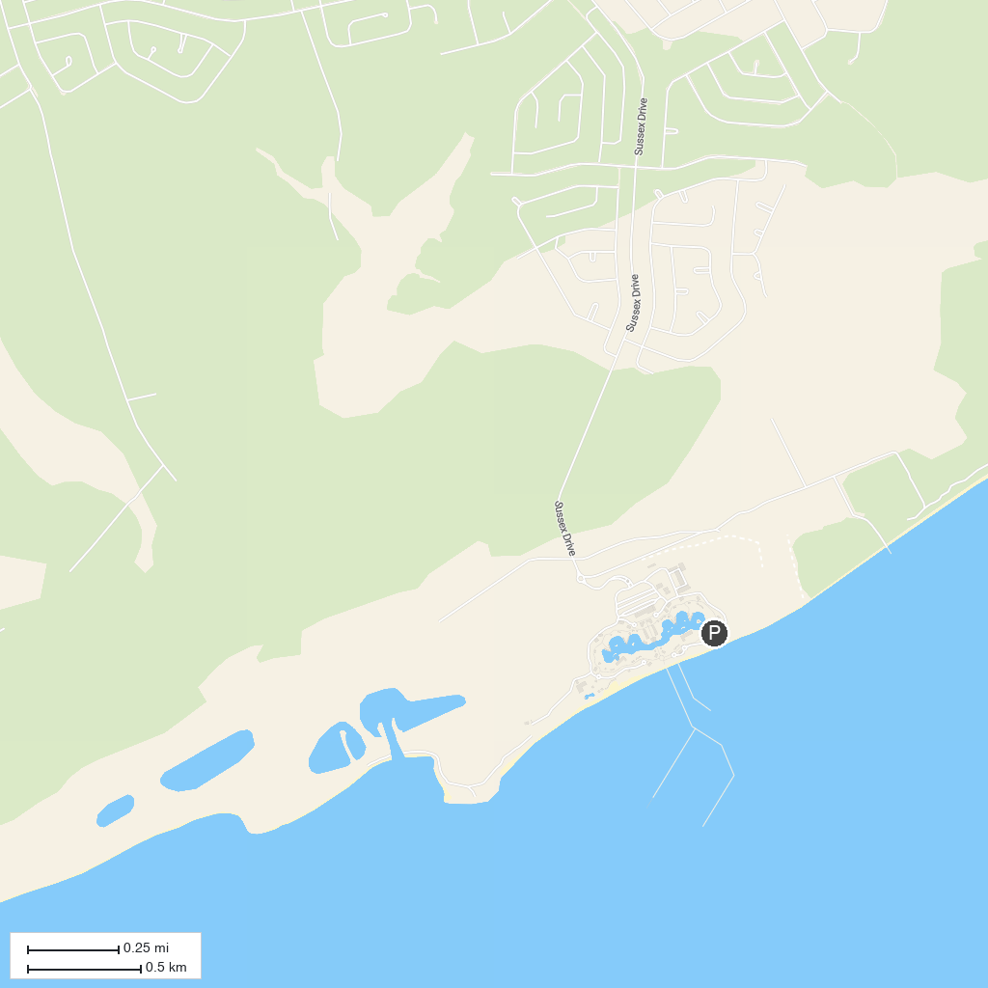
MAP KEY
1. Rand Nature Center | 4. Calvary Temple
2. Jubilee Cathedral | 5. Mermaid Pond
3. Port Lucaya Marina | 6. Pinders Point Lighthouse
P. Cruise port / terminal
Map © MapTiler © OpenStreetMap contributors · cruiseports.org

