Cernavoda, Constanța, Romania
Where the Danube meets its canal to the Black Sea, Cernavoda punches well above its size — a launching pad for the delta, the coast, and centuries of Romanian history.
⚓ Docked (river pier) · 🕒 Typical call: 6-8 hrs · 💵 Romanian Leu (RON) · 🗣️ Romanian
✍️ MY DAY IN PORT (FILL IN)
Ship / Date
In port | arrive ______ · all aboard ______
Booked excursion
Notes / meeting point
GETTING ASHORE
- Docking: River pier; ships moor directly on the Danube, ~10-min walk to town center
- Best For: Danube Delta nature, Roman-era Constanța, Murfatlar wine tasting
- Don't Miss: Anghel Saligny Bridge & the start of the Danube–Black Sea Canal
- Walk to Center: ~10 minutes flat from the river pier
GETTING AROUND
- 🚕 Taxi: 10–20 RON — Local taxis (Go Taxi, Cony Taxi) are available near the port. Fares are metered at roughly 2.5 RON base + 2 RON/km — con
- 📱 Rideshare: ✅ Uber
TOP THINGS TO DO
- Danube Delta Wildlife Cruise — Explore Europe's largest river delta — a UNESCO World Heritage Site teeming with over 300 bird species.
- Constanța & Roman Mosaic Museum — Romania's largest Black Sea city was the Roman port of Tomis.
- Murfatlar Winery Visit — The Murfatlar wine region sits just ~18 km from Constanța and produces acclaimed Chardonnay and Pinot Gris from chalky limestone…
- Anghel Saligny Bridge & Canal Walk — The 19th-century Anghel Saligny Bridge over the Danube was one of Europe's longest bridges when built in 1895.
- Histria Ancient Ruins — Founded by Greek colonists in the 7th century BC, Histria is Romania's oldest known settlement — a remarkable open-air site on…
BEST WALKS
- Danube Embankment to Anghel Saligny Bridge: 1.5 km · 20 min · Flat — From the river pier, follow the embankment south along the Danube toward the striking…
WEATHER · DAYLIGHT · MONEY
Month | High °F | Low °F | Rainy days
May | 72 | 54 | 10
Jul | 85 | 66 | 7
Sep | 77 | 59 | 4
Daylight: May 5:41AM–8:28PM · Jul 5:38AM–8:49PM · Sep 6:47AM–7:18PM
cruiseports.org/cernavoda · Confirm terminal & all-aboard time with your ship

Cernavoda, Constanța, Romania — Port Map
Red = walkable sights · Amber = excursions farther out · P = cruise terminal
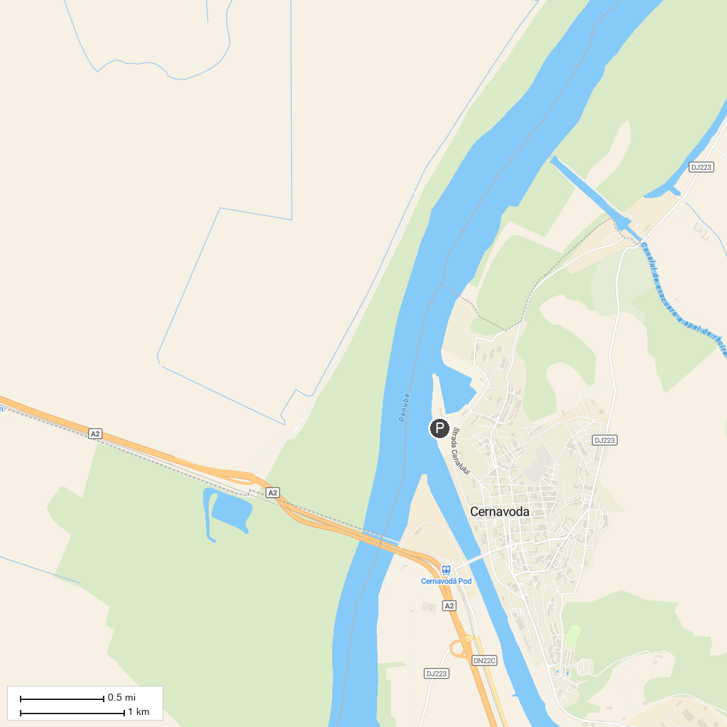
MAP KEY
1. Muzeul de Artă "Dinu și Sevasta Vintilă" | 4. The "Capidava" Fortress
2. Civitas Tropaensium | 5. Piațeta Decebal
3. The Archaeological Museum of Adamclisi | 6. Monumentul Tropaeum Traiani
P. Cruise port / terminal
Map © MapTiler © OpenStreetMap contributors · cruiseports.org

