Çeşme, İzmir Province, Turkey
A breezy Aegean resort town where an Ottoman castle overlooks the marina and the charming stone lanes of Alaçatı are just 15 minutes away. Çeşme punches well above its size for a half-day port call.
⚓ Docked (pier) · 🕒 Typical call: 6-8 hrs · 💵 Turkish Lira (TRY) · 🗣️ Turkish (English widely spoken in tourist areas)
✍️ MY DAY IN PORT (FILL IN)
Ship / Date
In port | arrive ______ · all aboard ______
Booked excursion
Notes / meeting point
GETTING ASHORE
- Docking: Cruise pier in town centre — most ships dock alongside; very large vessels may tender
- Walk to centre: 5 min to castle & marina; 10 min to main square
- Best For: History buffs, beach lovers, foodies, windsurfing day-trippers
- Don't Miss: Alaçatı village & windmills (15 min by taxi)
GETTING AROUND
- 🚕 Taxi: €8–10 — Taxis are available at the port entrance and use meters. Short trips around Çeşme cost roughly €8–10; confirm the fare b
- 📱 Rideshare: ✅ Uber, BiTaksi, Marti
TOP THINGS TO DO
- Çeşme Castle & Archaeological Museum — This well-preserved 16th-century Ottoman fortress dominates the waterfront, a 5-minute walk from the pier.
- Alaçatı Village & Windmills — Just 15 minutes by taxi, Alaçatı is one of the Aegean's best-preserved villages — cobbled lanes, bougainvillea-draped stone…
- Ilıca Thermal Beach — About 5 km from port, Ilıca Beach is famous for its shallow golden-sand shoreline fed by natural hot springs that warm the sea to…
- Windsurfing & Kitesurfing at Alaçatı — Alaçatı's bay is a world-class windsurfing destination, regularly hosting international competitions.
- Ancient City of Erythrai (Ildırı) — About 25 minutes northeast of port, the ruins of ancient Ionian Erythrai include a theatre, temple of Athena, and city walls.
BEST WALKS
- Waterfront Castle Walk: 1.5 km · 30 min · Flat & easy — From the cruise pier, stroll along the marina promenade past moored yachts and seafront cafés to…
- Alaçatı Village Wander: 2 km in village · 45 min walking · Take taxi out & back — Taxi to Alaçatı (15 min), then walk the main cobbled street (Kemalpaşa Caddesi) past the windmills…
WEATHER · DAYLIGHT · MONEY
Month | High °F | Low °F | Rainy days
May | 74 | 63 | 4
Jul | 87 | 74 | 0
Sep | 80 | 70 | 2
Daylight: May 6:03AM–8:18PM · Jul 6:03AM–8:37PM · Sep 6:56AM–7:22PM
cruiseports.org/cesme · Confirm terminal & all-aboard time with your ship

Çeşme, İzmir Province, Turkey — Port Map
Red = walkable sights · Amber = excursions farther out · P = cruise terminal
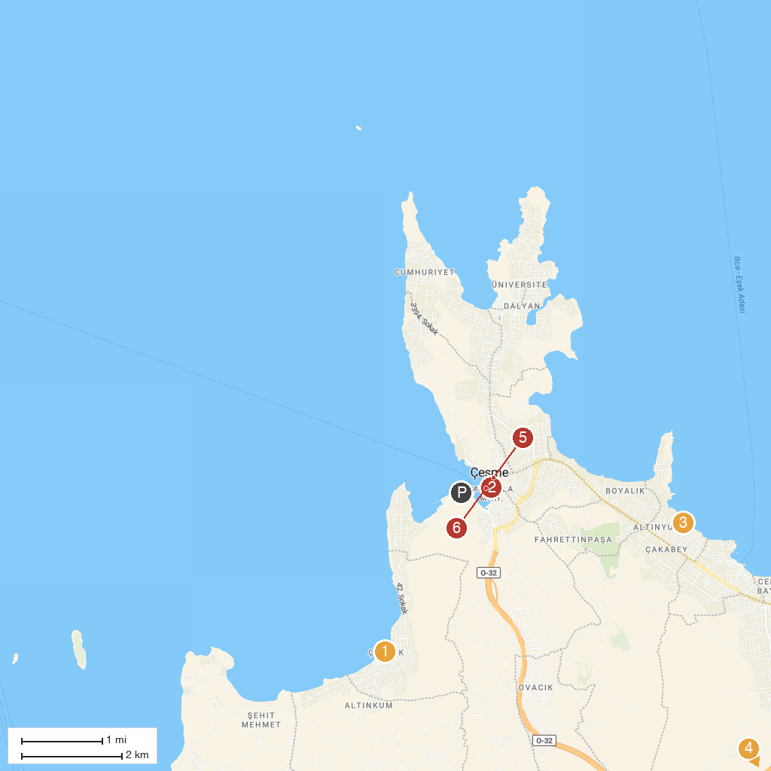
MAP KEY
1. Çiftlik Köy Cami | 4. Alacati debt Water Sports
2. Cesme Castle | 5. Ayios Haralambos Church
3. Aqua Toy City | 6. Güneşlenme Terası
P. Cruise port / terminal
Map © MapTiler © OpenStreetMap contributors · cruiseports.org

