Cetate, Dolj County, Romania
A quiet Danube village opposite Vidin, Bulgaria, Cetate offers a glimpse of rural Romanian river life.
⚓ Docked (river pier) · 🕒 Typical call: 4-6 hrs · 💵 Romanian Leu (RON) · 🗣️ Romanian
✍️ MY DAY IN PORT (FILL IN)
Ship / Date
In port | arrive ______ · all aboard ______
Booked excursion
Notes / meeting point
GETTING ASHORE
- Docking: River pier on the Danube embankment
- Best For: Danube scenery, views across to Vidin fortress, rural Romania
- Don’t Miss: View of Vidin Fortress across the river
- Walk to Center: ~5 minutes from the river pier
GETTING AROUND
- 🚕 Taxi: Ask on board — Vidin (across the river in Bulgaria) is the usual longer outing and is typically a ship excursion or pre-arranged transf
- 📱 Rideshare: ❌ not available
TOP THINGS TO DO
- Port Cetate Cultural Stop — The village's old 19th-century grain port has been converted into Port Cetate, a small cultural venue founded by Romanian poet…
- Danube Riverside Walk — A short, flat walk along the embankment and into the village center, about 5 minutes from the pier — a low-key way to see rural…
- View Baba Vida Fortress from the Danube — Across the river in Vidin, Bulgaria, sits Baba Vida Fortress, a 10th-century medieval castle and one of the best-preserved on the…
cruiseports.org/cetate · Confirm terminal & all-aboard time with your ship

Cetate, Dolj County, Romania — Port Map
Red = walkable sights · Amber = excursions farther out · P = cruise terminal
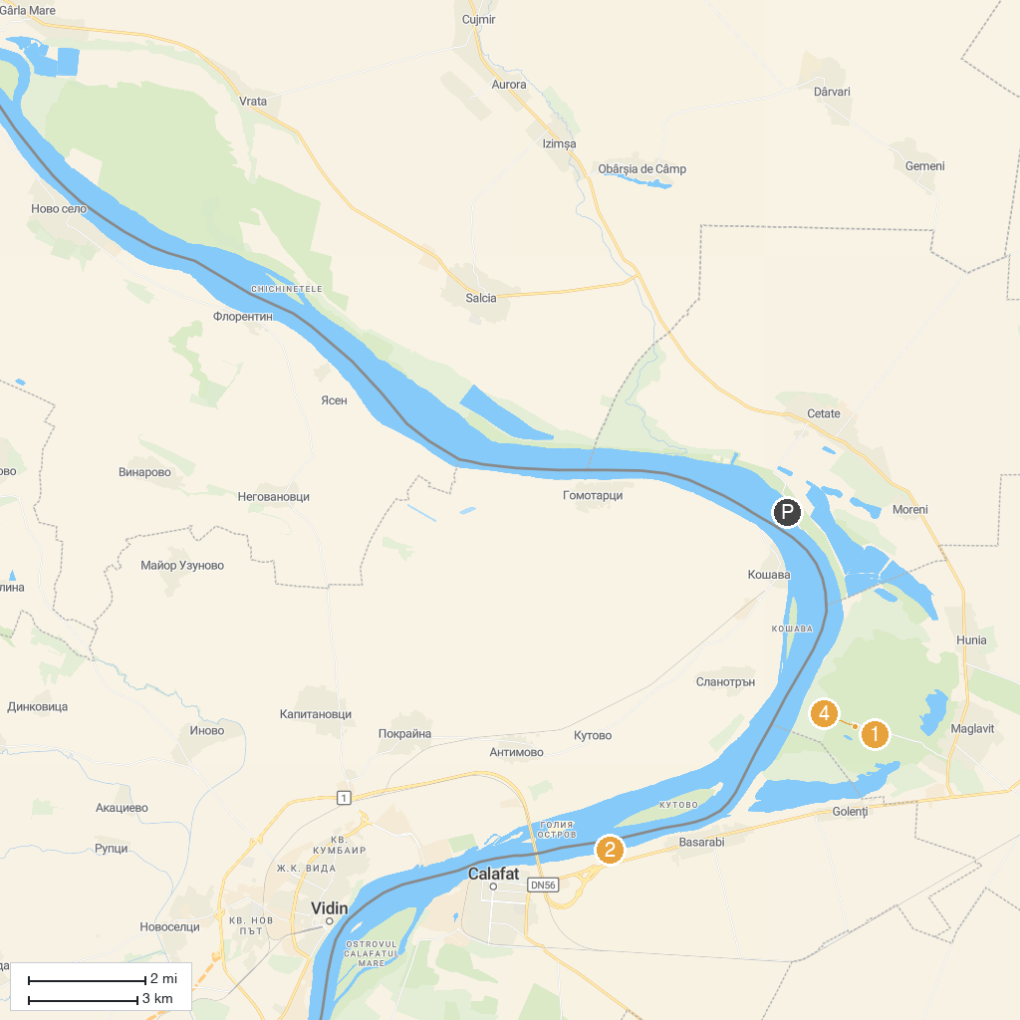
MAP KEY
1. Mănăstirea Maglavit | 3. Port Cultural Cetate
2. Sunny Beach Bascov | 4. Salcia lui Petrache Lupu
P. Cruise port / terminal
Map © MapTiler © OpenStreetMap contributors · cruiseports.org

