Chalon-sur-Saône, Burgundy, France
Birthplace of photography and gateway to Burgundy's legendary vineyards, Chalon-sur-Saône rewards explorers with a walkable old town, free world-class museums, and cellar doors just minutes away.
⚓ Docked (Saône quays) · 🕒 Typical call: 7–9 hrs · 💶 Euro (€) · 🗣️ French
✍️ MY DAY IN PORT (FILL IN)
Ship / Date
In port | arrive ______ · all aboard ______
Booked excursion
Notes / meeting point
GETTING ASHORE
- Docking: Ships berth along Quai Gambetta or Quai des Messageries — steps from the city center
- Walk to center: 2–5 min on foot to Place de l'Hôtel de Ville
- Best For: History, photography, Burgundy wine, relaxed riverfront strolls
- Don't Miss: Nicéphore Niépce Museum (free) and Saint-Vincent Cathedral's Romanesque cloister
GETTING AROUND
- 🚕 Taxi: €8–€14 — Taxis are metered with a €5 base fare plus ~€1.80/km. A ride from the marina to the train station or nearby attractions
- 📱 Rideshare: ✅ Uber
TOP THINGS TO DO
- Nicéphore Niépce Museum — The world's foremost photography museum occupies a mansion on the Saône quay.
- Saint-Vincent Cathedral & Cloister — A soaring Gothic cathedral begun in Romanesque style around 1090.
- Burgundy Wine & Côte Chalonnaise Tasting — The Côte Chalonnaise — Mercurey, Givry, Rully, Montagny — begins right at Chalon's doorstep.
- Beaune Day Trip — Just 30 km north, Beaune is Burgundy's wine capital.
- Autun Roman Ruins — An hour's drive brings you to Autun, one of the best-preserved Roman cities in France.
BEST WALKS
- Chemin de l'Orbandale — Historic Center Circuit: 2–3 km | 1.5–2 hrs | Easy | Self-guided — The city's official heritage walk loops through 30 architectural highlights: half-timbered houses…
- Saône Riverside Stroll to Saint-Laurent Island: 1.5 km | 30–45 min | Easy | Scenic — Walk south along the quays to the Pont Saint-Laurent and cross to Île Saint-Laurent, where a…
WEATHER · DAYLIGHT · MONEY
Month | High °F | Low °F | Rainy days
May | 68 | 50 | 12
Jul | 81 | 62 | 9
Sep | 73 | 55 | 8
Daylight: May 6:06AM–9:08PM · Jul 6:02AM–9:30PM · Sep 7:18AM–7:51PM
cruiseports.org/chalon-sur-saone · Confirm terminal & all-aboard time with your ship

Chalon-sur-Saône, Burgundy, France — Port Map
Red = walkable sights · Amber = excursions farther out · P = cruise terminal
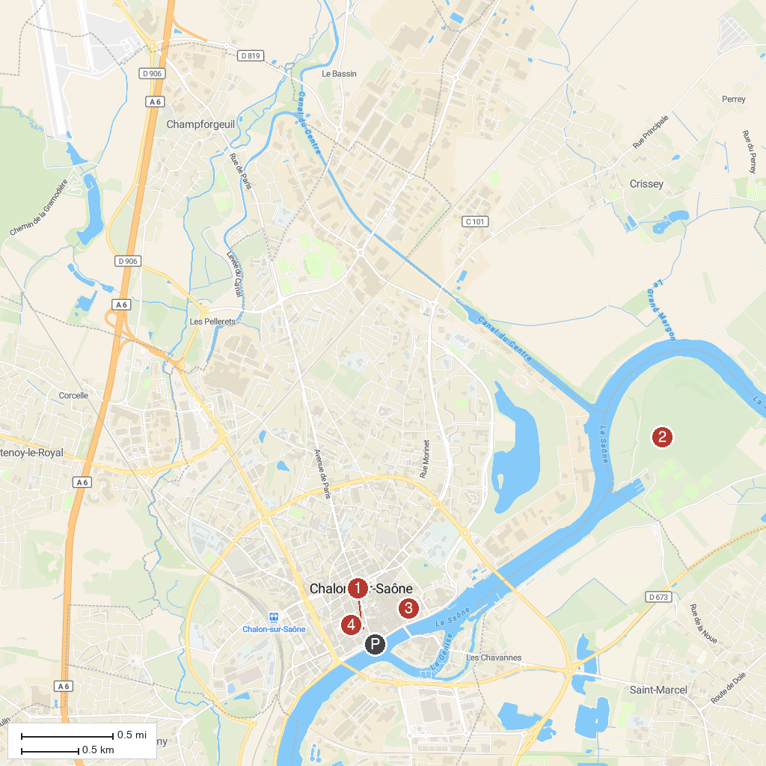
MAP KEY
1. Hotel de Ville de Chalon-sur-Saone | 3. Cathedrale Saint-Vincent
2. Roseraie Saint-Nicolas | 4. Musee Denon
P. Cruise port / terminal
Map © MapTiler © OpenStreetMap contributors · cruiseports.org

