Charlestown, Nevis, Saint Kitts and Nevis
A quietly historic gem in the Leeward Islands, Charlestown rewards walkers with Georgian streetscapes, Alexander Hamilton's birthplace, and natural hot springs — all within a short stroll or taxi ride of the tender pier.
⚓ Tender port · 🕒 Typical call: 6–8 hrs · 💵 USD & Eastern Caribbean Dollar · 🗣️ English
✍️ MY DAY IN PORT (FILL IN)
Ship / Date
In port | arrive ______ · all aboard ______
Booked excursion
Notes / meeting point
GETTING ASHORE
- Docking: Tender only — ships anchor offshore; tenders land at Charlestown waterfront pier
- Walk to center: 2 min — tender pier is at the edge of the compact town center
- Best For: History buffs, beach lovers, and those seeking a laid-back Caribbean escape
- Don't Miss: Museum of Nevis History (Hamilton's birthplace) and Pinney's Beach at Sunshine's Bar
GETTING AROUND
- 🚕 Taxi: From ~$20 USD — Licensed taxis meet cruise tenders at the Charlestown pier. Government-set fares cover up to 4 passengers; confirm price
- 📱 Rideshare: ❌ not available
TOP THINGS TO DO
- Museum of Nevis History — Hamilton's Birthplace — The two-storey Hamilton House, a 5-minute walk from the tender pier, is the traditionally recognised birthplace of Alexander…
- Pinney's Beach & Sunshine's Bar — Nevis's most famous beach stretches for miles just 15–20 min walk (or 5 min taxi) north of town.
- Botanical Gardens of Nevis — Set on the historic Montpelier Estate with views of Mount Nevis and the sea, these roughly six-acre gardens feature orchid…
- Bath Hotel Hot Springs — Just south of Charlestown, natural volcanic mineral springs bubble up at 104–108°F (40–42°C).
- Island Taxi Tour — Plantation Ruins & Ring Road — Hire a taxi-guide for a circuit of the island taking in plantation ruins (Montpelier, Nisbet), St.
BEST WALKS
- Charlestown Town Walk: 45 min · Flat · Easy — A self-guided stroll through Charlestown's well-preserved Georgian streetscape.
- Pier to Pinney's Beach Stroll: 20 min each way · Mostly flat · Easy — Head north from the pier along the coastal road past the Four Seasons resort to reach Pinney's Beach.
WEATHER · DAYLIGHT · MONEY
Month | High °F | Low °F | Rainy days
May | 81 | 77 | 17
Jul | 83 | 79 | 19
Sep | 84 | 79 | 21
Daylight: May 5:38AM–6:34PM · Jul 5:45AM–6:47PM · Sep 5:58AM–6:12PM
cruiseports.org/charlestown-nevis · Confirm terminal & all-aboard time with your ship

Charlestown, Nevis, Saint Kitts and Nevis — Port Map
Red = walkable sights · Amber = excursions farther out · P = cruise terminal
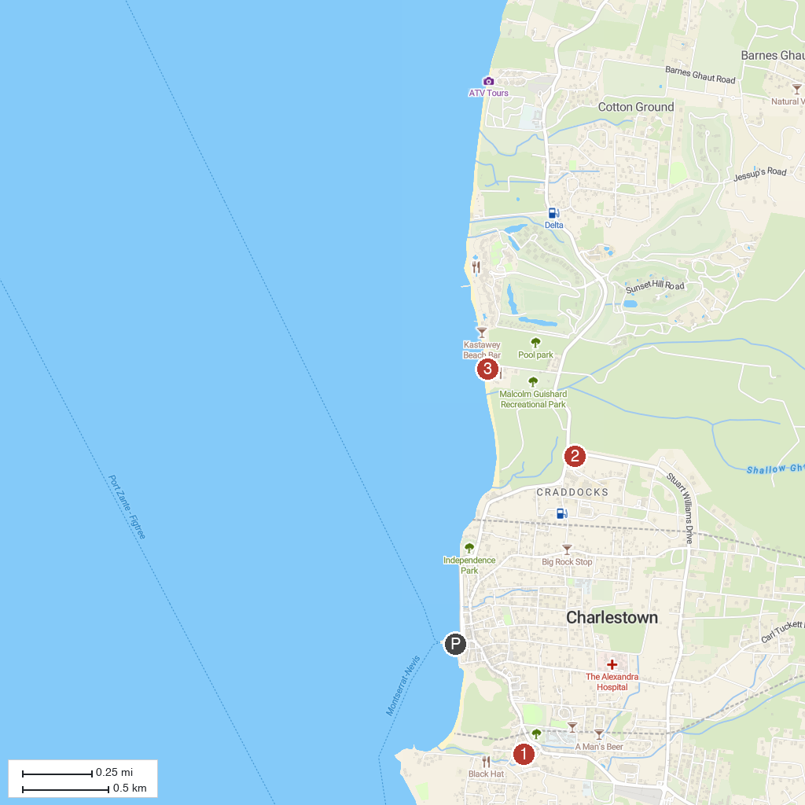
MAP KEY
1. Nevis Hot Springs | 3. Supreme + Motorsports SKN
2. Nevis Artisan Village
P. Cruise port / terminal
Map © MapTiler © OpenStreetMap contributors · cruiseports.org

